Our Class Charter
Children (Right Holders) respect these rights by… | 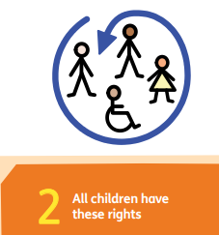 | Nursery’s Rights | Adults (Duty Bearers) respect these rights by… | 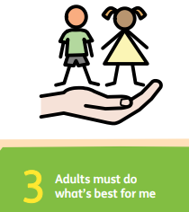
⭐Share their ideas and feelings in kind ways.  ⭐Listen to others when they speak.  ⭐Use their words, drawings, or actions to express themselves.  ⭐Take turns ake turns to talk. |  | Respect for all of our views   | - Listen carefully to children’s ideas and feelings.  - Encourage children to talk, draw, sing, or use other ways to express themselves.  - Create a safe, welcoming environment where every voice matters.  - Respond to children’s ideas and show they are valued.
⭐ Share toys and take turns.  ⭐Include others in their games.  ⭐Look after toys and equipment.  ⭐Play kindly and help friends if they need it. |  | A right to rest and enjoy a variety of play  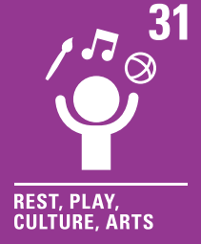 | - Provide safe, fun, and interesting spaces (indoors and outdoors) for play.  - Make sure everyone gets a turn and feels included.  - Join in play respectfully to support, not take over.

