Our Class Charter
Children (Right Holders) respect these rights by… | 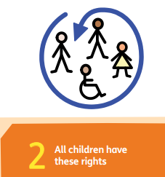 | Reception’s Rights | Adults (Duty Bearers) respect these rights by… | 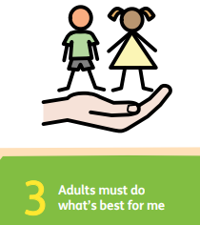
⭐Share our ideas during circle time or play.  ⭐ Listen to our friends when they are talking.  ⭐ Take turns and use kind words. |  | Respect for all of our views  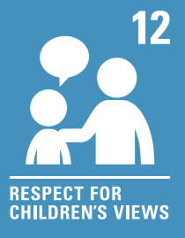 | - Listen carefully to what children say.  - Give children choices in their learning and play.  - Make time for children to express their thoughts and feelings.
⭐ Help keep the classroom tidy.  ⭐ Take care of resources.  ⭐ Make clear choices in the dinner hall.  ⭐ Thank the lunch time staff for cooking and serving me lunch. |  | A right to food, clothing and a safe space  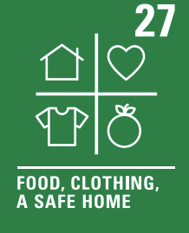 | - Provide a safe, clean, and welcoming classroom.  - Offer healthy snacks and make sure children are warm and comfortable.  - Help families when they need support.
⭐ Join in play with others and try new things.  ⭐ Include everyone and play fairly.  ⭐ Show respect for different ways of playing and learning.  ⭐ Show sensible behaviour when playing inside and outside. |  | A right to rest and enjoy a variety of play  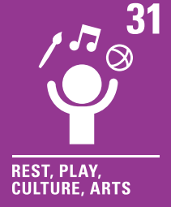 | - Plan fun and creative activities every day.  - Make sure children have time to rest and play.  - Celebrate different cultures through stories, music, and art.

