Our Class Charter
Children (Right Holders) respect these rights by… | 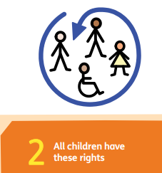 | Class 1’s Rights | Adults (Duty Bearers) respect these rights by… | 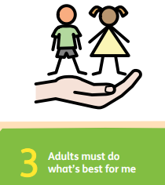
- Listening carefully when others share ideas.  - Taking turns to speak.  - Sharing ideas respectfully. |  | 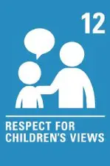  We have the right to be listened to. | - Giving you time to share your views.  - Making sure everyone gets a chance to speak.
- Using kind hands and kind words.  - Telling an adult if you feel unsafe.  - Looking out for each other. |  | 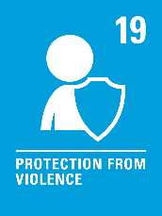  We have the right to be safe and happy. | - Act quickly if you are upset or feeling unsafe.  - I will teach you how to manage feelings and solve problems peacefully.
- Playing fairly and including others.  - Taking care of equipment and toys.  - Know when it is time to play and time to learn. |  | 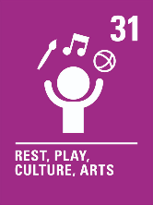  We have the right to relax and play. | - Making sure there is Choosing time.  - Listening to your ideas about what games/activities you would like.
- Always try your best.  - Don’t give up if things feel tricky.  - Taking care of books, resources and our classroom. |  | 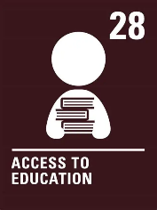  We have the right to learn. | - Planning fun, interesting lessons.  - Helping anyone who is struggling.

