Our Class Charter
Children (Right Holders) respect these rights by… | 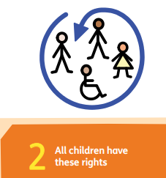 | Class 3’s Rights | Adults (Duty Bearers) respect these rights by… | 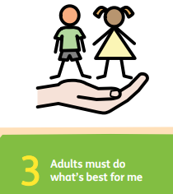
- We will sit quietly when the teacher is teaching.  - We will wait our turn to speak.  - We will listen in class. |  | 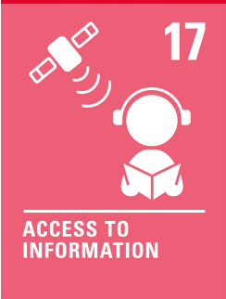 | - We can support you  - We can teach you the skills and information
- We will only speak when we need help with our work.  - We come to school everyday  - We bring our bookbags to school  - We do our work quietly |  | 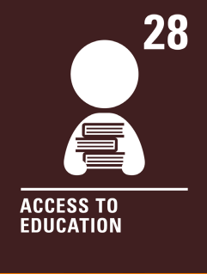 | - We will give you access to books  - We will give wordbanks  - We will support you with your work.
- Play with our friends  - Do art in schools  - Participate in culture day |  | 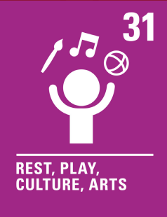 | - Be given play time, lunch time and daily mile  - Teaching fun art lessons

