Our Class Charter
Children (Right Holders) respect these rights by… | 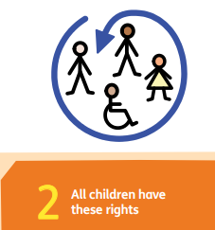 | Class 4’s Rights | Adults (Duty Bearers) respect these rights by… | 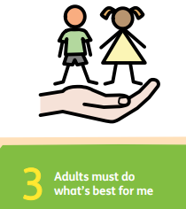
- Think before we speak  - Letting everyone join in with our games.  - Show love and kindness to everyone with our words and actions.  - Treat others the way that we want to be treated.  - Listen to others |  | 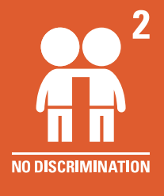 | - Help make sure nobody is bullied  - Making sure everyone feels safe  - Make sure all children are being kind with their hands and words  - Help people who might be hurt  - Listen to all sides of a story.
- Help others including our teachers  - Listen to the adults even when the decision isn’t what we wanted.  - Show respect to everyone  - Follow instructions that we are given. |  | 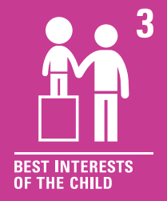 | - To show love to everyone  - To show that they care for us all  - To help keep us safe  - To teach us fun lessons to help us learn  - To show respect to everyone.
- Sharing our thoughts with others.  - Listen to others and don’t talk over them.  - Supporting our friends when they need us.  - Support anyone who needs it.  - Think carefully before we speak to avoid upsetting others.  - Letting everyone have a go with our games.  - Make sure we speak loudly and clearly. |  | 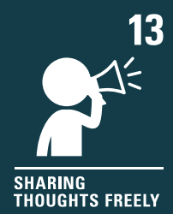 | - Listen to everyone  - Make sure everyone gets the chance to speak  - Join in with the children- dancing playing outside etc  - Give us the chance to access a quiet space to talk if needed.
- Having fun outside with our friends  - Make sure nobody gets hurt when playing.  - Kind hands, feet and words when playing.  - If there is a problem, tell an adult instead of getting ourselves involved.  - Looking out for our seed.  - Look after the equipment outside. |  | 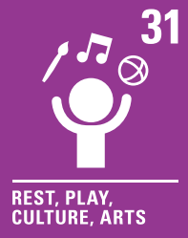 | - Keep a look out to make sure everyone is being kind.  - Joining in with the children’s play.  - OPAL assembly  - Help us to play safely  - Make sure there is enough equipment outside.

