Our Class Charter
Children (Right Holders) respect these rights by… | 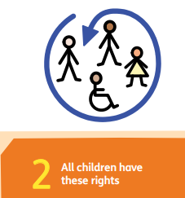 | Class 7’s Rights | Adults (Duty Bearers) respect these rights by… | 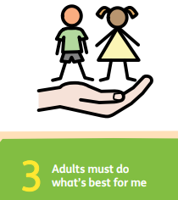
- Give someone equipment if they need it  - Comfort others when they feel sad  - Share your equipment with them  - Always ask before borrowing equipment  - Be respectful |  | 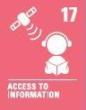 | - Keep an eye out to see people sharing with one another  - Make sure everyone is safe  - Look out for kindness in the classroom  - Make sure no one gets injured  - Prevent arguments  - Be respectful
- Treat everyone the same  - Be kind to each other  - Respect everyone equally  - Treat others as you want to be treated  - Don’t be racist (Show racism the red card day)  - Don’t bully others |  | 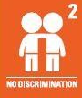 | - Be visible on the playground so children know who to go to if they need help  - No favouritism  - Encourage children to respect each others  - Supervise gardeners and seeds playing together  - Encourage children to play with others  - Have a gardeners and seeds day
- Listen to others when they’re talking in class  - Listen to the teacher’s instructions so you know what to do in your work  - Treat all students the same, and all teachers the same  - Help others if they are stuck on a question  - Treat everyone how you want to be treated  - Be patient  - Show kindness to everyone  - Work hard |  |  | - Be patient with pupils if they are working slowly  - Listen to pupils if they need help  - Smile at pupils if they are sad

