Class 8 Class Charter
Children (Right Holders) respect these rights by… | 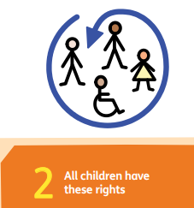 | Class 8’s Rights | Adults (Duty Bearers) respect these rights by… | 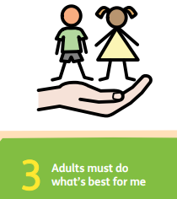
- Make sure everyone in our class feels safe and welcome.  - Use language free from racism, body shaming and disability.  - To include everyone in our play and work.  - Treat everyone fairly.  - Be a good role to each other and other children in the school.  - Playing with everyone even if they are not your friends |  | 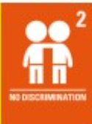 | - Be a good role model to children.  - Be fair and equal to everyone.  - Don’t have favourites.  - Follow the behaviour system fairly
- Respect each other’s personal space and belongings.  - Be truthful.  - Listening to each other when you are talking.  - Taking turns to talk. |  | 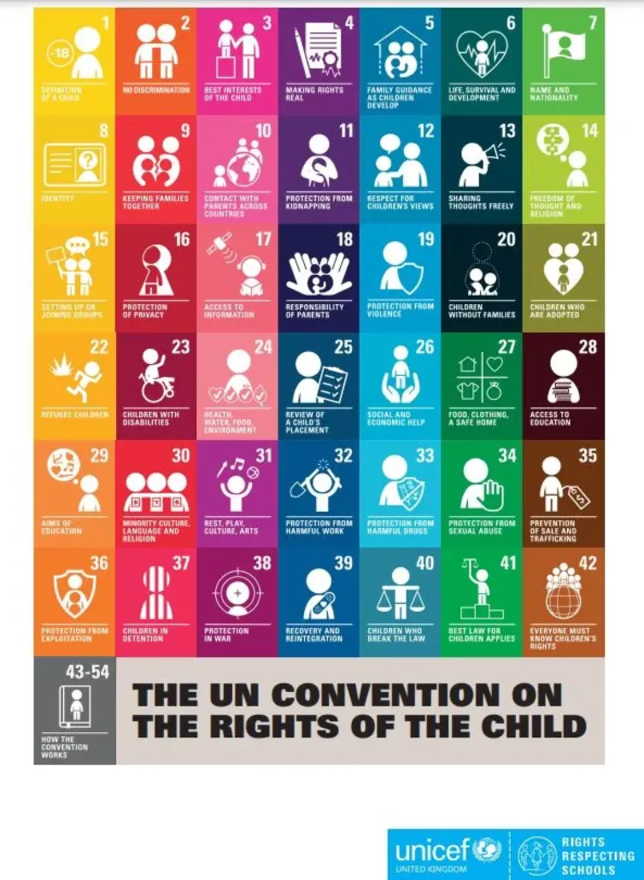 | - Listen to all children, not just some.  - Use the zones of regulation to communicate feelings.  - Listen to the children.  - Give everyone a chance when they put their hands up.  - Use the communication box.  - Select a school councilor.  - Make rights real.  - Make sure we get playtime.  - Plan brain breaks when children are tired/fidgety.  - Make sure children have a lunch time meal.
- Respect everyone for who they are.  - Respect everyone for their religious beliefs.  - Keep an open mind - ask questions.  - Respect each other’s point of view and listen. |  |  | - When children have a all out make sure that the children are ok before continuing with the lesson.  - Don't side with a child because they have the same religion as me.  - Respect all religions, cultures and ways of life.  - Don’t tease anyone for the way they dress.
- Don’t disrupt each other during the lesson by not talking over the teacher and not messing with equipment.  - Work hard in lessons.  - Don’t copy each other.  - Keep the classroom tidy and look after equipment.  - Ask to leave the classroom.  - Come into school when you can. |  |  | - Educate everyone equally.  - Don’t limit anyone’s learning.  - Make sure that we have the correct equipment for the lesson.  - Help children when they are unsure.

