

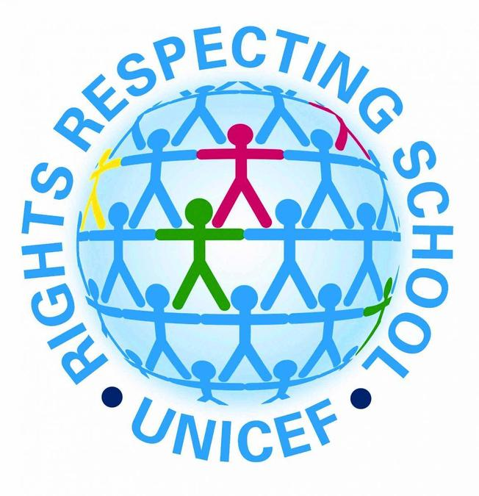

Day | Challenge | Rights
1 | Say ‘Good morning’ and smile at 5 people | Article 12- Respect each child’s views  Article 2- No discrimination
2 | Hold the door open for someone | Article 12- treating everyone with respect
3 | Include someone who is alone at playtime | Article 15- setting up and joining groups  Article 31- Right to rest and play  Article 9- Keeping families together
4 | Help a younger child with their shoes or coat | Article 3- Best interest of the child
5 | Give 3 people a compliment | Article 8- Sharing thoughts freely
6 | Help to keep the classroom tidy | Article 24- right to a safe environment
7 | Let someone else go first | Article 7- make rights real for everyone.  Article 3- the best interest of a child.
8 | Play with someone new | Article 31- right to rest and play  Article 15- setting up groups
9 | Pick up some litter | Article 24- right to a safe environment
10 | Offer to help a teacher | Article 28- access to our education
11 | Sit with someone who is left out | Article 2- No discrimination  Article 15- Setting up and joining groups
12 | Say thank you to someone | Article- Share your thoughts freely
13 | Share equipment | Article 31- The right to rest and play
14 | Invite someone new to play | Article 15- setting up and joining groups
15 | Be a fantastic helper | Article 29- Aims of education
16 | Write a kind note to someone | Article 13- Sharing our thoughts freely.
17 | Let someone borrow something | Article 3- the best interest of the child
18 | Give someone a turn | Article 31- Right to rest and play
19 | Help someone with their coat | Article 13- setting up groups and helping one another
20 | Say something kind to yourself | Article 14- Freedom of thought
21 | Help tidy a shared space | Article 24- Health, water, food and environment.
22 | Listen carefully to others | Article 13- Sharing your thoughts freely
23 | Ask an adult at home if you can help them with a job | Article 9- Keeping families together.
24 | Show kindness at home | Article 27- the right to food, clothing and a safe home.

