

Sacred Heart RC Primary School
'Where Every Heart is Sacred’
Week Commencing: 20th January 2025

The Conversion of St. Paul
January 25th
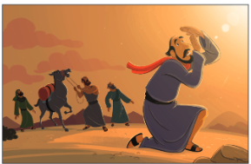
St. Paul’s story shows that anyone can change with God’s love. His conversion, celebrated on January 25 as the Feast of the Conversion of St. Paul, marks when he transformed from an enemy of Christians into a missionary spreading Jesus’ teachings.
Paul, originally named Saul, was born around A.D. 8 in Tarsus, modern-day Turkey. As a devout Jew and Pharisee, he hated Christians, believing their teachings violated Jewish law. Saul even helped imprison Christians and witnessed St. Stephen’s death.
On his way to Damascus to arrest more Christians, Saul’s life changed forever. A bright light knocked him down, and he heard Jesus’ voice asking why Saul was persecuting him. Temporarily blinded, Saul went to Damascus, where he was baptized and regained his sight. He then dedicated his life to spreading Jesus’ message and became known as Paul.
Paul traveled extensively, preaching to non-Jews, or Gentiles, and writing letters to guide early Christians. Despite dangers, imprisonment, and hardships, he never gave up. His faith inspired many, and he became known as the Apostle of the Gentiles.
Paul’s conversion reminds us that God can use anyone to do great things, regardless of their past. His writings, called epistles, remain vital in Christian teachings today. Here is a clip that your children may enjoy: https://www.youtube.com/watch?v=IlXFy3zjJh4&t=1s
THIS WEEK’S TOP STORIES
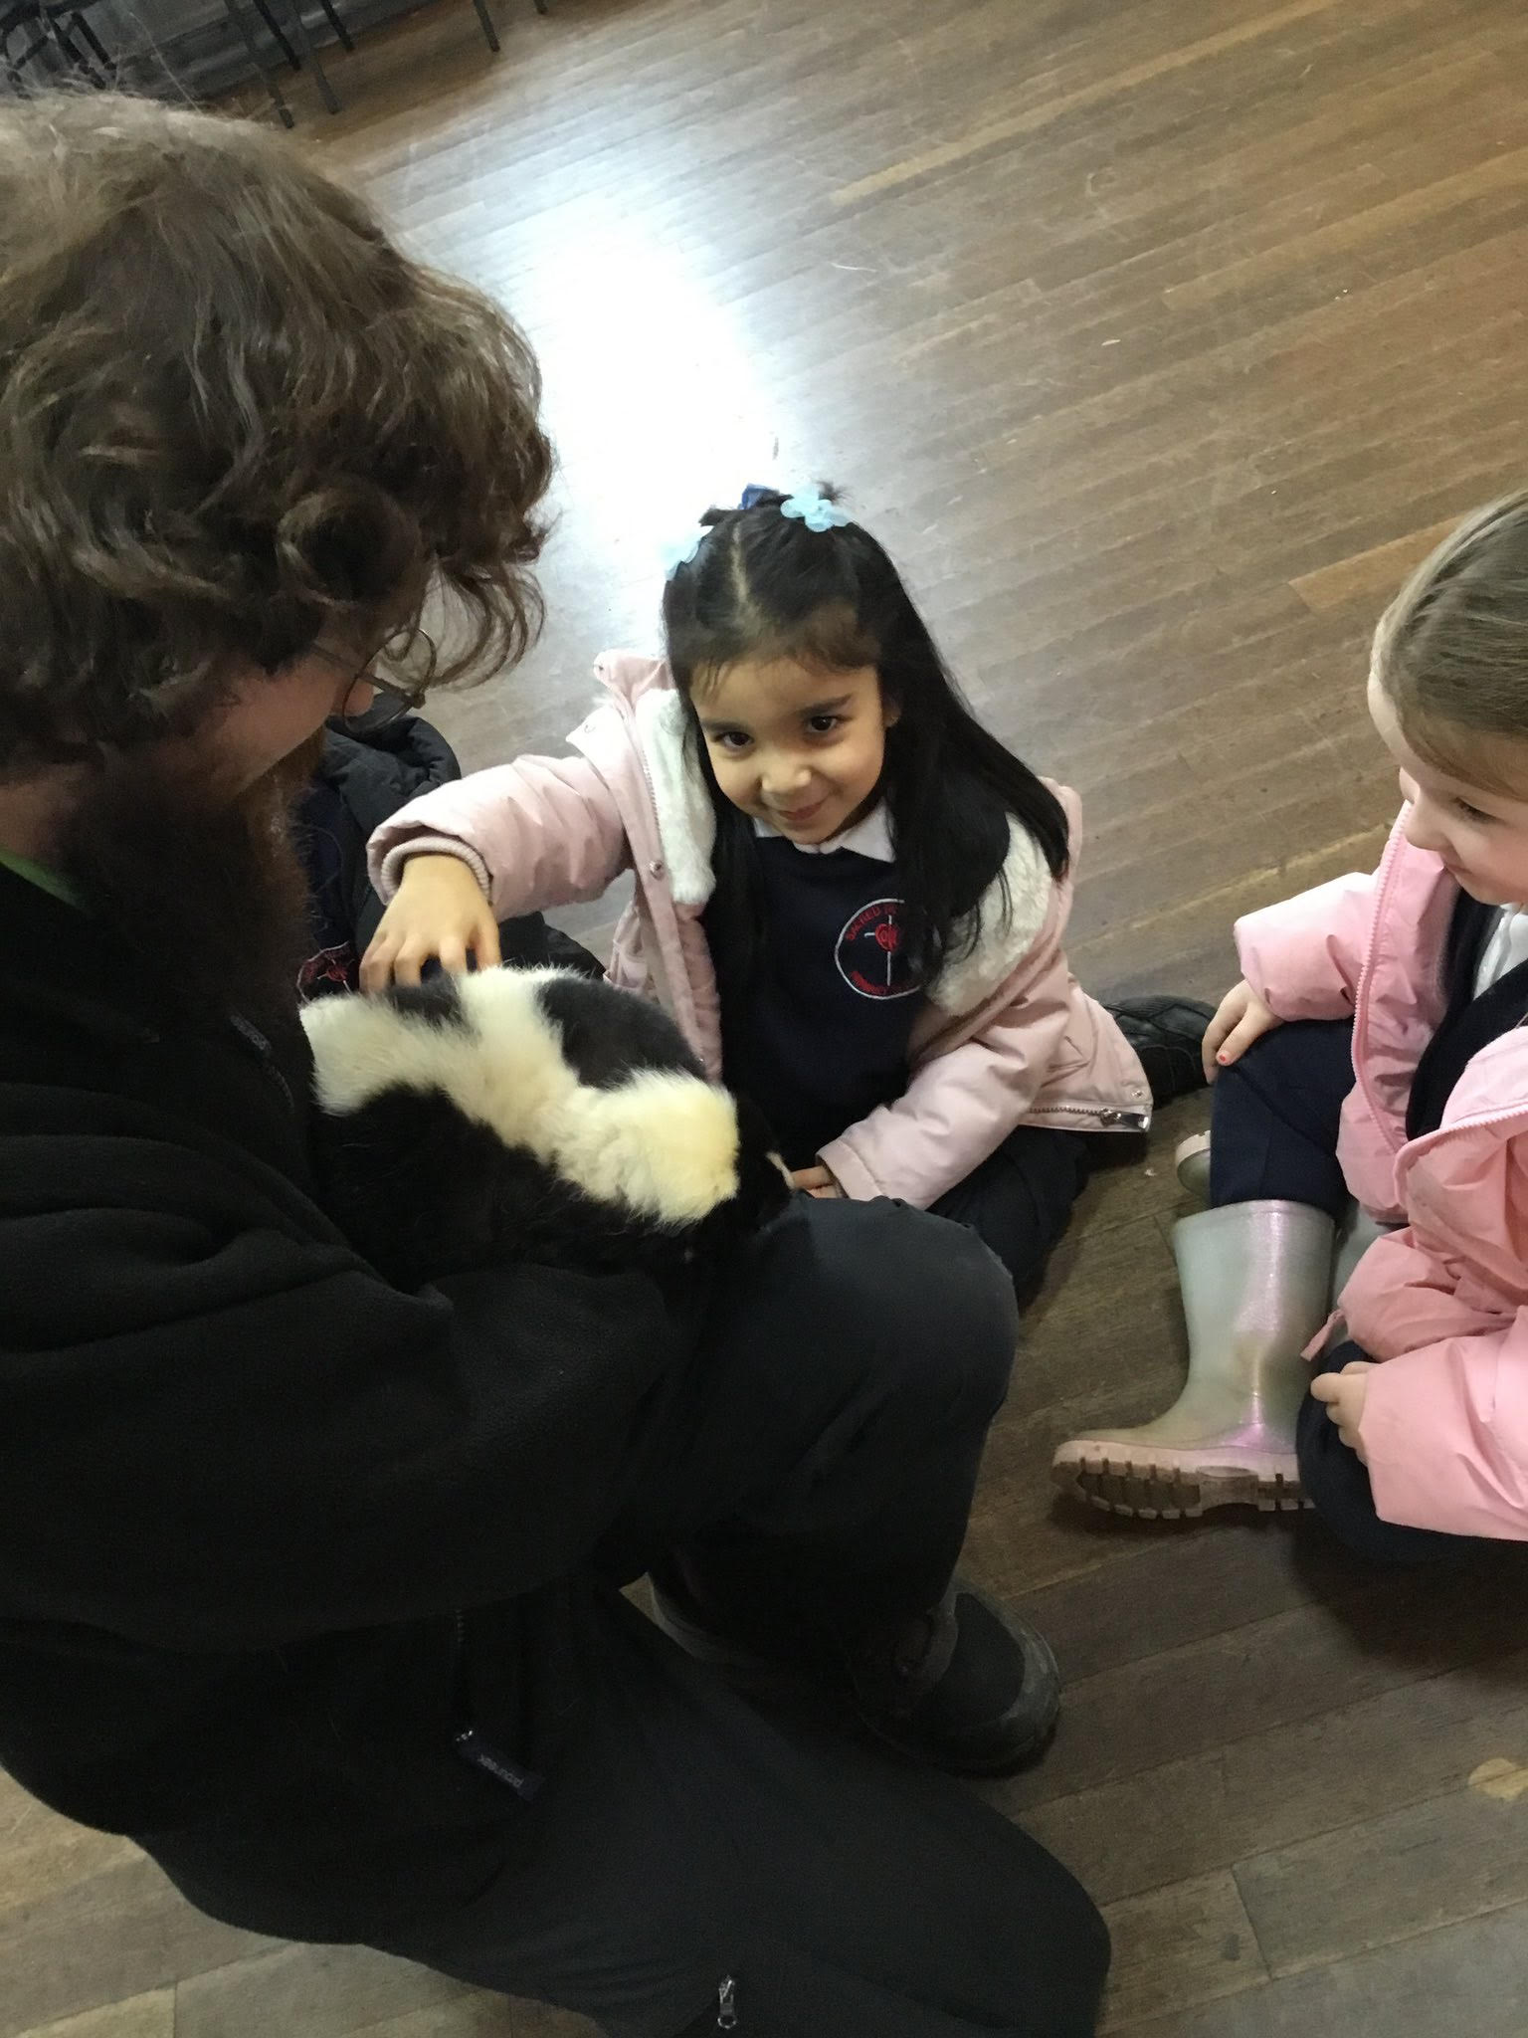

Zoo 2 U in EYFS!
Nursery and Reception
Our Early Years and Butterflies children had the opportunity to meet some furry friends from ‘Zoo2U’ last week! The children have been learning about what things are needed for living creatures to stay healthy.
Ask Nursery and Reception: what do guinea pigs need to stay healthy?

Confirmation in 2025
Please see Father’s note regarding Confirmation for those in Year 8 and above:
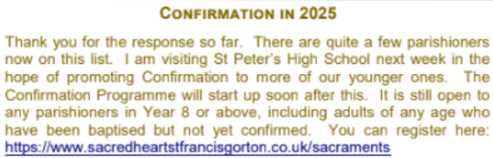

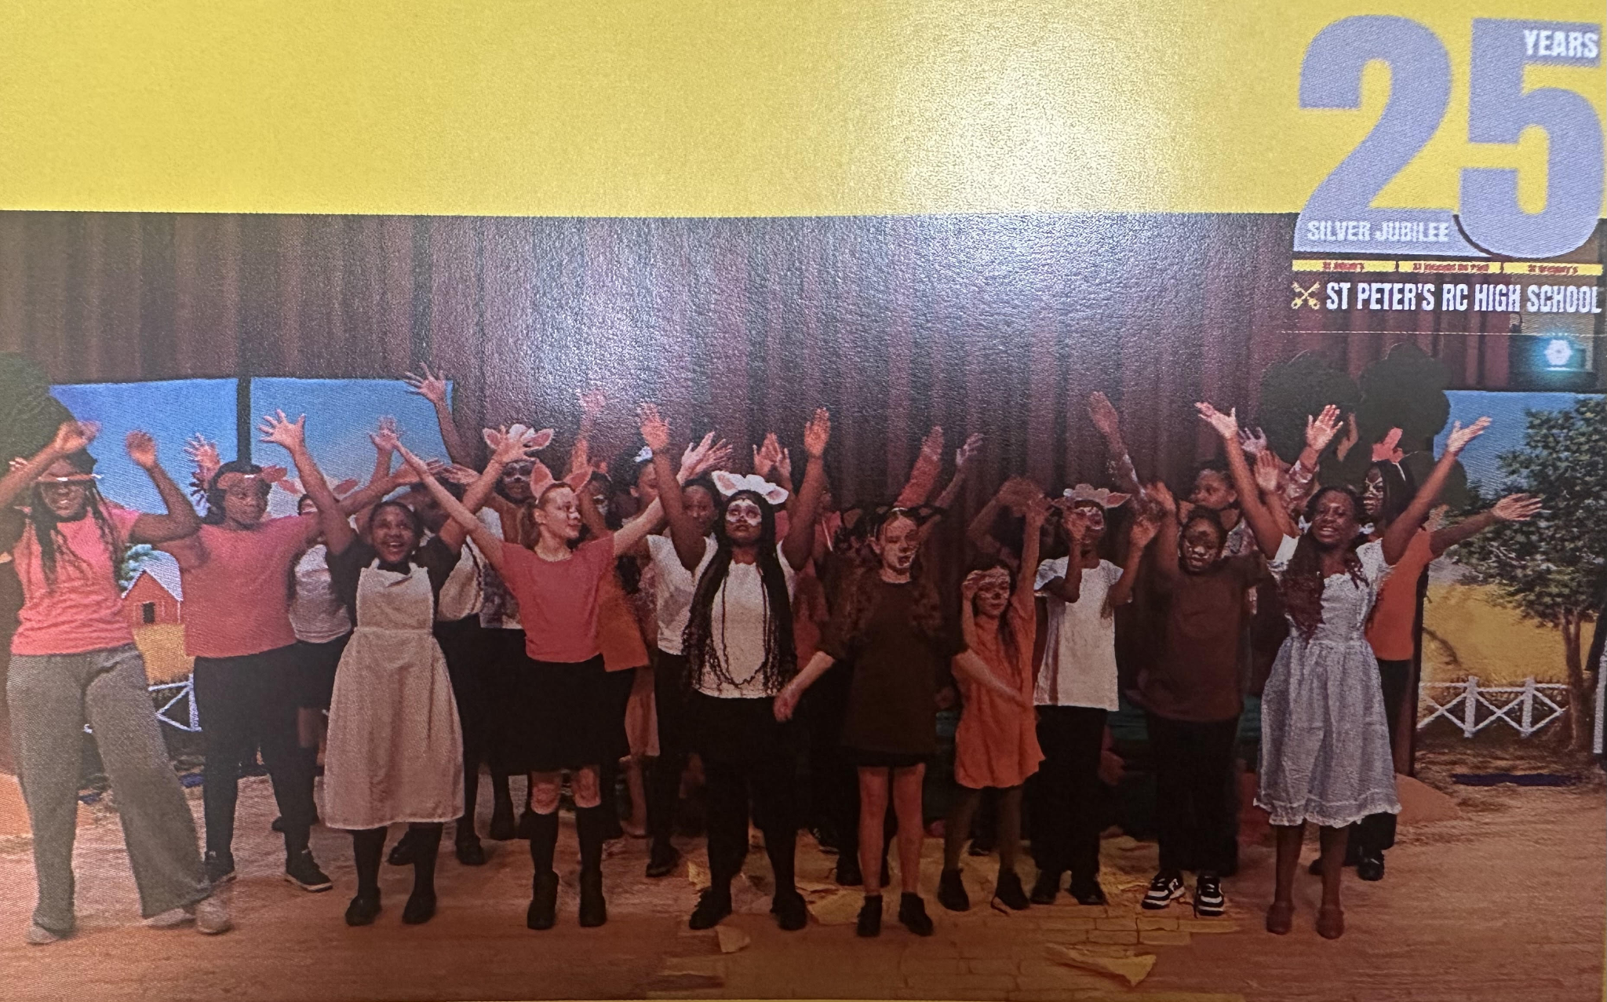

St Peter’s Pantomime!
Congratulations!
Our Year 5 children have been working incredibly hard over the past few weeks to perfect their singing for St. Peter’s Pantomime: The Wizard of Oz. Their performance was outstanding, and they represented Sacred Heart with pride and excellence.
A special congratulations to Isabella and Samuella, who played their parts brilliantly, and to our past pupils Jorgie, Destiny, and Rachel-Megan for their fantastic singing, dancing, and acting. Once Sacred Heart, always Sacred Heart - we’re so proud of you all!
A big thank you to the staff who prepared our children so well and to everyone who came along to support them. I had the pleasure of watching the pantomime on Thursday night, and it was an absolute treat. Well done to everyone involved!

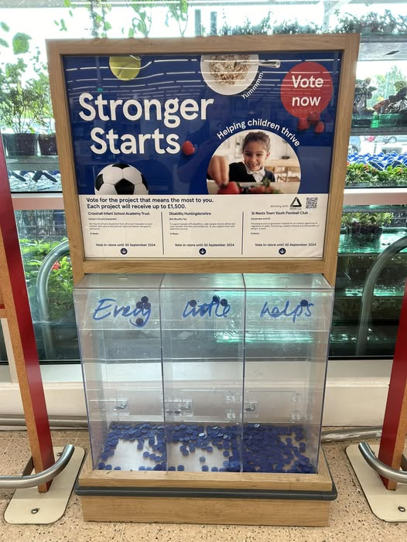
Tesco Stronger Starts
Please vote for us!
If you happen to visit any of the following Tesco stores before the end of March, please vote for our reading project!
Droylsden Large unit M43 6TQ
Beswick Exp Small unit M11 3DS
Failsworth Extra Large unit M35 0EJ
Manchester Gorton Extra Large unit M18 8LD
To vote, you will need to make a purchase of any value. You will receive one token per transaction and it's not necessary to purchase a carrier bag in order to receive a token, which you can then deposit in Sacred Heart’s token box.
The project with the highest number of votes across your region will receive £1,500, the second placed project £1,000, and the third placed project £500. If we are lucky enough to win, the prize money will go towards funding for books in school to better the life chances of our pupils; ensuring all children can read by the time they leave primary school.

📚 SUPERSTAR READERS 📚
LKS2 - Class 4 who read 112,124 words this week! 💫
UKS2 - Class 9 who read 215,171 words this week! 🌟

🎓 TT ROCKSTARS 🎓
Well done to our TT Rockstars winners this week!
LKS2 - Jacob M💫
UKS2 - Jacob T🌟

🏆 ATTENDANCE AWARDS 🏆
Class 9 with 100% attendance!!
Class 2 with 98.6% attendance!
Nursery with 94.6% attendance
🏆Class 9 can come to school wearing their own clothes on Friday 31st January in recognition of their 100% attendance! Well done Class 9!🏆
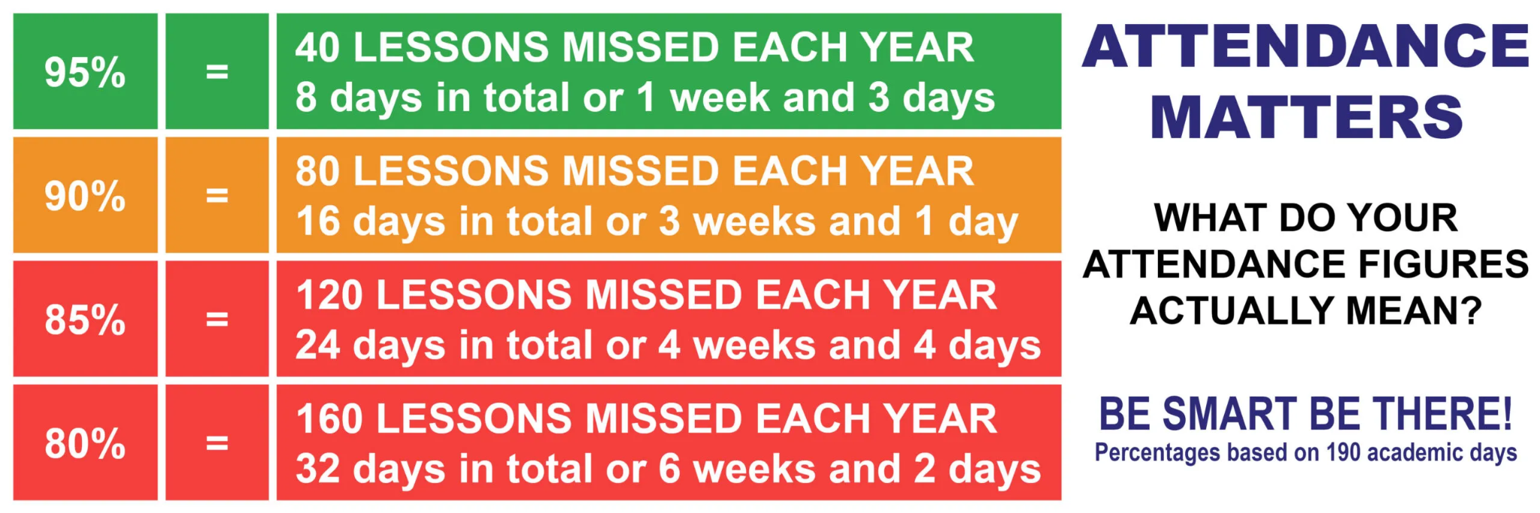


Keep our children safe!
PLEASE NO PARKING OR STOPPING ON KNUTSFORD ROAD!
Unless you have a blue disabled badge, please do not park or even stop on Knutsford Road opposite the school or outside the school between the hours of 8am and 5pm as clearly marked on the yellow signs on both sides of the road.
In accordance with the Highway Code, please do not park within 10 metres of the junctions on Knutsford Road. There was an extremely dangerous situation this week involving two large buses and many cars. I need to be clear that my staff are here to teach and care for your children; they are not traffic wardens or police officers. Please be respectful of other road users in order to reinforce the message we share daily with our children: Every Heart is Sacred.
If you are experiencing difficulties navigating the roads near our school due to dangerous or illegal parking, you can report your concerns here.

Experiencing difficulties?
Parking, litter or fly-tipping issues?
If you are experiencing difficulties navigating the roads near our school due to dangerous or illegal parking, you can report your concerns here.
If you are experiencing issues with litter or fly-tipping, you can report your concerns here.

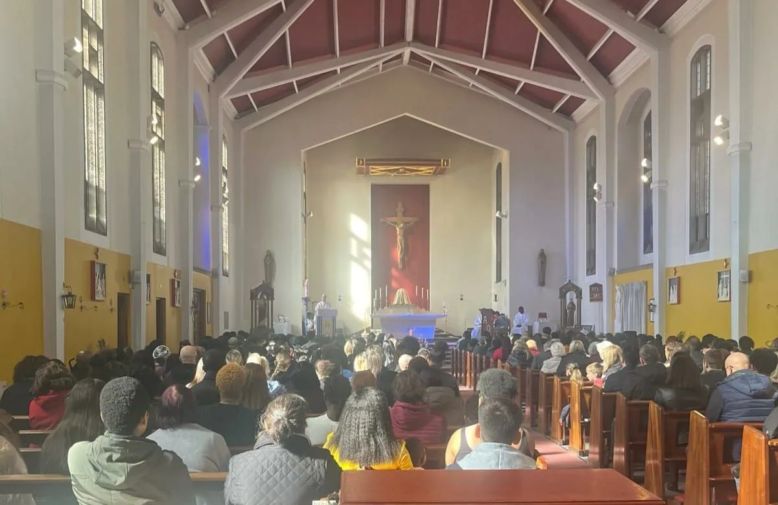
Click here for Mass times and other events in
the Parish of Sacred Heart and St Francis, Gorton

https://www.sacredheartstfrancisgorton.co.uk/mass-schedule

Sacred Heart RC Primary School
'Where Every Heart is Sacred’

