

Sacred Heart RC Primary School
'Where Every Heart is Sacred’
Week Commencing: 27th January 2025

The Presentation of the Lord
February 2nd
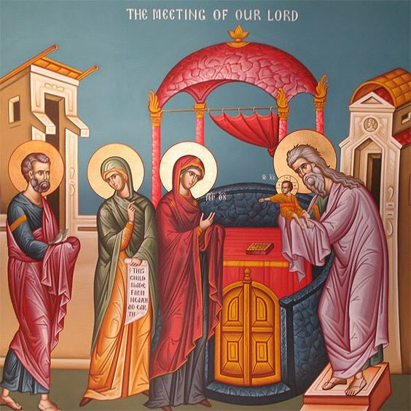
Thank you to Classes 1 and 9 for their beautiful assemblies today and for helping us all to deepen our understanding of this significant event in the life of Jesus. Forty days after Christmas, Mary and Joseph took Jesus to the Temple to be presented. There, the Holy Family met Anna and Simeon who had something wonderful to say about Jesus. Click here to learn more. Class 9 prayed that we might all be blessed with the hope, faith, and patience of Anna and Simeon. I wholeheartedly echo that prayer - imagine the joy and peace that would bring to our lives.

Next year:
L Today we celebrate the Presentation of the Lord, also known as
Candlemas Day, when Jesus was presented in the Temple in Jerusalem by his parents. Because the feast
falls on a Sunday this year, it replaces the normal Sunday Mass. The feast reminds us that Jesus was
welcomed as the light and salvation of all peoples by Simeon and Anna. Candles are blessed on this feast
day for this reason. Like Simeon and Anna, may we also welcome Jesus as the light of our lives and seek to
follow him more wholeheartedly.
(Father Michael)

THIS WEEK’S TOP STORIES
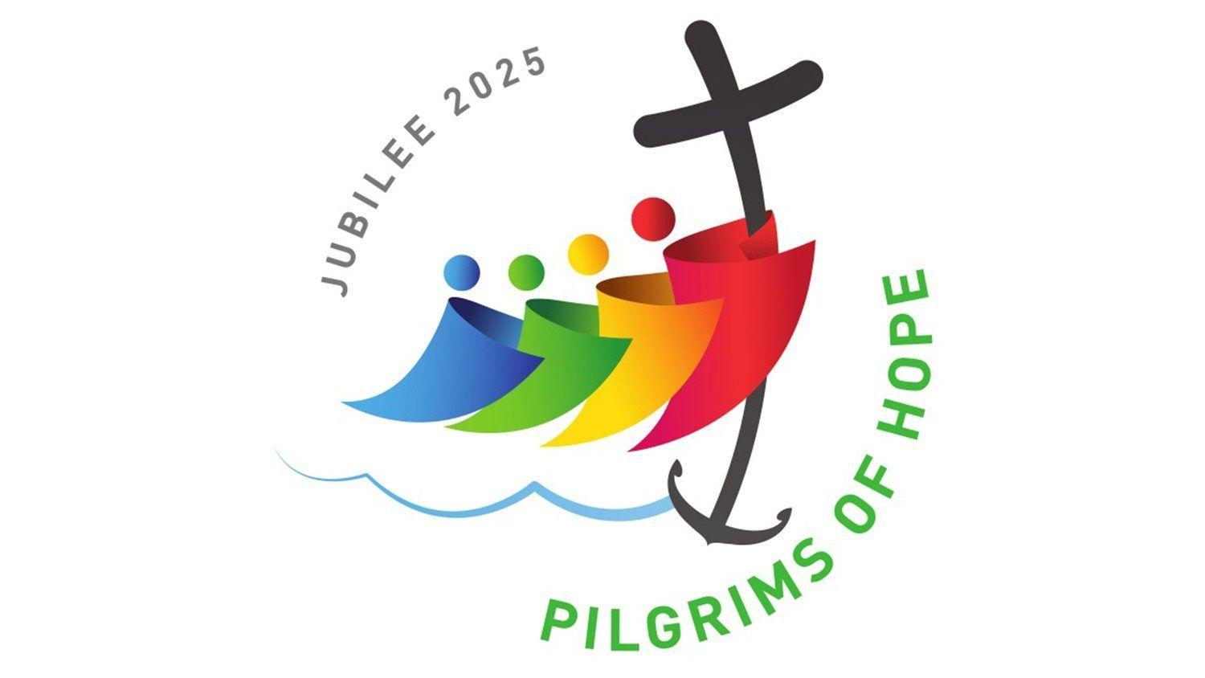
Introducing the Pilgrims of Hope Jubilee!
Pope Francis has declared that the year 2025 will be a Holy Year of Jubilee for the Catholic Church - an event that takes place once every 25 years.
The theme for the 2025 Jubilee is ‘Pilgrims of Hope’: an invitation to showcase the hope of our Christian faith to people right across the world at a time when there is so much suffering from the impact of war, poverty, climate change, and the lasting effects of the COVID pandemic.
The Pilgrims of Hope Jubilee presents each one of us with an opportunity to reignite the flame of our faith in our own hearts and to share the light of that faith with those in darkness. EYFS and KS1, click here to find out more; KS2, click here to find out more. A comprehensive booklet for adults is available to download here.
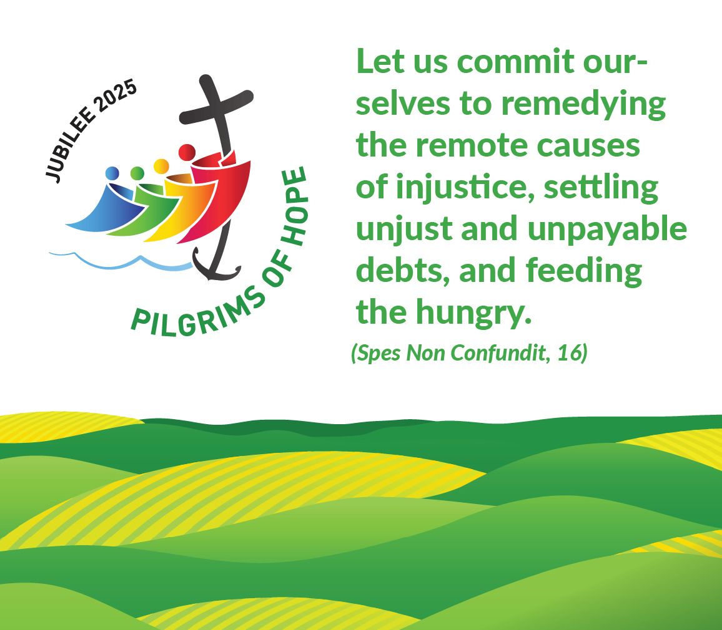

Forces in LKS2
Children in Class 6 had a busy afternoon investigating which magnet is the strongest. The class concluded that the horseshoe magnet was the strongest which we could tell by looking at our bar graphs  
Ask Class 6: Why was the horseshoe magnet the strongest?

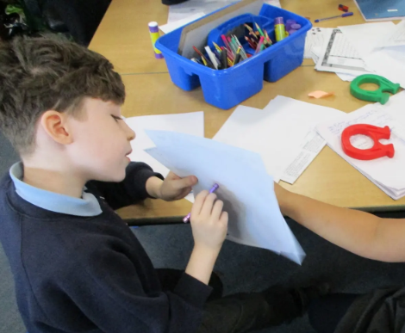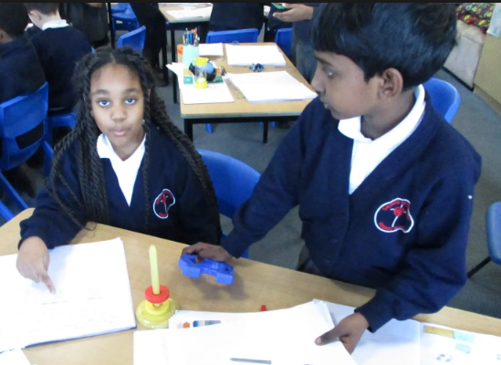

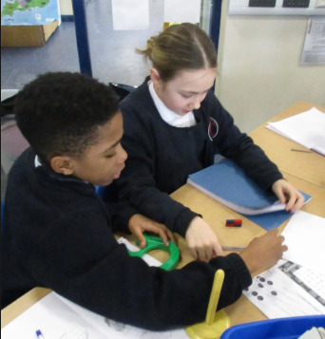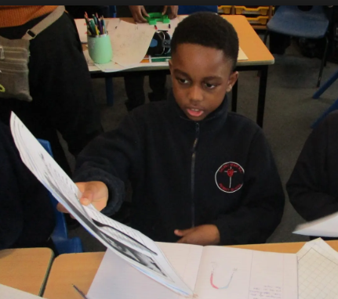

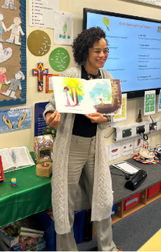
More author visits for LKS2!
Thank you, Keziah!
We were delighted to welcome Keziah Brooks back to school this week! Keziah worked with Classes 4 and 6, sharing her beautiful book and even officially opening Class 6’s new reading corner! Copies of Bella and the Sword of the Spirit are available to purchase for £7. Please let the office know if you would like to order a book. Thank you.
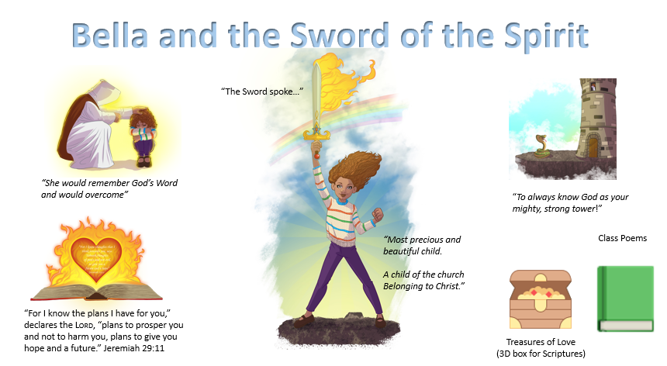
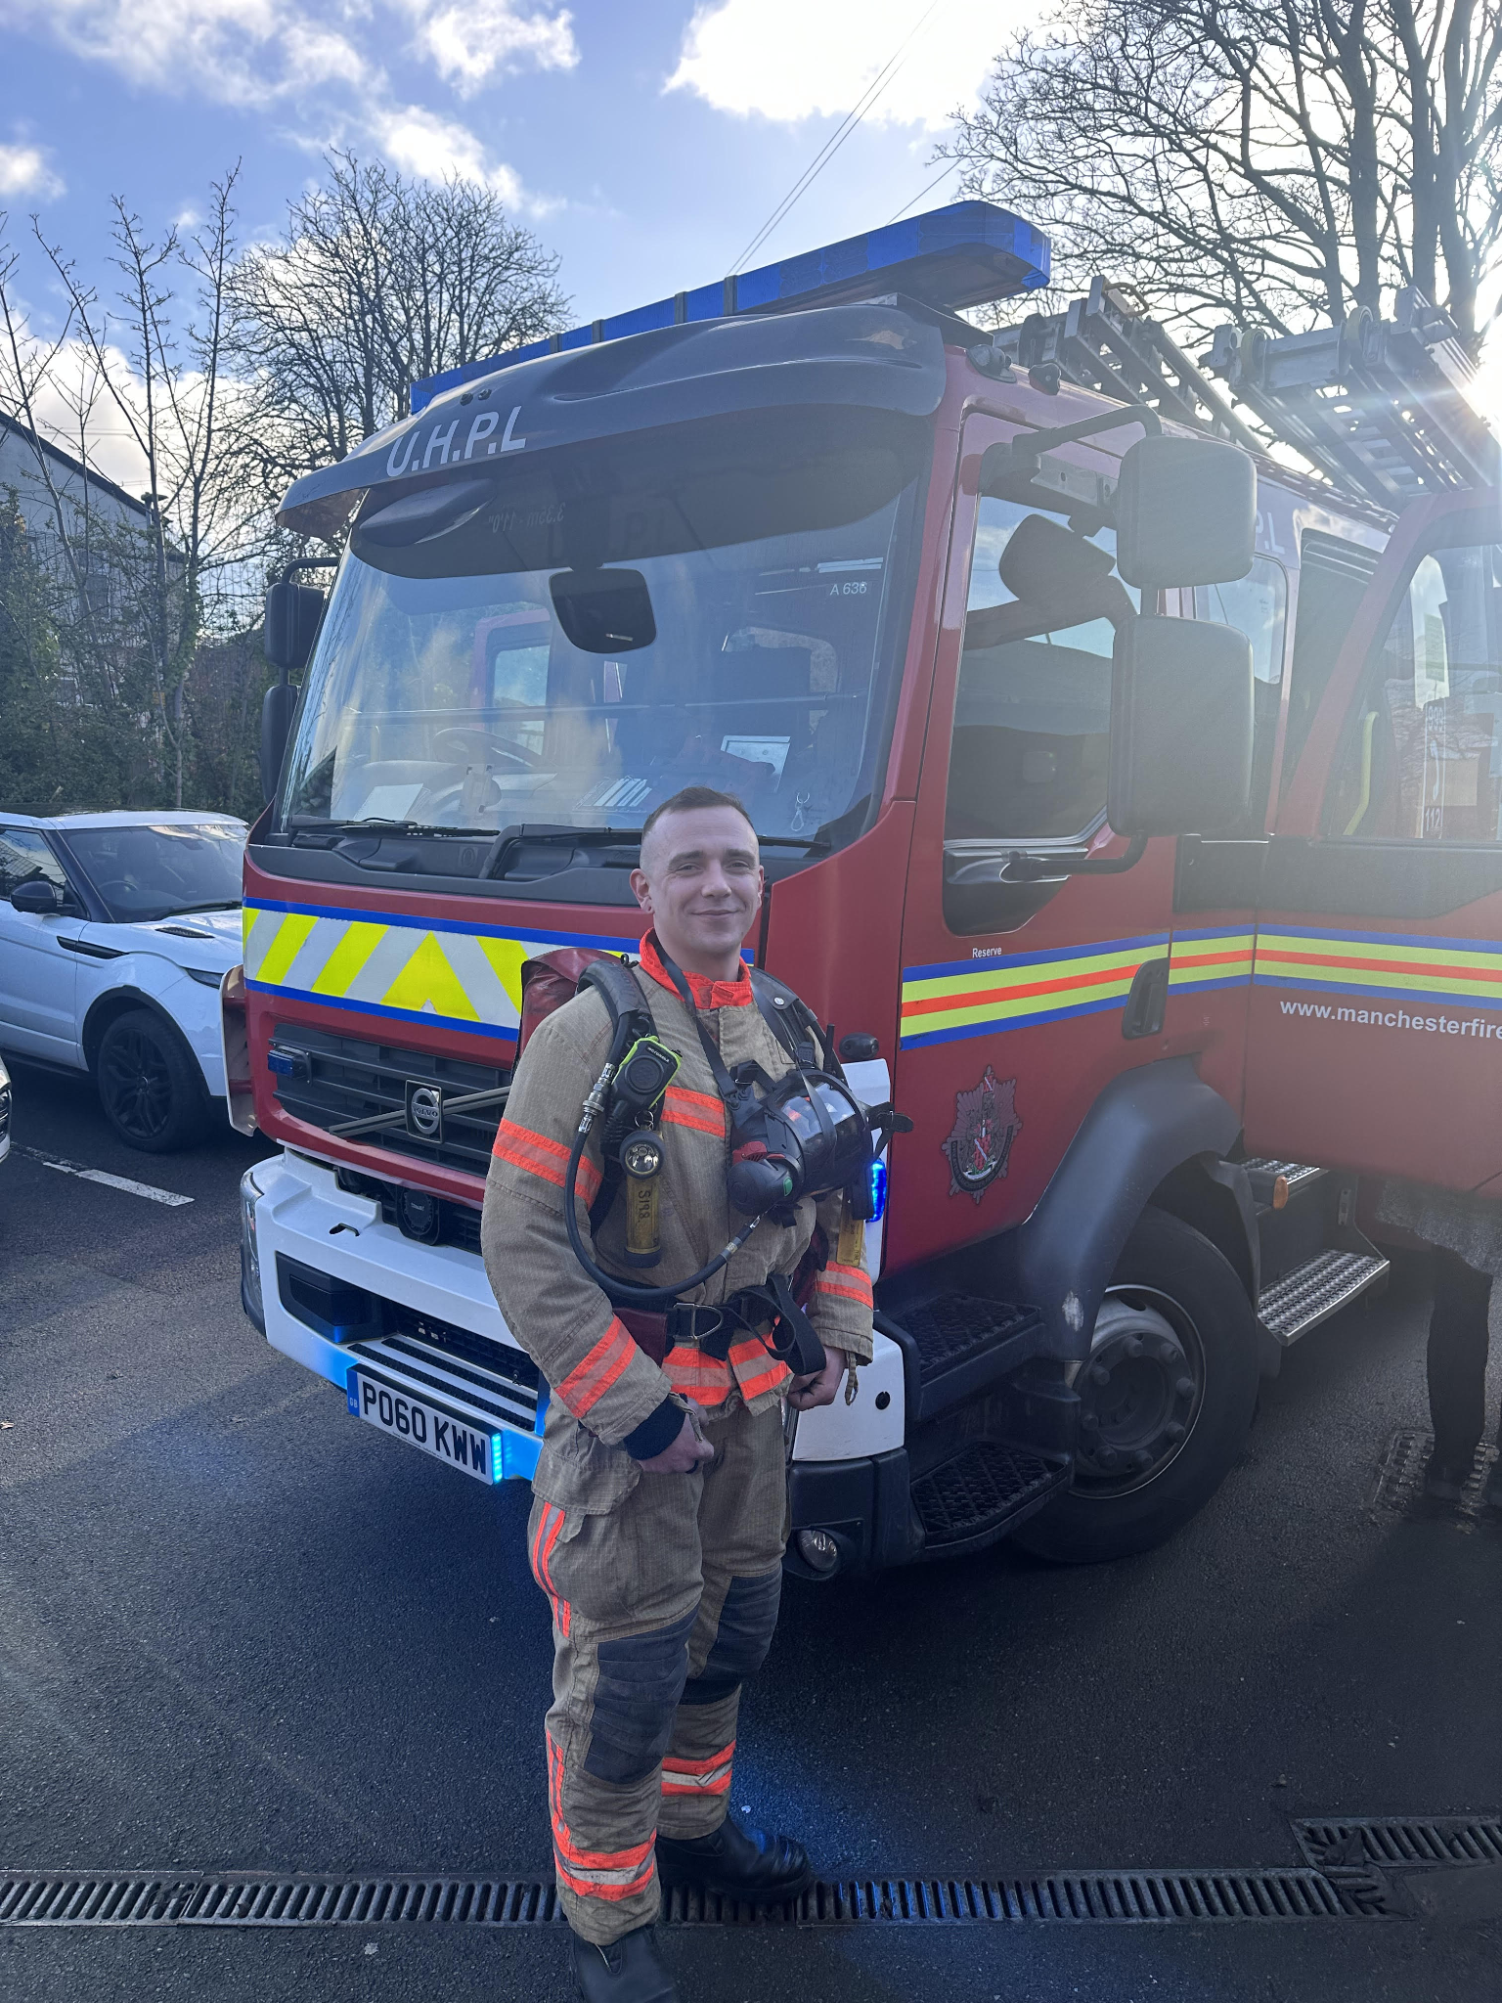
Fire Brigade in EYFS!
Thank you so much to Firefighter Liam and his watch, who generously brought their fire engine to visit our youngest children this week. Nursery and Reception had a fantastic time exploring the fire engine, chatting with the firefighters, and learning about their important work. Their faces lit up with excitement as they arrived to find our little staff car park packed out with a fire engine and its entire crew!
Ask Nursery and Reception: What was your favourite part of the fire engine visit? 🚒🔥

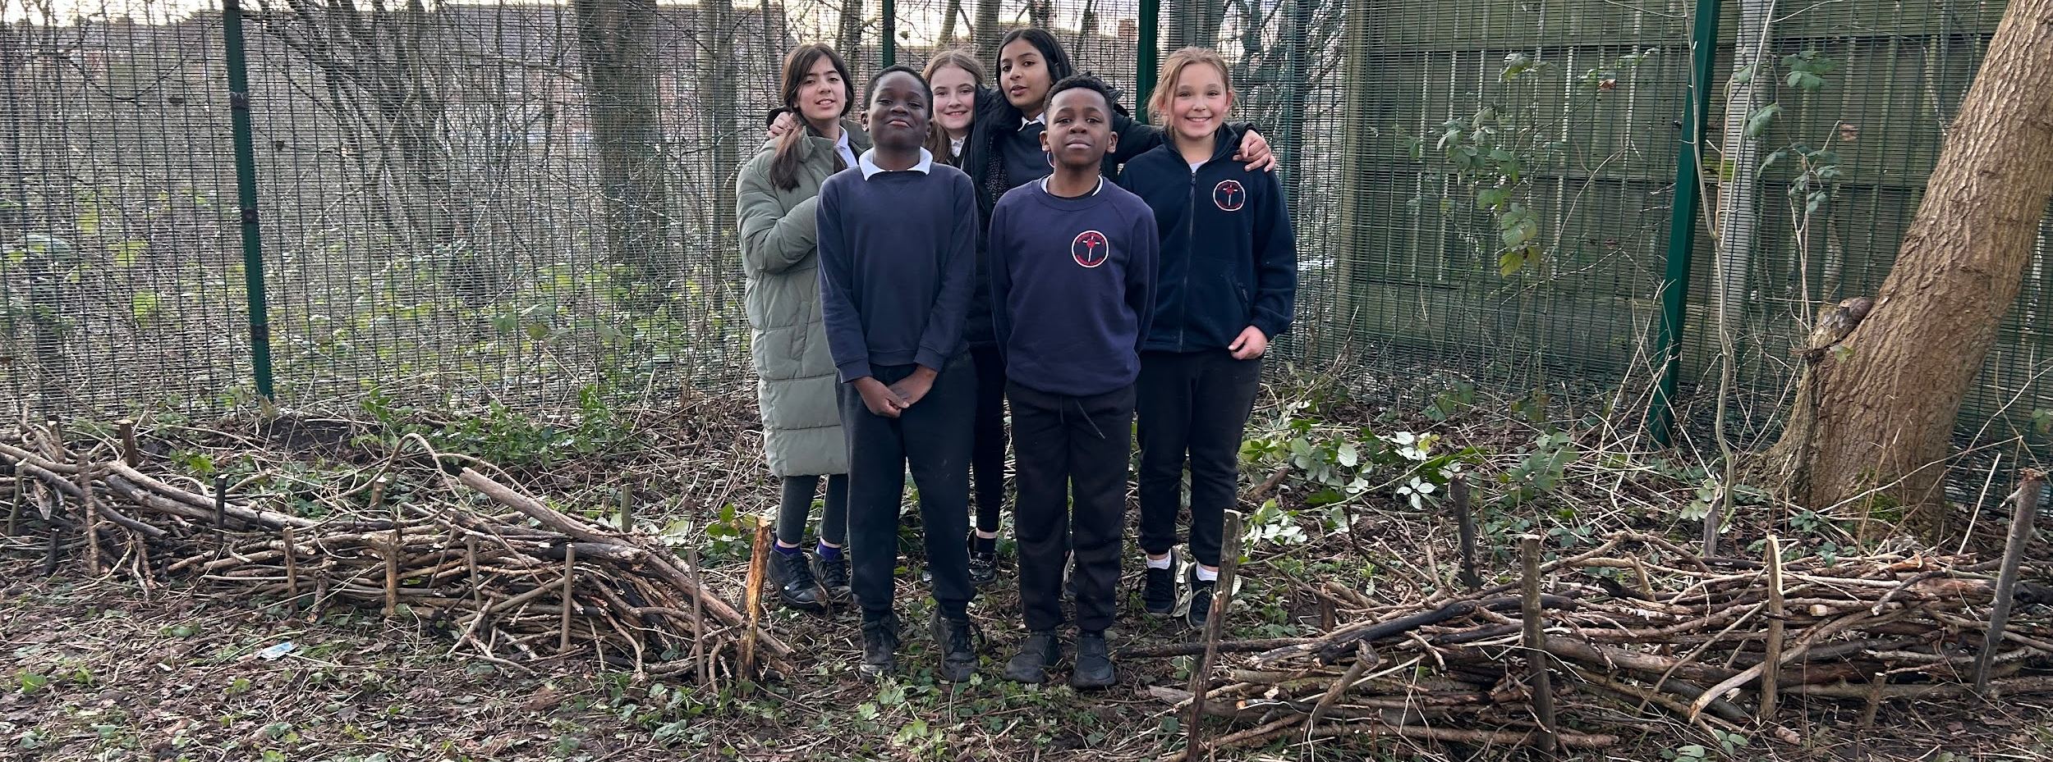

Forest School is Coming!
Thank you, Class 8, for all your hard work!
Yesterday, Class 8 worked really hard to help Martha, our Forest School teacher, to prepare our Forest School space at the far corner of our shared field. There is still lots of preparation to do before our sessions begin but we are very grateful to Class 8 for giving so generously of their time. Watch this space for more Forest School news!
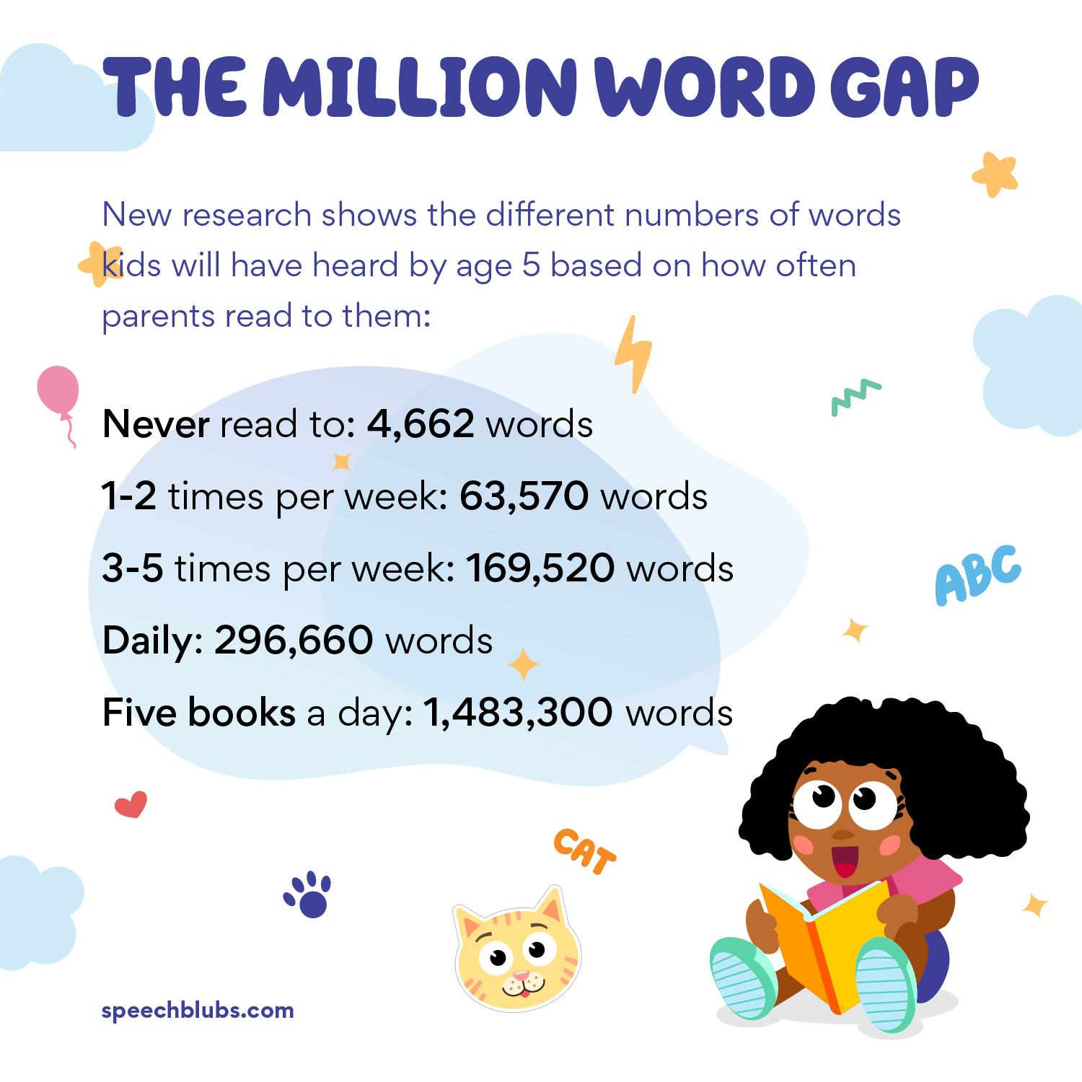

📚 SUPERSTAR READERS 📚
LKS2 - Class 5 who read 178,996 words this week! 💫
UKS2 - Class 8 who read 169,571 words this week! 🌟

🎓 TT ROCKSTARS 🎓
Well done to our TT Rockstars winners this week!
LKS2 - Jacob and Class 4! 💫
UKS2 - Prayjen and Class 7! 🌟

🏆 ATTENDANCE AWARDS 🏆
Class 6 with 99.3% attendance!
Classes 2 & 3 with 95% attendance
Nursery with 97% attendance!

Because Class 9 achieved 100% attendance last week, they were allowed to come to school in their own clothes today! It was a wonderful way to celebrate this fantastic achievement; excellent role modelling Class 9! Well done!

Experiencing difficulties?
Parking, litter or fly-tipping issues?
If you are experiencing difficulties navigating the roads near our school due to dangerous or illegal parking, you can report your concerns here.
If you are experiencing issues with litter or fly-tipping, you can report your concerns here.

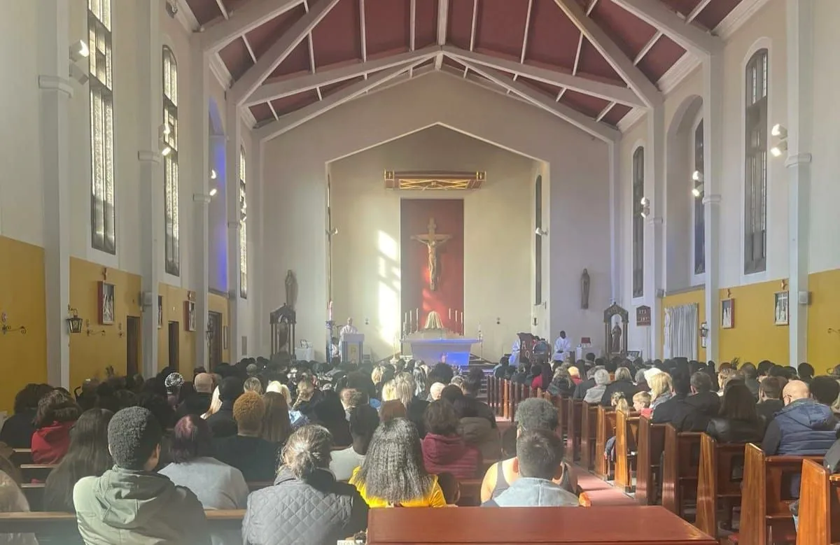
Click here for Mass times and other events in
the Parish of Sacred Heart and St Francis, Gorton

https://www.sacredheartstfrancisgorton.co.uk/mass-schedule

Sacred Heart RC Primary School
'Where Every Heart is Sacred’

