

Sacred Heart RC Primary School

**'Where Every Heart is Sacred’**

Week Commencing: 6th January 2025

horizontal line



I am delighted to report that the first week of term has been as happy and successful as ever, despite the Arctic frost! Thank you to everyone who helped keep the school day running smoothly in subzero temperatures and to our parents and carers for ensuring children were well-equipped with warm coats, hats, and gloves. Thanks to this teamwork, children enjoyed healthy playtimes every day. We’ve shown great resilience in the face of adversity, but we’re all looking forward to warmer weather next week!

We are delighted to welcome the new members of our staff team, who have already made a wonderful start to their journey with us. Mrs. McCarthy has stepped into the role of Acting Deputy Head with great enthusiasm and dedication. Mrs. Morrison, as Class 8 Teacher and Wider Curriculum Lead, is bringing fresh ideas and expertise to enrich our curriculum. Mrs. Scapaticci, who joins us as Class 5 Teacher, EVC, and Handwriting Lead, is already making a positive impact in her various roles. In our Early Years team, we are pleased to have Miss Ghafoor as Reception 2 Class Teacher and Miss Speed as EYFS Teaching Assistant, both of whom have embraced their roles with energy and warmth.

We are thrilled to have such talented and committed individuals join the Sacred Heart family, and we look forward to the positive contributions they will make in the months ahead. Mrs. Garrett has also taken over as Early Years Lead, providing excellent guidance and support to the team to ensure the best possible start for our youngest learners. Additionally, you will see Miss Tennant back in the office a few times this half term as she prepares for her full return to work after the February half term.

horizontal line

**THIS WEEK’S TOP STORIES**



**Caritas: The Dignity of Work**

This half term, our Caritas lessons focus on another important theme of Catholic Social Teaching: The Dignity of Work. We are delighted that two special visitors are coming into school to talk to our children about the work that they do (one author and one charity worker). We would be equally delighted if any more of our parents were able to come into school to talk to our children about their work and, in particular, the good that their work does for other people. If you would like to come in and talk to the children, please let the class teacher know or get in touch with me via our [admin email address](mailto:admin@sacredheart-jun.manchester.sch.uk). Thank you!





## Swimming

January to Easter

Class 5 (Miss Scappaticci’s class) will be going swimming every Tuesday from January 14th until the Easter holidays in April.

Class 5 children will need:

* Girls: A swimming costume (not a bikini)
* Boys: Swimming shorts (not ‘bermuda’ shorts)
* All: A towel
* For those whose hair is longer than their eyebrows: a swimming cap





## Class Assemblies

Due to fire regulations, two family members are welcome to attend class assemblies which are held in our school hall.

Friday 17th January (9:05am) - Class 4 (Miss Leadbetter)

Friday 31st January (9:05am) - Class 9 (Miss Wynne)

Friday 31st January (2:50pm) - Class 1 (Miss Tabib)

Friday 14th February (9:05am) - Class 5 (Miss Scappaticci)

## Age Phase Masses - Tuesdays at 9:15am

Friends and family are all welcome to attend school Masses in Sacred Heart church.

Tuesday 14th January - Classes 7, 8 and 9

Tuesday 28th January - Classes 4, 5 and 6

Tuesday 11th February - Classes 1, 2 and 3



## The End of the School Day

We kindly ask that children do not use school equipment, including the woodland area, at the end of the school day. Our staff work incredibly hard and have important meetings, preparation, and assessments to complete immediately after dismissing their classes. Any delays in completing their work may impact their personal time with their families. Additionally, after-school clubs often need access to the playground and are hindered when children remain on site after being collected. In particular, KS2 children should leave the yard promptly after dismissal, as they have no reason to remain on school grounds. We greatly appreciate your support in respecting the work-life balance of our staff by leaving the school premises as soon as you collect your eldest child. Thank you for your understanding and cooperation.

**📚 SUPERSTAR READERS 📚**

LKS2 - Class 4 who read 23,837 this week! *💫*

UKS2 - Class 9 who read 233,492 words this week! *🌟*

**🏆 ATTENDANCE AWARDS 🏆**

**Class 8 with 99% attendance!**

**Class 3 with 96% attendance**

**Nursery with 95% attendance**

**Well done to everyone who came to school on time every day this week despite the very cold weather!**

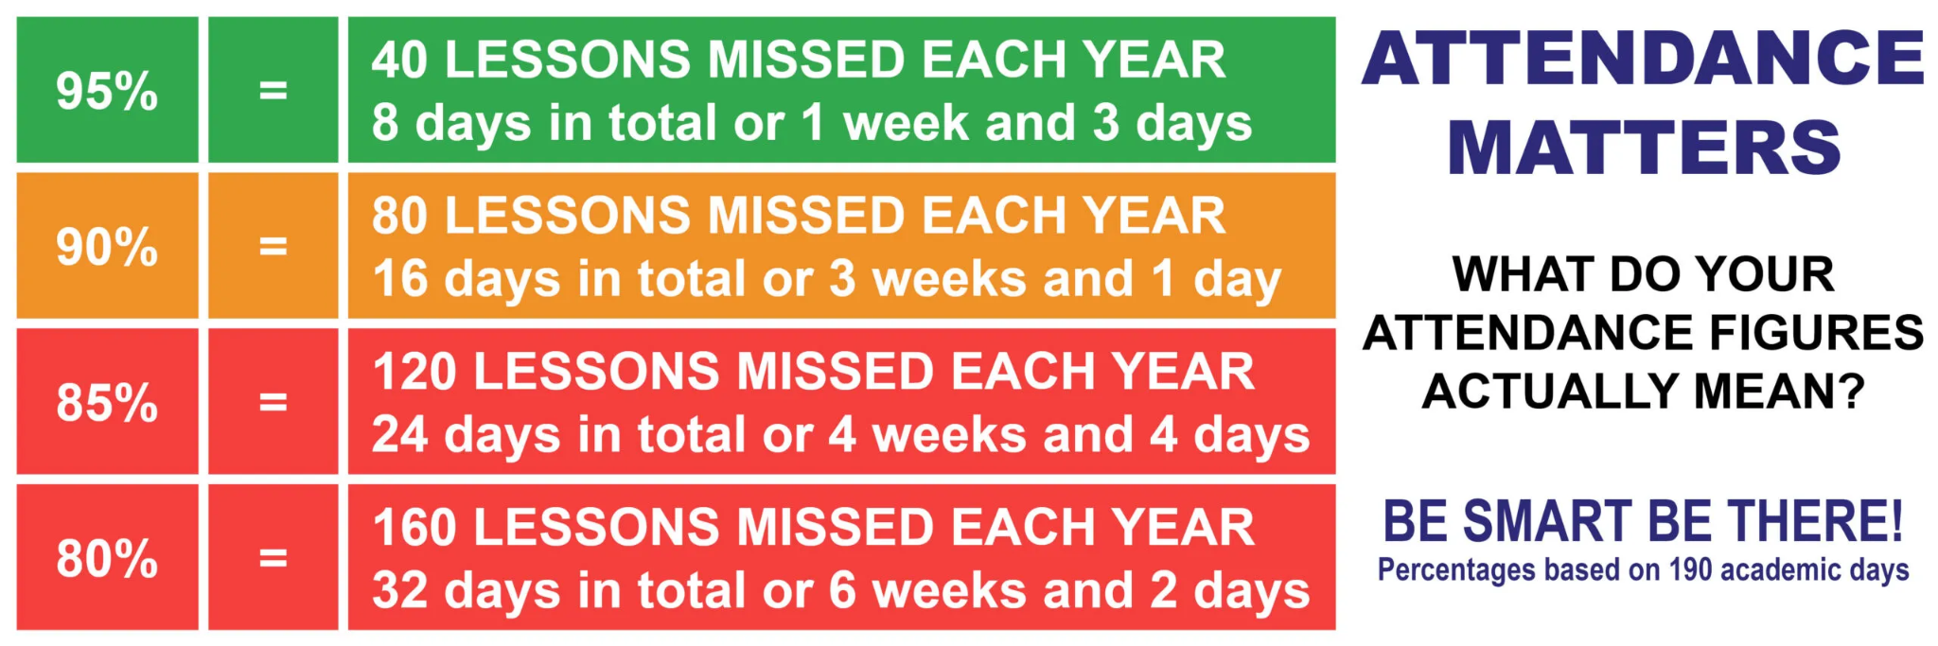

Experiencing difficulties?

Parking, litter or fly-tipping issues?

If you are experiencing difficulties navigating the roads near our school due to dangerous or illegal parking, you can report your concerns [here](https://www.gmp.police.uk/contact/af/contact-us-beta/contact-us/driving-vehicles-traffic/report-illegal-parking/).

If you are experiencing issues with litter or fly-tipping, you can report your concerns [here](https://www.manchester.gov.uk/environment).

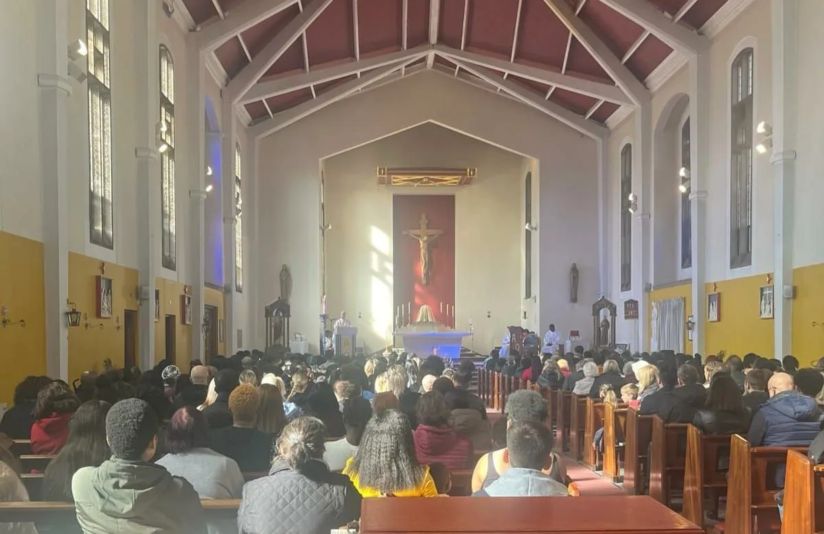

Click here for Mass times and other events in

the Parish of Sacred Heart and St Francis, Gorton

<https://www.sacredheartstfrancisgorton.co.uk/mass-schedule>

horizontal line

Sacred Heart RC Primary School

**'Where Every Heart is Sacred’**

