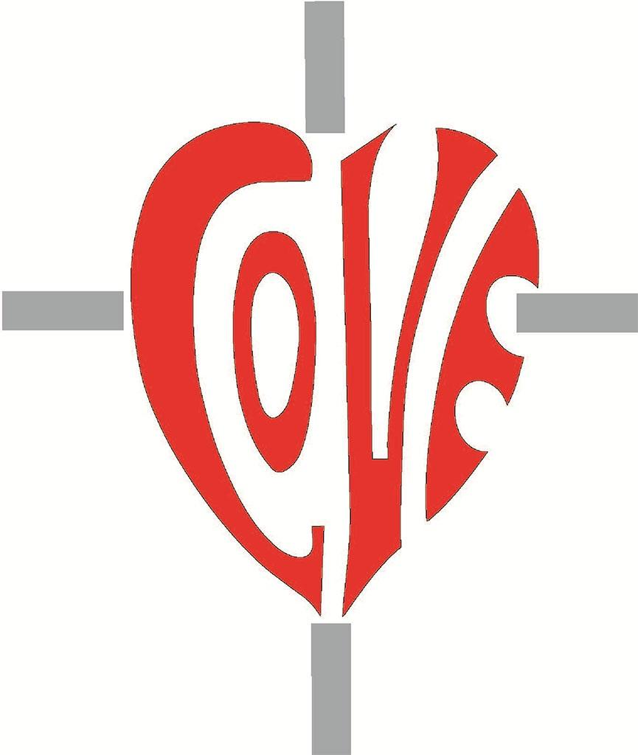

Sacred Heart RC Primary School

**'Where Every Heart is Sacred’**

Week Commencing: 28th October 2024

horizontal line

# All Saints and All Souls

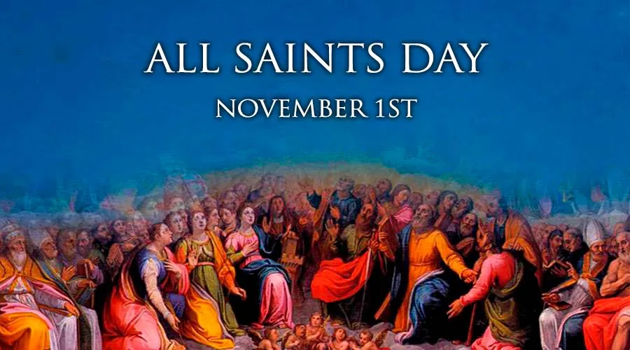

# It was wonderful to begin this very special half term with a large school Mass, celebrating all of the saints who inspire us every day. Thank you to Class 8 for their wonderful readings and thank you to Miss Wynne for preparing the music. Singing is a particular talent in our school and we were so pleased that parents, carers and friends were able to join us in church this week.

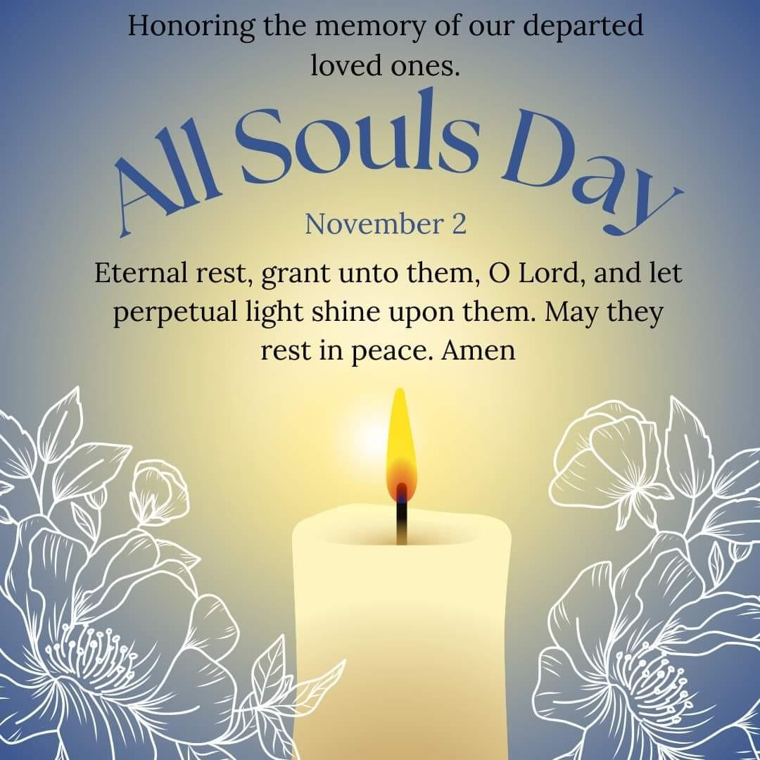

## 

## Autumn Parents’ Evenings

November 5th, 6th & 7th - 3:30-5:30pm

You should now have received a ParentMail regarding our first Parents’ Evenings of the new academic year for all classes. Class 6 will have their parents’ meetings at a slightly later date; we apologise for any inconvenience this may cause.

When you arrive for your parents’ evening appointment, please use the pedestrian gate to access the school building and please allow additional time so that you can look at your children’s books before, or after, you meet with the teacher. Staff will direct you to the correct classroom or meeting room on arrival.

## 

## Taekwondo

Ask us which moves we learnt!

Thank you so much to Miss Andrew for organising Taekwondo workshops for our children on Wednesday this week. We all thoroughly enjoyed them and loved learning about a brand new sport!

**THIS WEEK’S TOP STORIES**

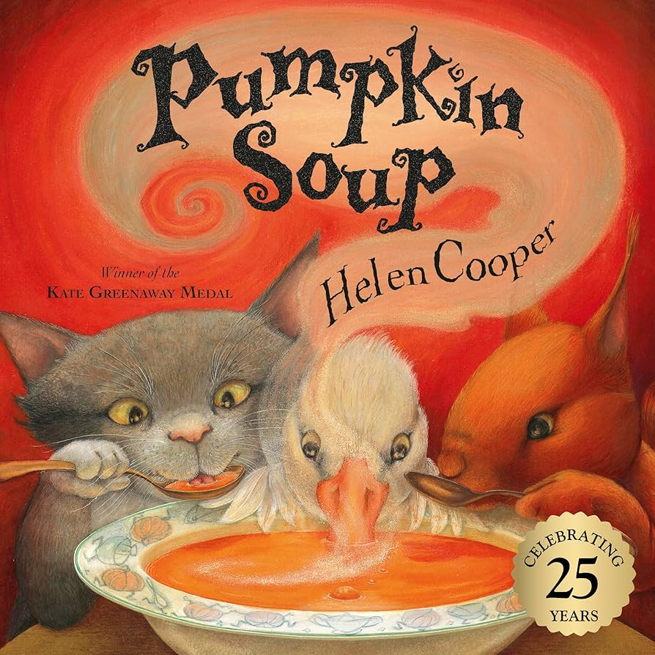

## Pumpkin Soup!

By Helen Cooper and Sacred Heart EYFS!

The children in Reception made their own pumpkin soup after reading the story Pumpkin Soup by Helen Cooper. They wrote their own shopping lists, sequenced the recipe and then followed the instructions to make it. The children then took it home to taste with their families. Yummy!

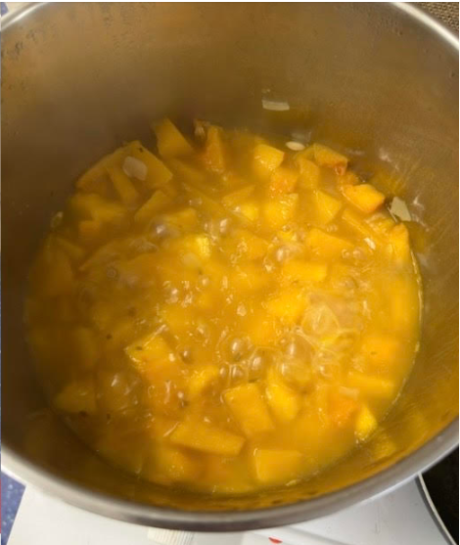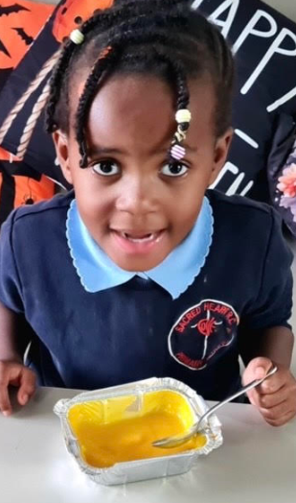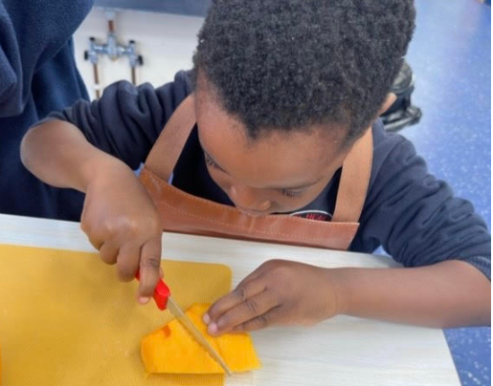

You can listen to the story [here](https://www.youtube.com/watch?v=MIAnCcyYUVU).

## 

## Thank you from Father Kevin!

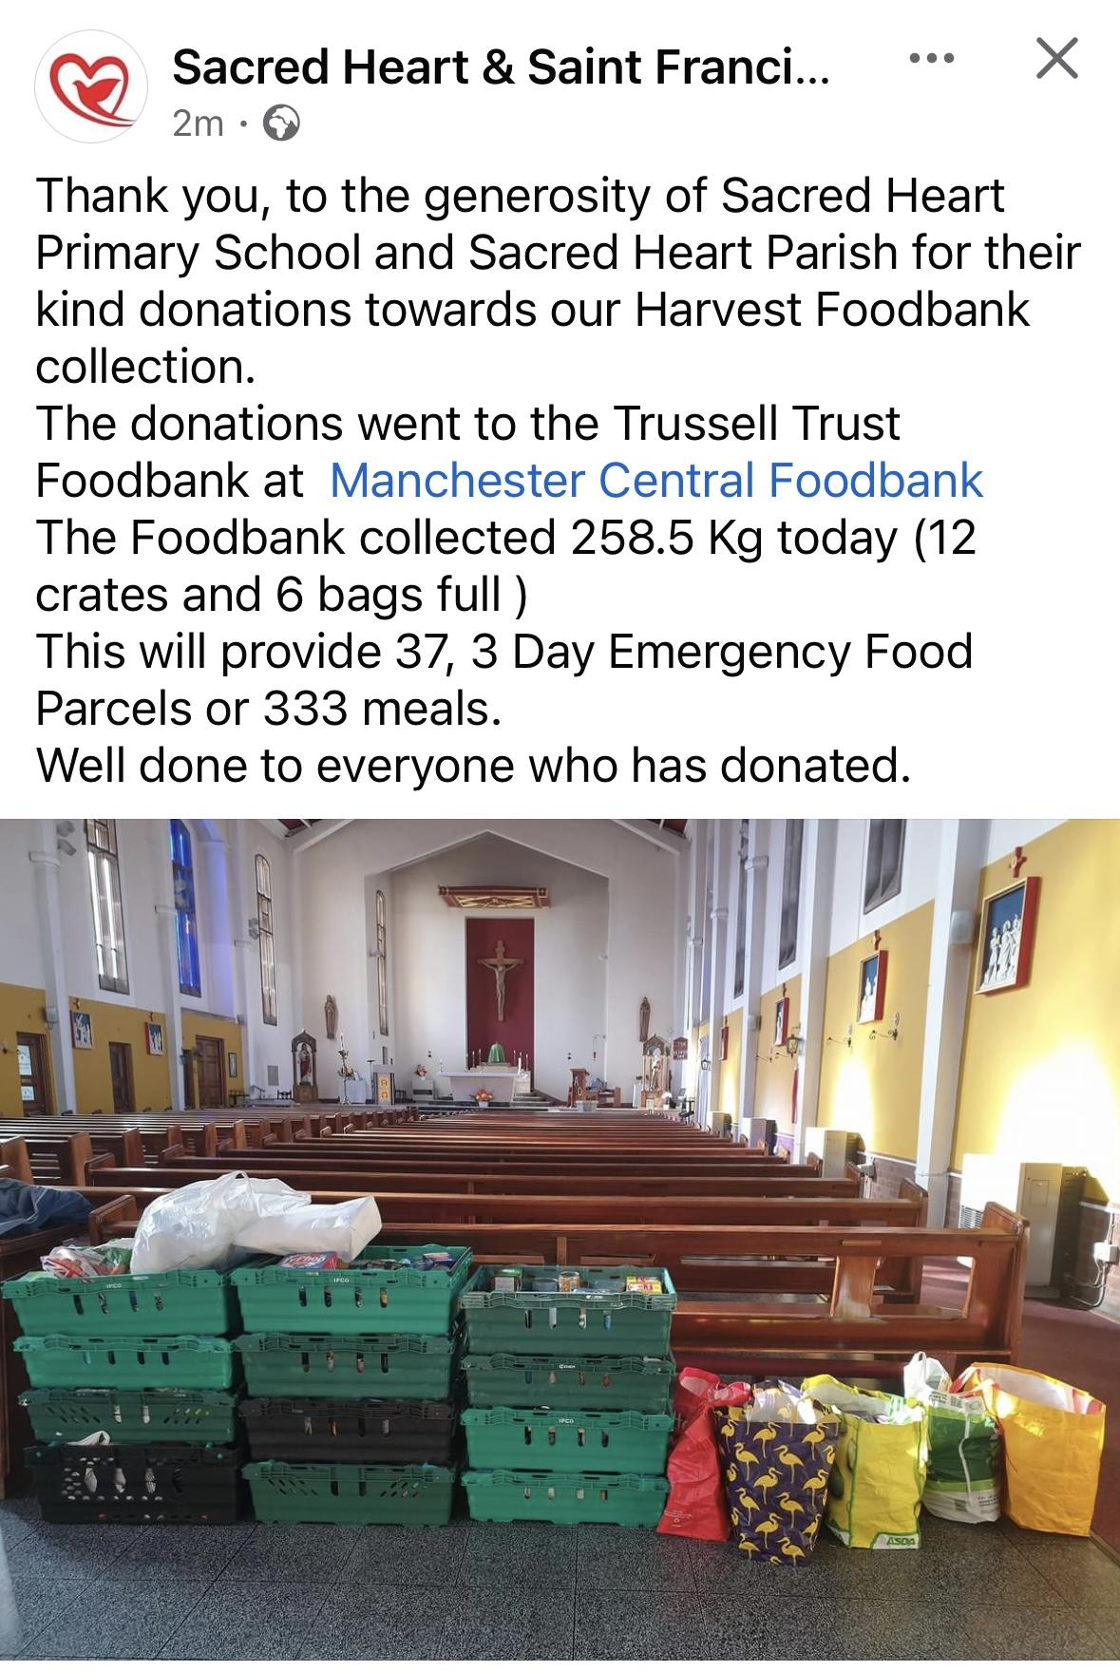

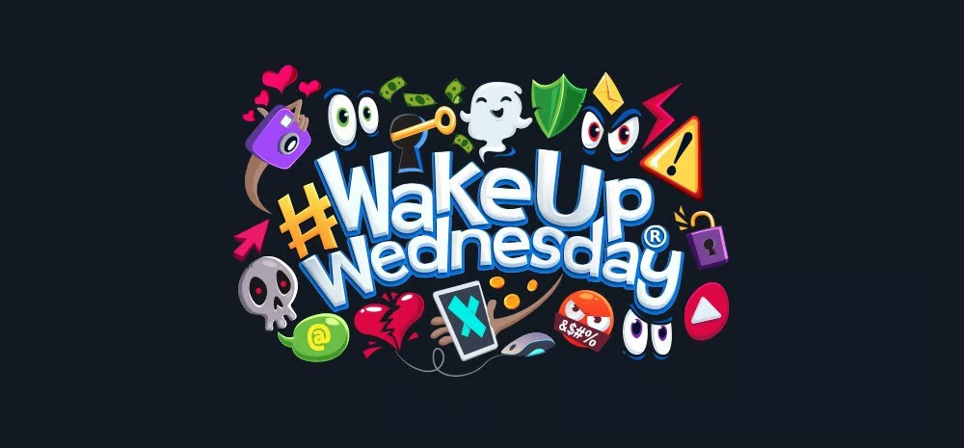

Staying Safe Online

Wake Up,Wednesdays

Now that ParentMail is behaving properly again, we have recommenced our Wake Up Wednesday online safety messaging. You will receive a poster attachment each Wednesday covering topics such as screen addiction, new app information including warnings and much more.

Thank you again to our very patient new families who were so understanding while the tech companies argued with, and about, our new server.



## U.K. Covid-19 Inquiry

Every Story Matters

The pandemic has touched every person in the UK, and for many, its effects are still being felt. Each of us has had a unique experience, and this is your chance to share with the Inquiry how it has affected you, your life, and those around you.

For those of us working in schools, the pandemic's impact remains evident daily. Reduced access to essential services, such as breastfeeding support, early parenting, and toddler groups, along with limited face-to-face contact with health visitors and other crucial professionals for children aged birth to five, has made it harder for children to learn and socialize compared to their pre-2020 peers.

You can share as much or as little information as you feel able. We understand that reliving some of your experiences may be difficult. You can start it now, and come back to finish it when you feel ready. Emotional [support](https://covid19.public-inquiry.uk/support-whilst-engaging-with-the-inquiry/) is available if you feel this would be helpful.

More information is available [here](https://covid19.public-inquiry.uk/every-story-matters/).

You can share your story [here](https://www.everystorymatters.co.uk/share?locale=en-gb).

**📚 SUPERSTAR READERS 📚**

LKS2 - Class 6 (for reading 106,000 words over half term!) 💫

UKS2 - Class 9 (for reading 370,000 words over half term!)🌟

**🎓 TT ROCKSTARS 🎓**

LKS2 - Class 6💫

UKS2 - Class 7!🌟

**🏆 ATTENDANCE AWARDS 🏆**

**Reception 2 with 97.4% attendance**

**Class 1 with 96.3% attendance!**

**Classes 5 & 6 with 98.9% attendance!**

**Well done to everyone who came to school on time every day this week!**

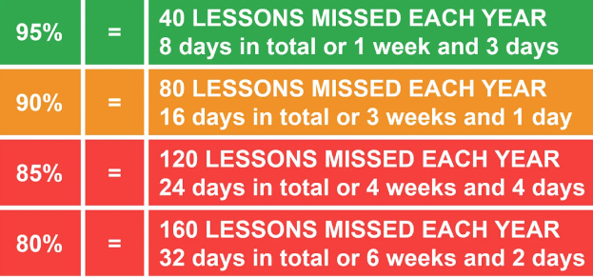

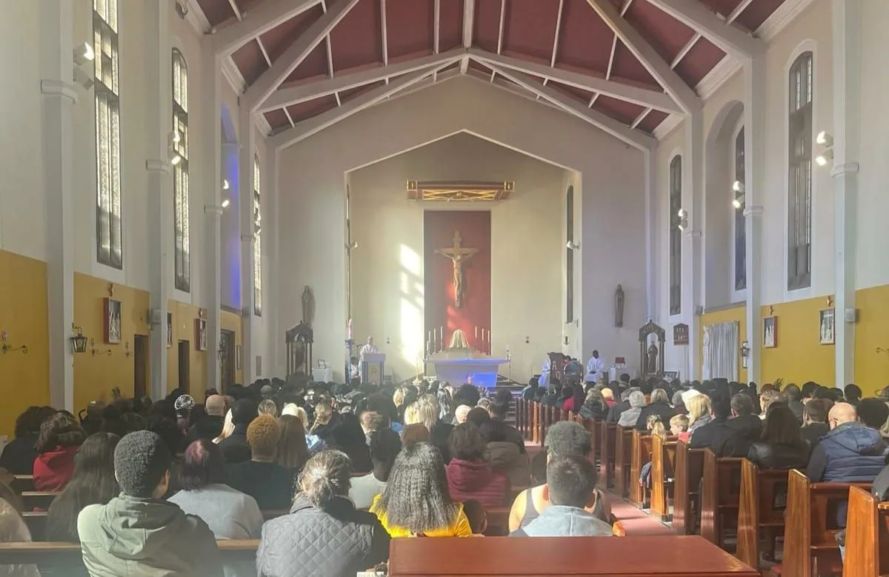

**Please note: Friday November 1st is a Holy Day of Obligation. All Saints Mass will be celebrated at 7pm at Sacred Heart church on Friday November 1st.**

Click here for Mass times and other events in

the Parish of Sacred Heart and St Francis, Gorton

<https://www.sacredheartstfrancisgorton.co.uk/mass-schedule>

| **Don’t forget to check our X feed!****@SHGorton** |
| --- |

horizontal line

Sacred Heart RC Primary School

**'Where Every Heart is Sacred’**

