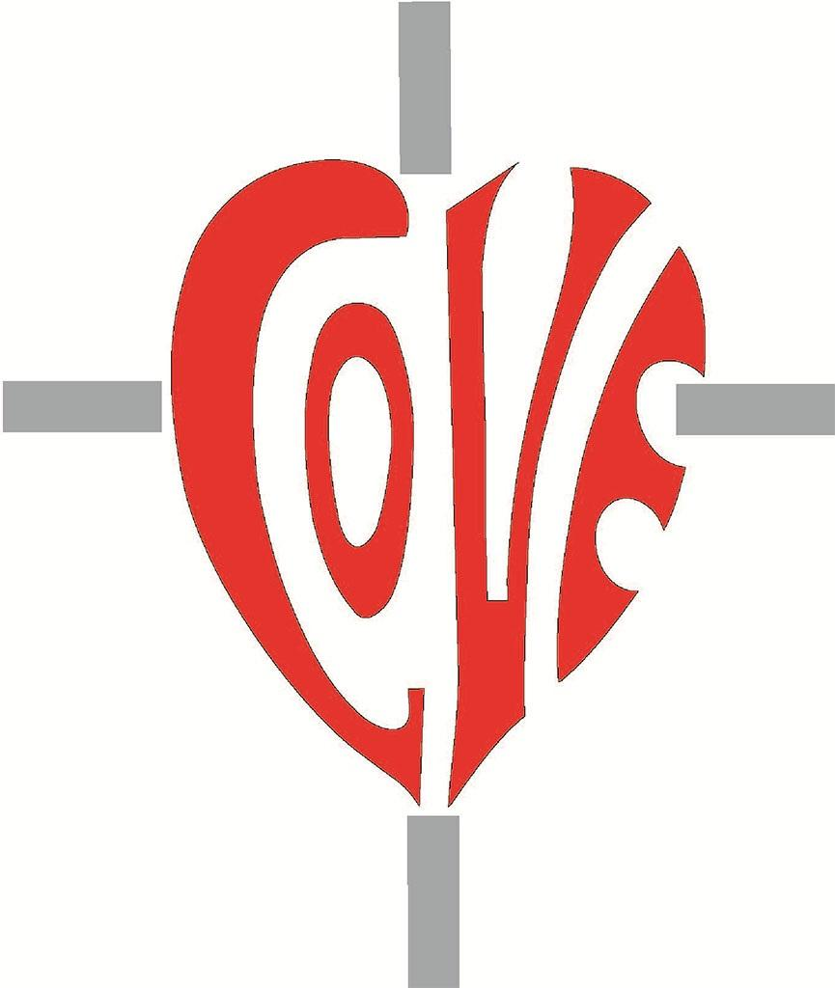

Sacred Heart RC Primary School

**'Where Every Heart is Sacred’**

Week Commencing: 18th November 2024

horizontal line

# Solemnity of Christ the King

Sunday November 24th 2024

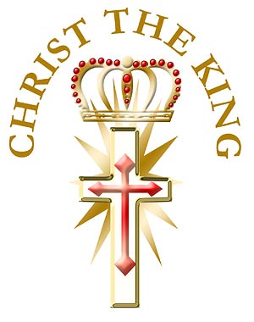

Thank you to Classes 2 and 5 who prepared KS1 and KS2 beautifully for the [Solemnity of Christ the King](https://mycatholickids.com/the-solemnity-of-christ-the-king-of-the-universe/) this Sunday. The children read and sang beautifully, showing great confidence. Thank you to all of the family members who were able to join us; it was wonderful to see you all.

*“When once men recognize, both in private and in public life, that Christ is King, society will at last receive the great blessings of real liberty, well-ordered discipline, peace, and harmony.”*

*Pope Pius XI*

horizontal line

**THIS WEEK’S TOP STORIES**

## Attendance Policy

Please [click here](https://sacredheartschool-gorton.org.uk/wp-content/uploads/2024/11/Attendance-Policy-2024-2025.pdf).

Please familiarise yourself with our updated attendance policy. We follow the Manchester model for attendance and safeguarding and all of our practices are in line with new statutory guidance which came into effect in August 2024.

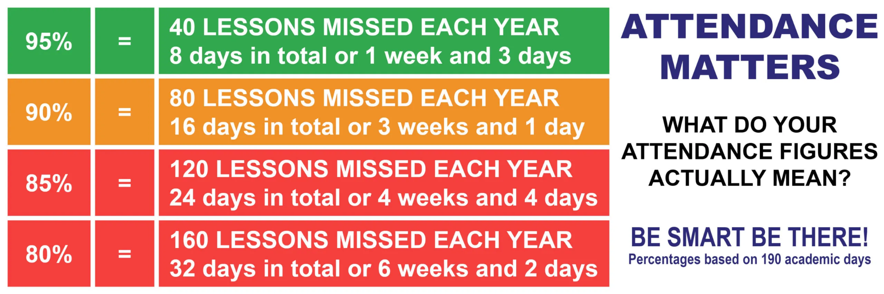



## Parish Christmas Fair

Sunday 24th November, after the 10:30am Mass

## Christmas Dates for your Diaries:

## **Christmas Dinner & Christmas Clothes**

Thursday 12th December 2024

Children are invited to come to school in Christmas jumpers or their own clothes on Thursday 12th December. Children who are on school dinners will be having Christmas dinner on this day and a very special guest will be visiting our younger children too!

## **KS1 & KS2 Christmas Mass**

Tuesday 17th December 2024, 9:15am

Friends and family welcome.

## **Reception Nativity Red Carpet Event**

Tuesday 17th December 2024, approximately 2:15pm (time to be confirmed)

2 adults maximum per child please due to fire safety regulations.

## **KS1 Christmas Carols**

Wednesday 18th December 2024, 1:30pm

2 adults maximum per child please due to fire safety regulations.

## **School Closes**

Wednesday 18th December 2024, 2pm

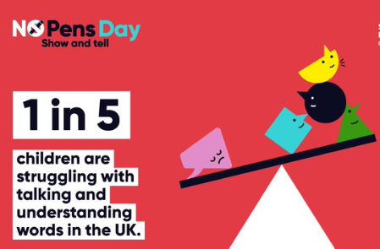

No Pens Day!

Wednesday 27th November 2024

No Pens Day is a nationwide initiative where students put down their pens and pencils for the day, focusing on learning through spoken language and listening activities. All lessons will be carefully designed to promote learning through activities such as discussions, debates, drama, role play, and interactive group work. The event encourages students to develop essential skills in speaking, listening, and understanding, which are key to their overall academic success and personal development.

This unique event is organised in support of Speech and Language UK, a charity dedicated to helping children with speech, language, and communication needs.

By participating in No Pens Day, we aim to:

* Raise awareness of the importance of spoken language and communication skills.
* Encourage students to develop their confidence in speaking and expressing ideas verbally.
* Support Speech and Language UK in their mission to help children who face challenges with communication.

As part of No Pens Day, we will also be raising funds for Speech and Language UK to support their vital work. Thank you for your support in making this day both enjoyable and impactful for our students.

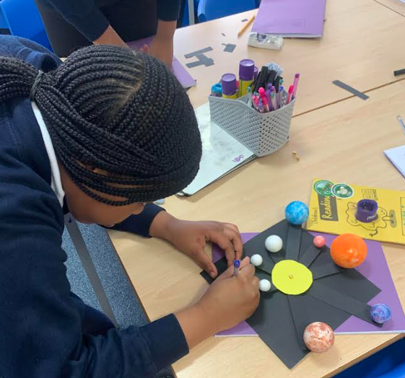 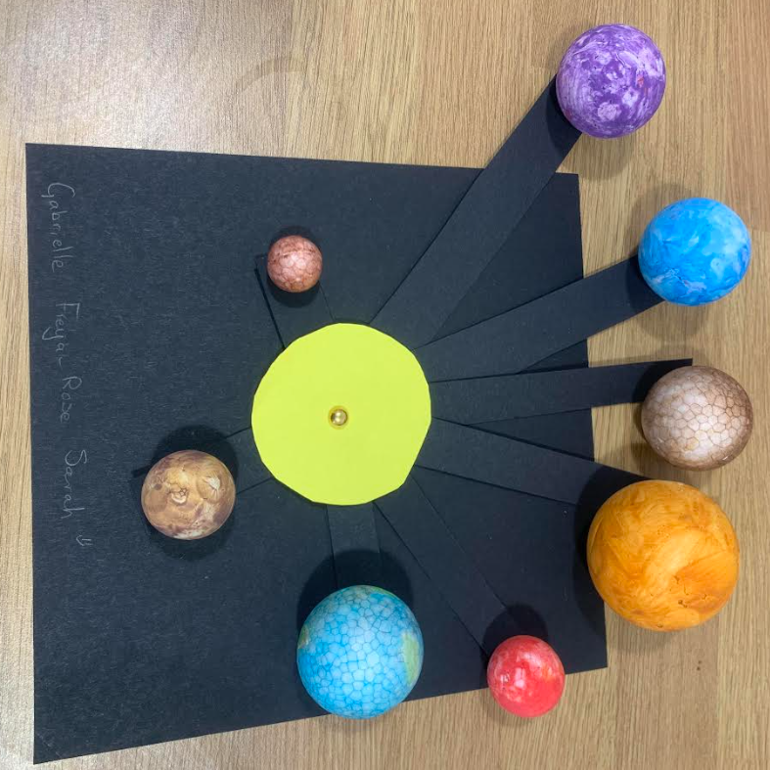

Solar Systems in UKS2

In science, our UKS children have been creating models of the solar system which show how each of the 8 planets orbits the sun.

Ask UKS2 what an elliptical orbit is, or whether bodies in our solar system are perfectly spherical.

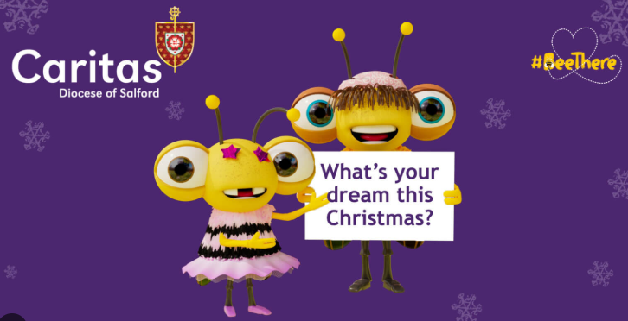

## Caritas Advent Appeal

Will You Be There This Christmas?

At this time of year, we can all feel under pressure to buy more, spend more, consume more and respond to the never-ending call to accumulate things.  But, some people don’t even have the basics.

No food for their baby, no warm clothes or heating; not even the security of a roof over their family’s heads.  Let’s not just make it about the tinsel, the parties and the supermarket queues.

Put the true meaning back into Christmas now and[BeeThere](https://www.youtube.com/watch?v=PNs2kjvfbnU) with a gift that can truly help transform lives.  However small those positive steps to help might feel, people in your area, your street, your place of work or your wider community can transform their lives this Christmas thanks to your kindness. Please visit [www.caritassalford.org.uk/BeeThereNow](http://www.caritassalford.org.uk/BeeThereNow) to find out more.

Keep our children safe!

PLEASE NO PARKING OR STOPPING ON KNUTSFORD ROAD!

Unless you have a blue disabled badge, please do not park or even stop on Knutsford Road opposite the school or outside the school between the hours of 8am and 5pm as clearly marked on the yellow signs on both sides of the road.

In accordance with the Highway Code, please do not park within 10 metres of the junctions on Knutsford Road. Please remember that my staff are here to teach and care for your children; they are not traffic wardens or police officers. Please be respectful of other road users in order to reinforce the message we share daily with our children: Every Heart is Sacred.

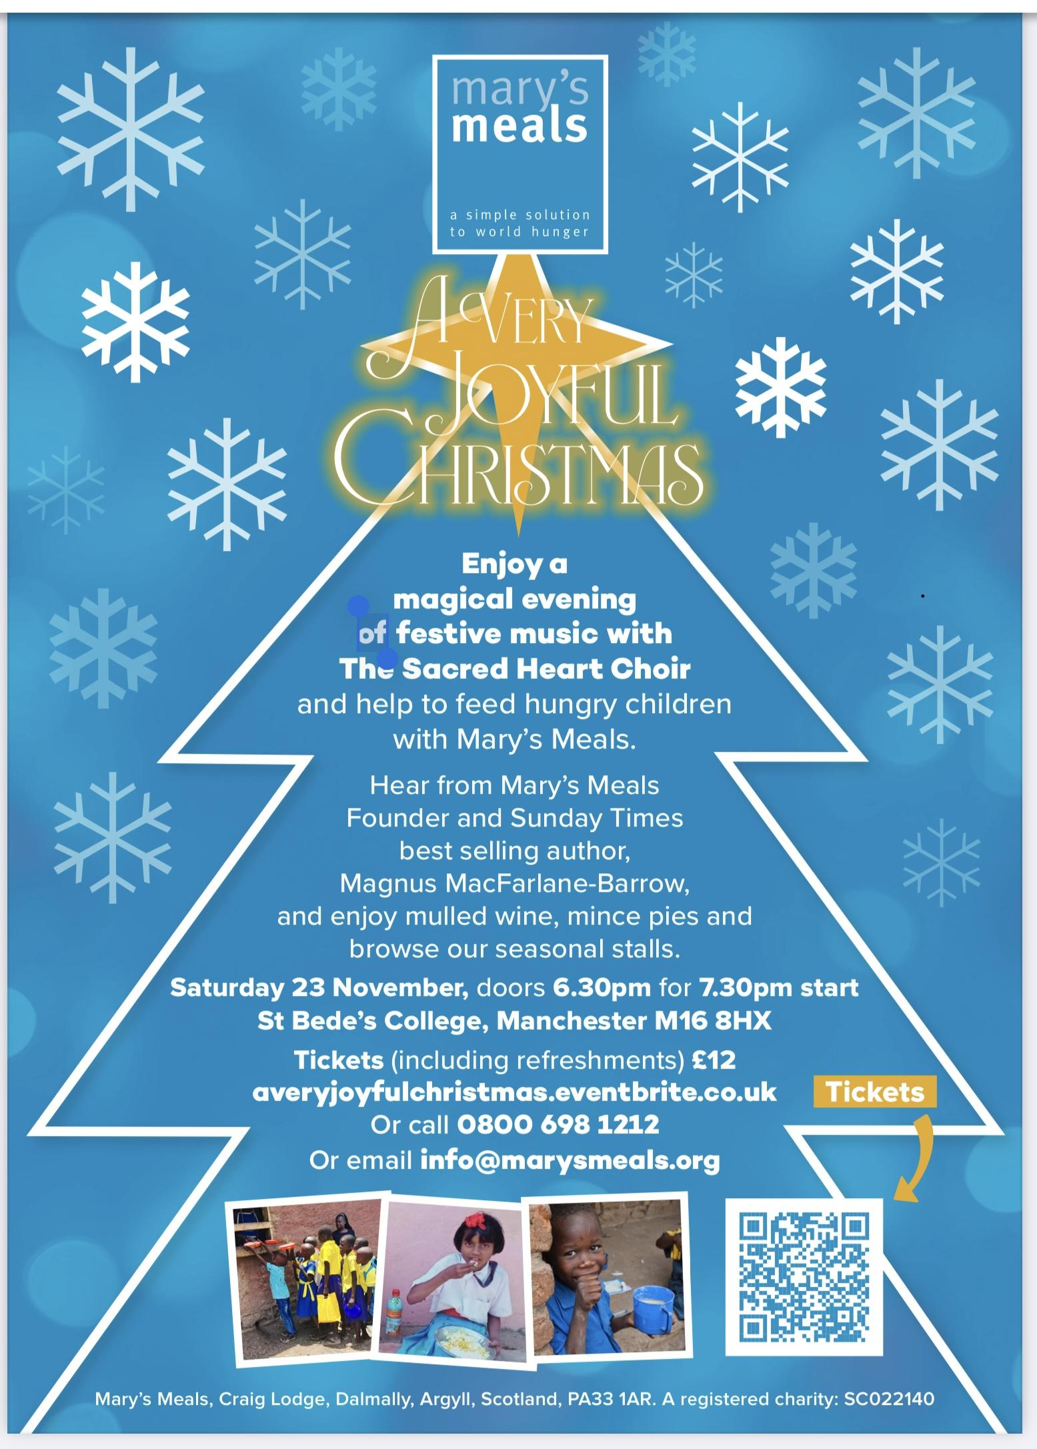

**📚 SUPERSTAR READERS 📚**

LKS2 - Class 6! *💫*

UKS2 - Class 9! *🌟*

**🎓 TT ROCKSTARS 🎓**

LKS2 - Ella and Class 5! 💫

UKS2 - Aadi and Class 8!🌟

**🏆 ATTENDANCE AWARDS 🏆**

**Reception 2 with 94.2% attendance**

**Class 3 with 97.2% attendance!**

**Classes 5 with 99.4% attendance!**

**Well done to everyone who came to school on time every day this week!**

**Well done to everyone who managed to avoid the awful sickness bug and came to school on time every day this week! We hope everyone who caught the bug feels much better very soon!**

**Christ the King**

O Jesus Christ, I acknowledge you as universal King.

All that has been made has been created for You.

Exercise all Your rights over me. I renew my Baptismal Vows.

I renounce Satan, his pomps and his works;

I promise to live as a good Christian.

And, in particular do I pledge myself to labour,

to the best of my ability,

for the triumph of the rights of God and of Your Church.

Divine Heart of Jesus, to You do I offer my poor services,

labouring that all hearts may acknowledge Your sacred kingship,

and that thus the reign of Your peace be established throughout

the whole universe. Amen.

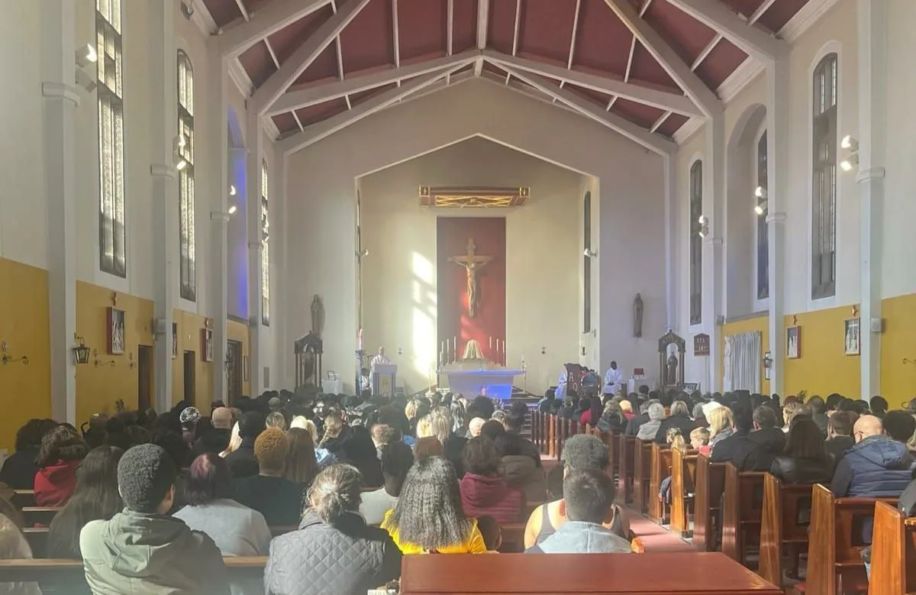

Click here for Mass times and other events in

the Parish of Sacred Heart and St Francis, Gorton

<https://www.sacredheartstfrancisgorton.co.uk/mass-schedule>

horizontal line

Sacred Heart RC Primary School

**'Where Every Heart is Sacred’**

