

Sacred Heart RC Primary School

**'Where Every Heart is Sacred’**

Week Commencing: 2nd December 2024

horizontal line

# The First Week of Advent



Advent is a truly special time: a season of waiting, preparation, and joyful anticipation as we get ready to meet the Saviour of the World. In today’s world, it’s easy to be distracted by the bombardment of expensive gifts and extravagant experiences that retailers push upon us, making it seem as if Christmas has little to do with God. But we know the truth: Christmas has *everything* to do with God.

This Advent, let’s come together to teach our children the real meaning of Christmas. God sent His Son to Earth as a humble, helpless baby to show us the way—to love one another, to recognise God as our Father, to speak to Him through prayer, and to care for the beautiful world He created for us.

As we prepare our hearts to meet the Baby Jesus—our Saviour, our Messiah—lying in the manger on Christmas Day, let’s resist the pressure to overspend or focus on material things. Instead, let us embrace a Christmas that is simple and full of love, just as Mary and Joseph did in that humble stable in Bethlehem.

May this Advent season be a time of grace for all of us, as we guide our children to the true joy of Christmas: the love of God made manifest in the birth of His Son.



Thank you so much to Mrs Hearn and Mrs Shorrock who dress our Christmas Tree and prepare our class Advent wreaths every year! Mrs Hearne and Mrs Shorrock took their well-earned retirements several years ago but still return to Sacred Heart every week to support our staff and children. We are so grateful to them and all of our very special volunteers who give so generously of their time. Thank you.

horizontal line

## 

## Christmas Dates for your Diaries:

## **Christmas Dinner & Christmas Clothes**

Thursday 12th December 2024

Children are invited to come to school in Christmas jumpers or their own clothes on Thursday 12th December. Children who are on school dinners will be having Christmas dinner on this day and a very special guest will be visiting our younger children too!

## **KS1 & KS2 Christmas Mass**

Tuesday 17th December 2024, 9:15am

Friends and family welcome.

## **Reception Nativity Screening**

Tuesday 17th December 2024, 2:30pm

2 adults maximum per child please due to fire safety regulations.

## **KS1 Christmas Carols**

Wednesday 18th December 2024, 1:30pm

2 adults maximum per child please due to fire safety regulations.

## **School Closes**

Wednesday 18th December 2024, 2pm

**THIS WEEK’S TOP STORIES**

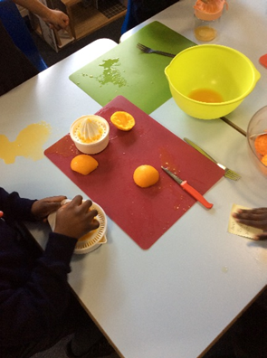 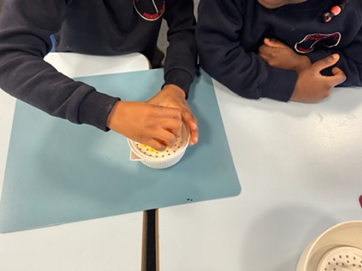

## Smoothies in KS1

This term in Design Technology, KS1 has been learning about fruits and practising food preparation skills. In Class 1, the children tasted and selected their favourite fruits to include in a class smoothie. Then, working collaboratively, they made a delicious smoothie using fresh fruits and juice.

In Class 3, the children had a delicious time exploring smoothies! They started by tasting pre-made smoothies, examining the packaging, and observing the color and texture before enjoying a sip. They then sampled fresh orange, lemon, and lime juice, with lemon juice emerging as the class favorite.

To wrap up, the children experimented with pairing fruits, voting on their favorite combinations. The winning blend? Pineapple and strawberry! This fun activity allowed them to discover new flavors and make group decisions while having a blast.

Ask KS1: Which tools are important when making smoothies?



Hellos and Goodbyes!

It is with a heavy heart that I share with you Miss Briggs’ and Miss McLaughlin’s January plans. They have both bravely decided to take a pause from teaching to try something new. Miss Briggs will be jetting off to travel the world in the new year and, I’m sure, spread joy wherever she goes; Miss McLaughlin is trying her hand at a new career to see if the grass really is greener on the other side! Miss Briggs and Miss McLaughlin are both expert teachers and leaders who have dedicated many years to Sacred Heart and I thank them wholeheartedly for the love, compassion, knowledge and wisdom that they have shared with our children, staff and families since joining our wonderful staff. Please remember them in your prayers; they will be greatly missed.

We have been very fortunate in securing several more wonderful teachers to join our dedicated teaching team. From January, Mrs Morrison will take over as Class 8 Teacher and Curriculum Lead, Mrs Scappaticci will take over as Class 5 Teacher and EVC Lead and Miss Ghafoor will take over as Reception 2 Class Teacher.

Class 8 and Reception 2 met their new teachers today and Class 5 will meet their new teacher next week. Your children remain in very capable hands and I’m sure you will make our new staff very welcome. Meet the Teacher meetings for parents and carers will be held in the new year for Reception 2, Class 5 and Class 8.

I am delighted to announce that Mrs Bowen’s baby girl was born this week, a full eleven days overdue! Baby Bowen has kept her parents on their toes throughout the final trimester but they are now enjoying their first experience of the beautiful ‘baby bubble’. We thank God for baby Daphne’s safe arrival and we look forward to meeting her when the time is right.



KS1 Parents and Carers

Please remember: the ‘Read with Me’ sticker means that KS1 children should not be asked to read this book aloud independently; it is a book to read together with an adult. This is because not all of the words in these books are decodable. We share these books so that children can enjoy the stories and the pictures they contain.

Phonics

For those children who are still becoming secure in their phonic knowledge (mostly children in Reception, Year 1 and Year 2), here are the sound videos to help you to use pure sounds with your children when they are reading and writing:

<https://vimeo.com/753929025/5eaa45c0aa?share=copy>

<https://vimeo.com/753931102/b9a2f8194f>

How often should we read together?

We strongly suggest:

5 minutes of reading each day for children in Reception

10-15 minutes of reading each day for children in Years 1 & 2

15-20 minutes for children in Years 3 & 4

30 minutes of reading per day for children in Year 5 & 6

Please remember to continue to read to your children as well as listening to them read to you. Hearing how reading should sound is a valuable learning experience for your child and sharing a bedtime story is a wonderfully positive way to end the day.

Reading Records

Please remember to sign your child’s reading record at least five times per week. Child in Y6 are welcome to complete their own entries as long as an adult in the home signs once per week.

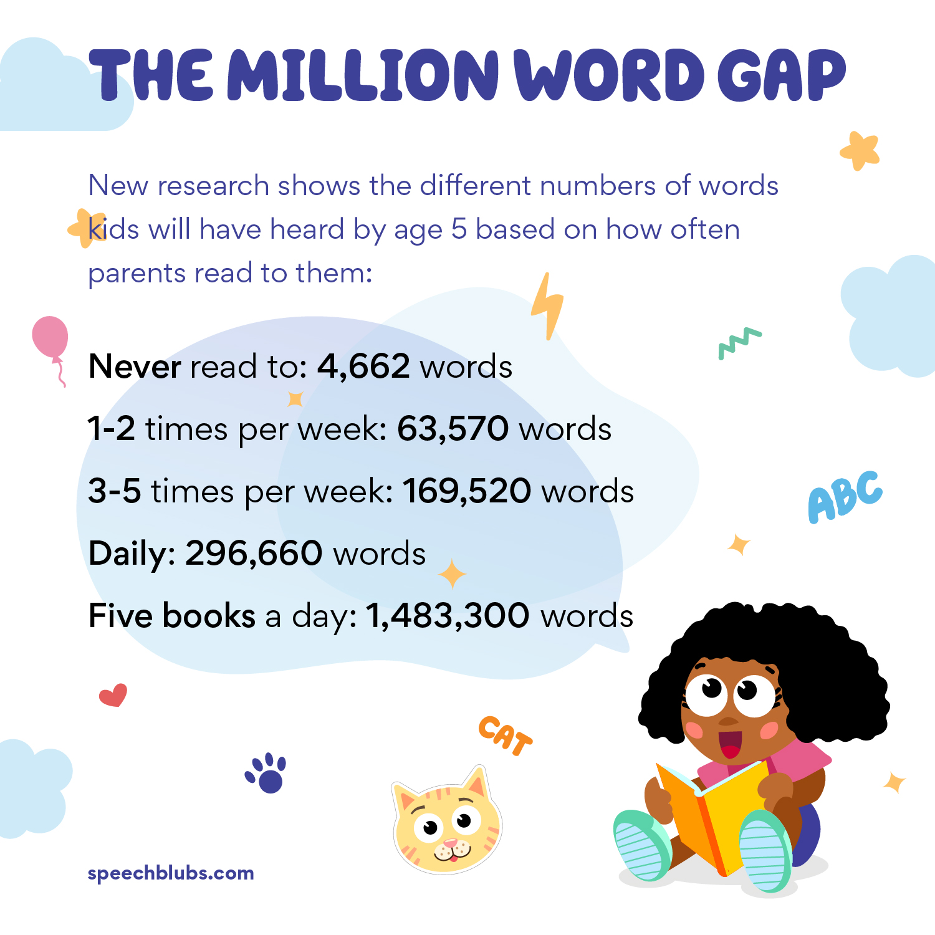

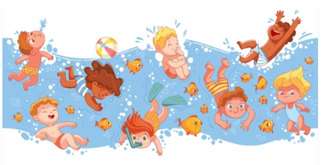

## Swimming

January to Easter

Class 6’s last swimming lesson of this academic year will take place on Tuesday January 7th. Mrs Lord and Miss Mills are so proud of how well the children have mastered their strokes and techniques and how well they have represented our school over the past three months. Super swimming, Class 6, well done!

Class 5 (Miss McLaughlin/Mrs Scappaticci’s class) children will be going swimming every Tuesday from January 14th until the Easter holidays in April.

Class 5 children will need:

* Girls: A swimming costume (not a bikini)
* Boys: Swimming shorts (not ‘bermuda’ shorts)
* All: A towel
* For those whose hair is longer than their eyebrows: A swimming cap





**Outside Class 6**

Lost property can be found in the large storage box on the playground step outside Class 6 (Mrs Lord's and Miss Mills’ class). Please feel free to look through this box whenever your child has misplaced an item of clothing - there are lots of lovely coats in there at the minute!



**Asda Cashpot for schools**

Thank you!

Thank you to everyone, staff and parents/carers, who contributed to our Asda cashpot! We will use this money for more play resources for lunchtimes due to the fact that Miss Wynne is raising money for books through the Tesco Stronger Start Scheme - more information to follow in the new year!

Experiencing difficulties?

Parking, litter or fly-tipping issues?

If you are experiencing difficulties navigating the roads near our school due to dangerous or illegal parking, you can report your concerns [here](https://www.gmp.police.uk/contact/af/contact-us-beta/contact-us/driving-vehicles-traffic/report-illegal-parking/).

If you are experiencing issues with litter or fly-tipping, you can report your concerns [here](https://www.manchester.gov.uk/environment).

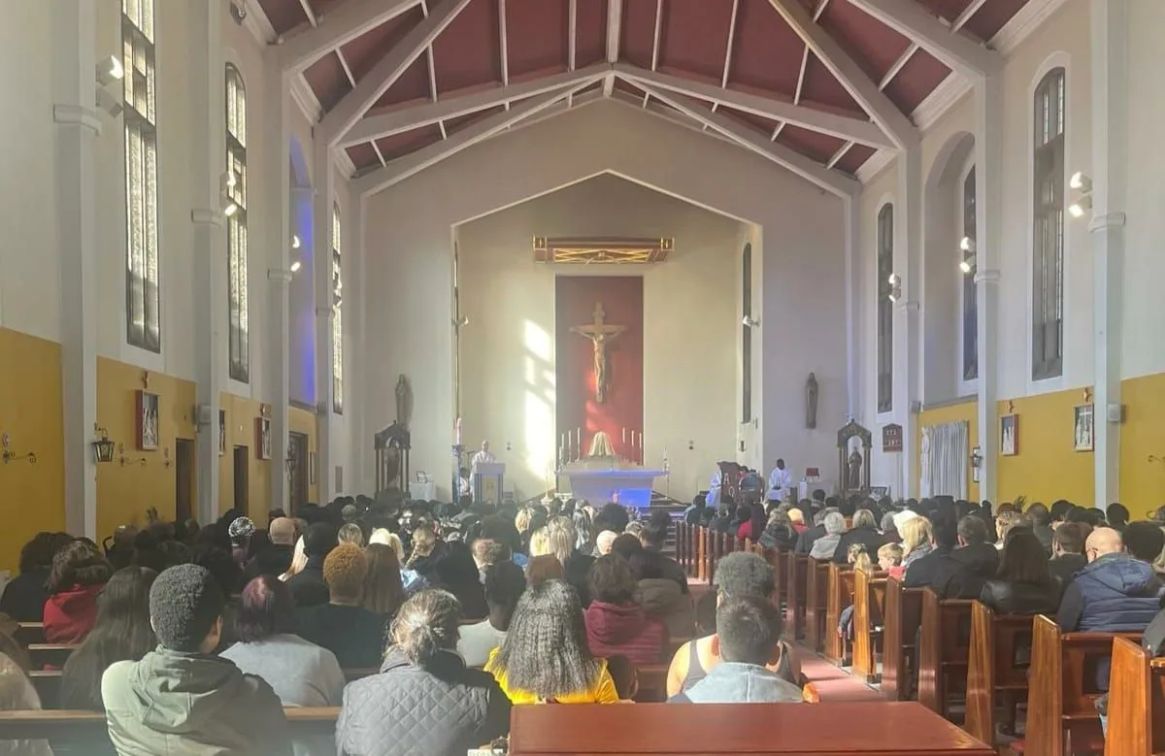

Click here for Mass times and other events in

the Parish of Sacred Heart and St Francis, Gorton

<https://www.sacredheartstfrancisgorton.co.uk/mass-schedule>

horizontal line

Sacred Heart RC Primary School

**'Where Every Heart is Sacred’**

