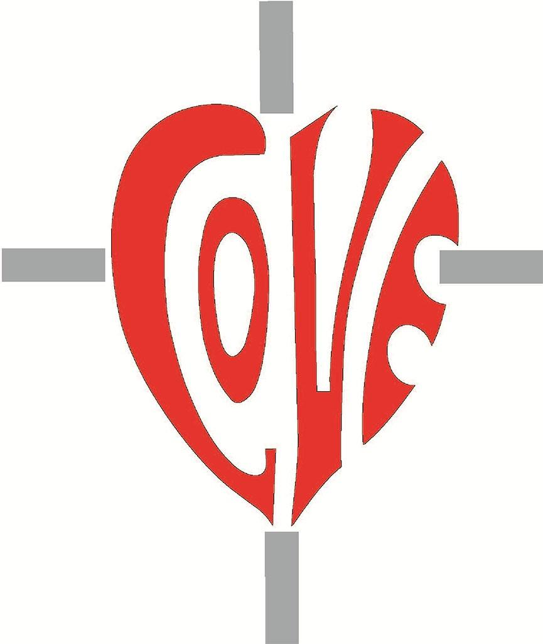

Sacred Heart RC Primary School

**'Where Every Heart is Sacred’**

Week Commencing: 14th October 2024

horizontal line



Wow, what a half term!

Thanks to you and the dedication of our wonderful team at Sacred Heart, we have had a fantastic start to the new academic year! Children have settled beautifully into their new classes, friendships are being nurtured, secured and renewed and our children know and remember more every day. Exciting visits and trips have already taken place and lots more are planned or are in the planning stages.

We have been blessed with plenty of Autumn sunshine and, through our work with Opal, we are working hard to increase opportunities for play whenever children are outside with their classmates and friends.

Looking out at a sea of red clothing during Fridays' assemblies, I could not have been more proud. Your children are a credit to you and it is a privilege and a joy to serve this loving, aspirational, vibrant community. Finally, a big thank you for your generous donations to the Manchester Food Bank; your kindness is truly appreciated.

May the Lord bless and keep you until we meet again. School will restart on Monday, 28th October.

## 

## Autumn Parents’ Evenings

November 5th, 6th & 7th - 3:30-5:30pm

You will soon be receiving a ParentMail regarding our first Parents’ Evenings of the new academic year. Please use the pedestrian gate to access the school building and please allow additional time so that you can look at your children’s books before, or after, you meet with the teacher. Staff will direct you to the correct classroom or meeting room on arrival.

## 

## Primary Science Quality Mark

Another great achievement!

We are thrilled to announce that, under Mrs. Lord’s diligent leadership, we have once again been awarded the prestigious Primary Science Quality Mark! This recognition reflects our dedication to delivering high-quality science education, both in and beyond the classroom. It highlights our commitment to fostering positive attitudes towards science while ensuring our students develop strong scientific knowledge and skills.

## Science in C2

This half term, Class 2 have been learning about living things and their habitats. To begin, we learnt about what a living thing needs to be able to survive. We spent some time outdoors searching for different types of plants, trees and minibeasts. Children also learnt about the different microhabitats that are in our surrounding areas and what minibeasts may be living in them.

Ask Class 2 what living things need in order to survive and where they found the most worms!

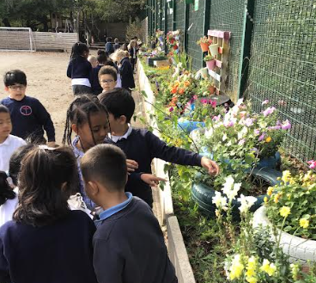 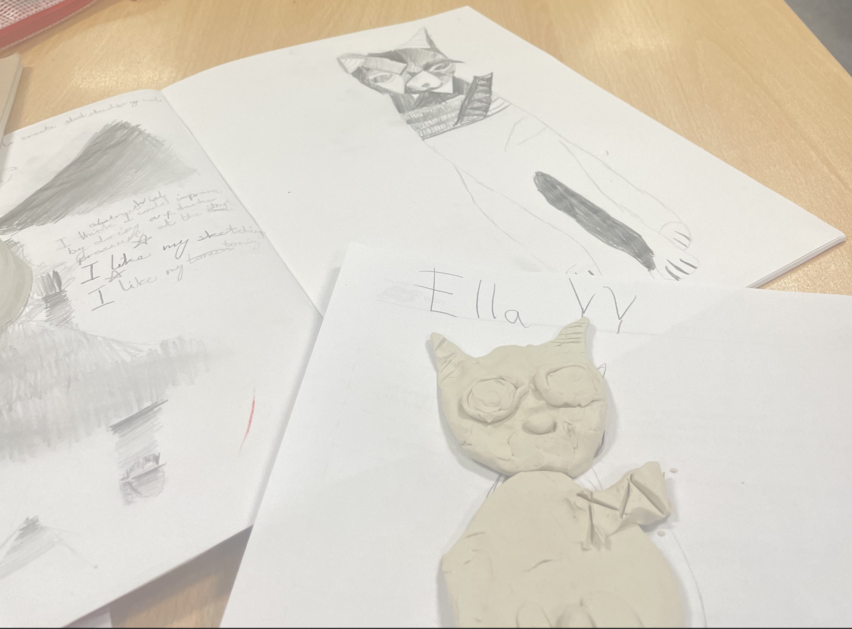

## Art in C5

In art, we used our observation skills and Cubism art techniques to create artwork featuring Bastet who is probably the best-known Ancient Egyptian feline goddess. We then recreated our artwork using clay to make a Bastet sculpture. It was so much fun!

Ask Class 5 if they can name some shapes that Cubist artists used in their artwork, and why they think the artists chose these shapes…

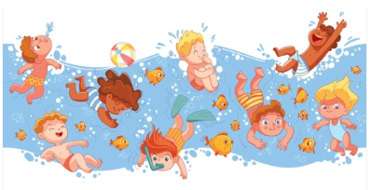

## Fantastic Swimming Results!

Back to Pre-Covid Standards!

Thanks to the dedication of Miss Andrew and our KS2 staff, pupils and families, we are delighted that we are now back to our pre-covid [swimming standards](https://sacredheartschool-gorton.org.uk/about-us/school-swimming-data/)!

There are lots of half term sporting activities on offer in Manchester this week.

Why not take a look?

<https://www.better.org.uk/manchester/activities-for-kids>



## Secondary School Admissions

The application deadline is looming for current Y6 pupils!

Year 6 Parents and Carers, if you haven’t yet applied for a place at secondary school for your son or daughter, please remember to do so before October 31st. Manchester residents, please follow this link:

<https://www.manchester.gov.uk/info/500322/secondary_school_admissions>



KS1 Parents and Carers

Please remember: the ‘Read with Me’ sticker means that KS1 children should not be asked to read this book aloud independently; it is a book to read together with an adult. This is because not all of the words in these books are decodable. We share these books so that children can enjoy the stories and the pictures they contain.

Phonics

For those children who are still becoming secure in their phonic knowledge (mostly children in Reception, Year 1 and Year 2), here are the sound videos to help you to use pure sounds with your children when they are reading and writing:

<https://vimeo.com/753929025/5eaa45c0aa?share=copy>

<https://vimeo.com/753931102/b9a2f8194f>

How often should we read together?

We strongly suggest:

5 minutes of reading each day for children in Reception

10-15 minutes of reading each day for children in Years 1 & 2

15-20 minutes for children in Years 3 & 4

30 minutes of reading per day for children in Year 5 & 6

Please remember to continue to read to your children as well as listening to them read to you. Hearing how reading should sound is a valuable learning experience for your child and sharing a bedtime story is a wonderfully positive way to end the day.

Reading Records

Please remember to sign your child’s reading record at least five times per week. Child in Y6 are welcome to complete their own entries as long as an adult in the home signs once per week.

Here are some prompts for Y6 children from Miss Wynne, our Reading Leader:

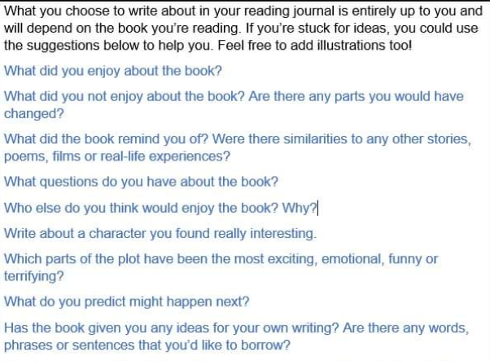

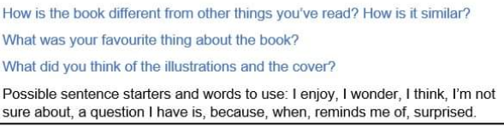

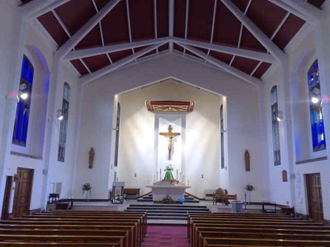

## All Saints

Holy Day of Obligation on November 1st

## This year, KS1 and KS2 will be celebrating All Saints Mass during our usual Tuesday morning Mass slot. You are very welcome to join us. Please see the revised timetable of school Masses below:

**Tuesdays at 9:15am, Sacred Heart RC Church:**

* Tuesday October 28th - Year 2 - Year 6 (All Saints and All Souls theme)
* Tuesday November 11th - Classes 4, 5 and 6 (Miss Leadbetter, McLaughlin, Mrs Lord and Miss Mills)
* Tuesday November 25th - KS1 (Classes 1, 2 and 3)
* Tuesday December 2nd - Classes 8 & 9 (Mr Wilson & Miss Wynne)
* Tuesday December 9th - KS1 & KS2 (Classes 1-9)

Please check with class teachers the day before the scheduled Mass as sometimes Masses are rearranged in accordance with the needs of the parish.

## AFRUCA Talks - Saturday Zooms

Our friends from AFRUCA has asked us to share this poster with you and invite you to join them on Zoom on Saturdays from 5:30-7pm.

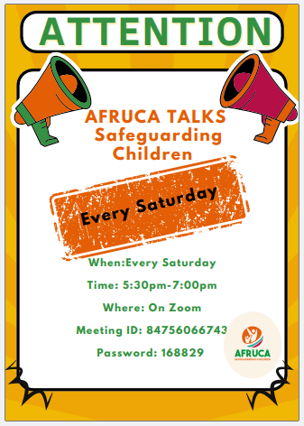

**🎓 TT ROCKSTARS 🎓**

**Well done to our TT Rockstars winners this week!**

KS1 - Aliza ⭐

LKS2 - Amaya 💫

UKS2 - Imade 🌟

Tournament Winners:

LKS2 - Class 6 ✨

UKS2 - Class 7 🎉

**🏆 ATTENDANCE AWARDS 🏆**

**Classes 7 & 8 with 99% attendance!**

**Class 2 with 99% attendance!**

**Reception 2 with 98% attendance!**

**Wow! What amazing attendance rates this week!**

**Absolutely fabulous!**



Mrs Bowen has now begun her maternity leave and we wish her and her family all the very best as they prepare to welcome their daughter into the world. Please remember our Sacred Heart babies in your prayers: those who have already joined us, those whose births are imminent and those who are longed for.

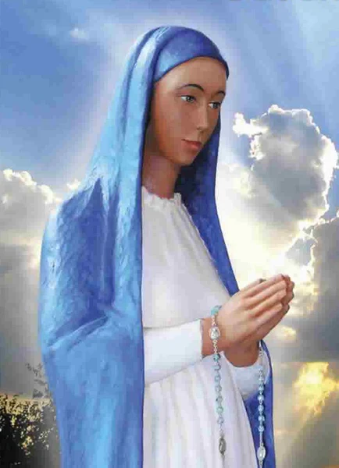

Our Lady,

Queen of the Most Holy Rosary,

Pray for us.

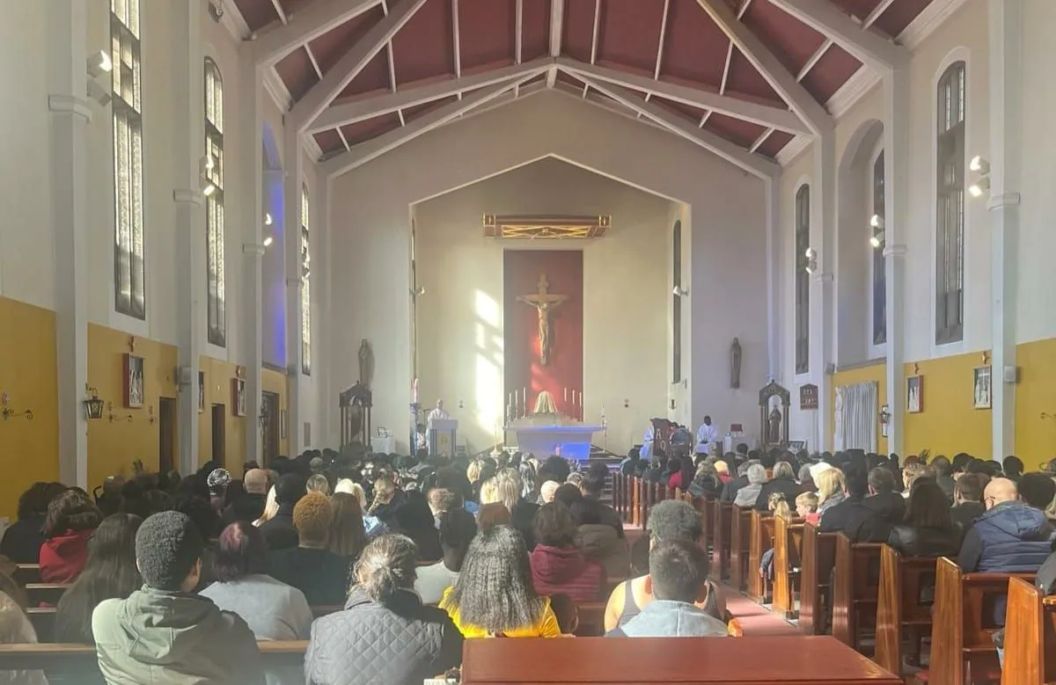

Click here for Mass times and other events in

the Parish of Sacred Heart and St Francis, Gorton

<https://www.sacredheartstfrancisgorton.co.uk/mass-schedule>

| **Don’t forget to check our X feed!****@SHGorton** |
| --- |

horizontal line

Sacred Heart RC Primary School

**'Where Every Heart is Sacred’**

