

Sacred Heart RC Primary School

**'Where Every Heart is Sacred’**

Week Commencing: 30th September 2024

horizontal line

# Feast of St Francis

Friday 4th October

Today is the Feast of St Francis of Assisi - a perfect opportunity to share one of our Chair of Governors’ favourite prayers as well as some beautiful art work by Cyra R. Cancel. Please remember the children, staff and families of our sister school, St Francis, in your prayers today.

**Morning Prayer of St. Francis**

Lord, help me live this day,

quietly, easily; to lean on your great strength,

trustfully, restfully; to wait for the unfolding

of your will, patiently, serenely; to meet others,

peacefully, joyfully; to face tomorrow,

confidently, courageously.

Amen.

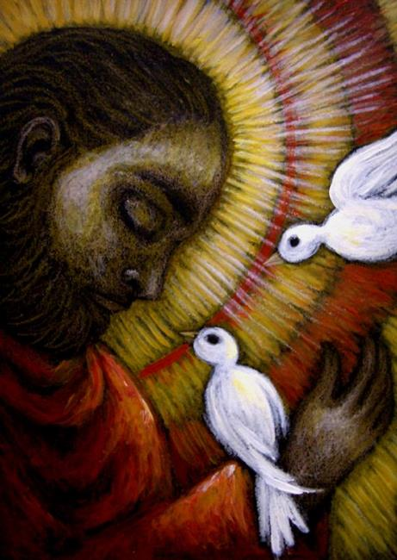

# Five Trusted People

This week, we have been talking to the children about their five trusted people. These are five people, adults or older children, to whom the children could talk if they had a big worry or a problem that they couldn’t solve for themselves. It’s a good idea to include people who aren’t in the family as well as people who are. Perhaps you could ask your child who their trusted people are and help them to find the full five if they can’t think of them all by themselves.



Children often choose their parents, their grandparents, aunties and uncles, older siblings or older cousins, their teacher, teaching assistant, a senior leader or someone they turn to for help with their pastoral needs, for example our Caritas family support worker (Alexis Slater).

horizontal line

THIS WEEK’S

**TOP STORIES**

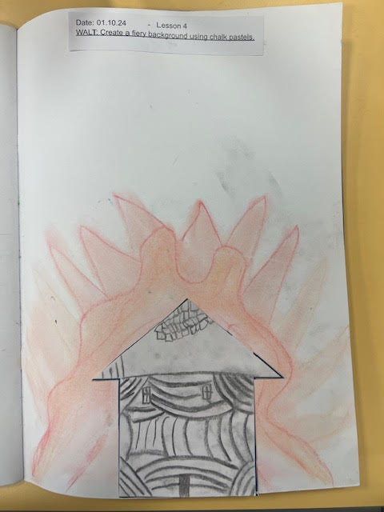 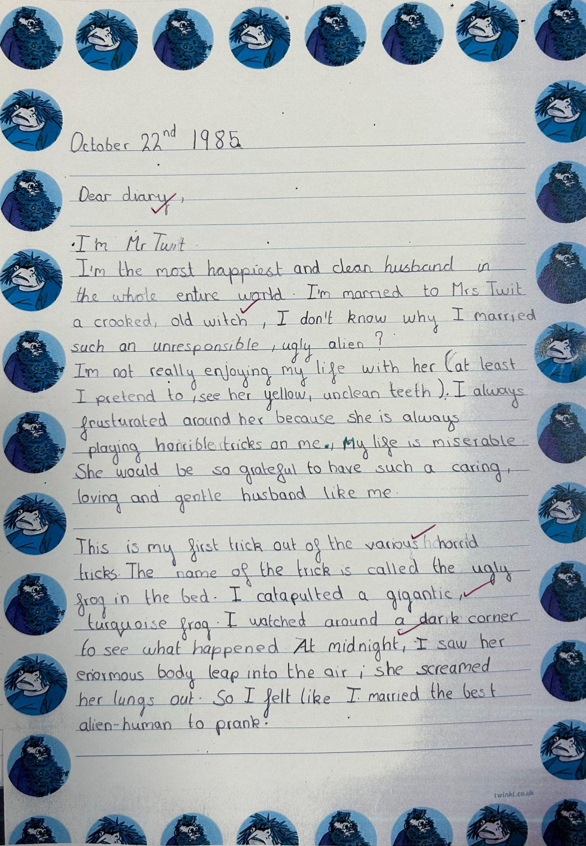

## Wonderful Work!

The Great Fire of London - KS1

This half term, our KS1 children have been learning about the Great Fire of London. This is such an interesting topic and children are always keen to know more. This year, our children have also produced some fantastic art work to complement their disciplinary knowledge. Ask KS1: How did the fire of London start and how did it end?

The Twits - LKS2

I was delighted to be invited into C6 this week to read the children’s Mr or Mrs Twit diaries. The whole class had worked so hard on their independent writing, making sure that their work was entertaining as well as grammatically correct and beautifully well-presented. Thank you, Class 6, for working so hard and for sharing your achievements with me! Ask Class 6: How many disgusting pranks did Mr and Mrs Twit play on each other?!



## Wonde logins - Classes 1-9

Please remember to enter the Wonde [website](https://www.wonde.com/) first and then use the QR code

Thank you for your patience regarding your children’s Wonde logins. These should now be stuck in the front of your child’s reading records. There are many Sacred Heart RC Primary Schools in the UK which often causes technical glitches for Wonde/Ed Shed at the start of the new academic year and our server was updated in the summer which is still causing some issues for our new starters unfortunately. Rest assured, Mrs Ellis is working extremely hard to rectify all of the issues we are facing but please let your child’s class teacher know if you are struggling with Wonde homework at all.

Please enter the Wonde [website](https://www.wonde.com/) first, then scan the QR code that has been stuck into your child’s reading record. Technology…!!!

Fly Tipping - Thank You!

Team work makes the dream work!

Thank you to all of the parents, carers and staff who reported the terrible fly tipping at the bottom of Glencastle Road to Manchester City Council. Thanks to you and the support we received from Councillor Reid and our friends at Gorton Family Hub and Tiny Steps Nursery, the fly tipping has finally been cleared! We hope your walk to and from school is never blighted by rubbish like that again.



## Secondary School Admissions

The application deadline is looming for current Y6 pupils!

Year 6 Parents and Carers, if you haven’t yet applied for a place at secondary school for your son or daughter, please remember to do so before October 31st. Manchester residents, please follow this link:

<https://www.manchester.gov.uk/info/500322/secondary_school_admissions>



## Congratulations St Peter’s!

Excellent GCSE results for our past pupils!

It is always wonderful to hear how well our past pupils are doing and I was particularly delighted to hear how well our former students achieved in their GCSE results at St Peter’s RC High School this year! Massive well done to all of those young people - I hope they are very proud of their achievements!



Friday 18th October 2024 - Non-uniform day for [Cafod](https://cafod.org.uk/)

Each Autumn, CAFOD holds a Family Fast Day in which we are invited to come together as a community to fast, pray and raise funds to address issues of food and hunger around the world. This year, our Caritas team is asking for donations for the Manchester Food Bank in exchange for coming to school dressed in their ‘own clothes’ on the final day of this half term. More information to,follow.

As October 18th is also [Show Racism the Red Card](https://www.theredcard.org/)’s Wear Red day, we invite our children to wear an item or two, or more if they choose, of red clothing on October 18th to show our commitment to changing hearts, changing minds and changing lives.





**St Francis of Assisi, pray for us.**

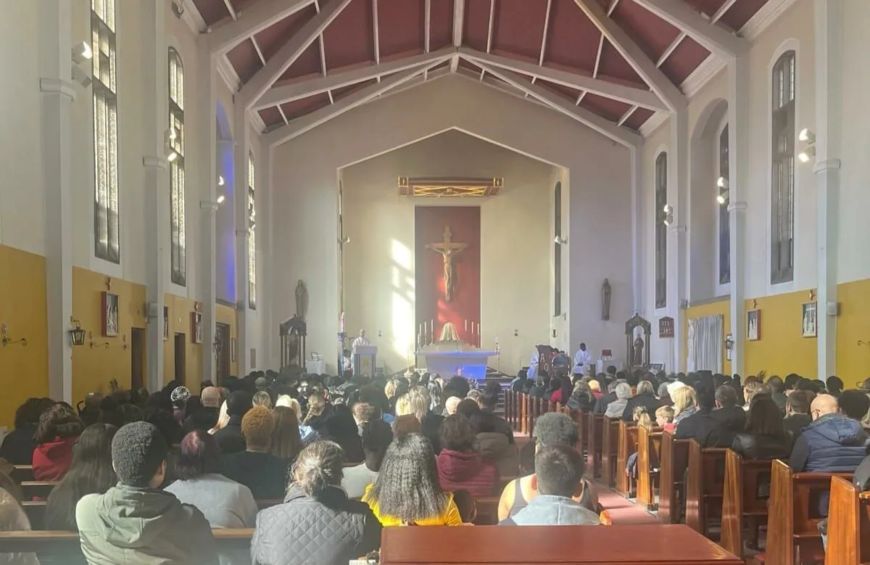

Click here for Mass times and other events in the Parish of Sacred Heart and St Francis, Gorton

<https://www.sacredheartstfrancisgorton.co.uk/mass-schedule>

| **Don’t forget to check our X feed!****@SHGorton** |
| --- |

horizontal line

Sacred Heart RC Primary School

**'Where Every Heart is Sacred’**

