

Sacred Heart RC Primary School
'Where Every Heart is Sacred’
Week Commencing: 23rd September 2024

The Rosary

As we draw near to the month of October, we are preparing to share the Rosary in full with our children in school. Our newly appointed leadership team will be visiting classes to pray the Rosary with their younger peers. There is a pictorial guide at the end of this newsletter in case you would like to pray the Rosary together as a family this October.

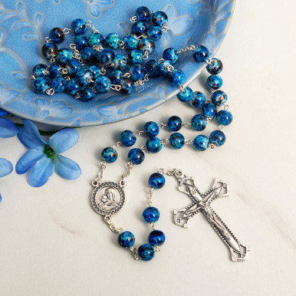

THIS WEEK’S
TOP STORIES



‘Serve one another in love.’
Galatians 5:13

This week, we appointed our new Year 6 Leadership Team! All 45 of our Y6 children now have an important role to play in overseeing the effective organisation of our busy school. From Prefecting duties at lunchtime to Eco-committee duties incorporating keeping our school litter-free, you will see our wonderful Y6 children helping to make our world a better place.
Year 6 all worked very, very hard to prepare and present their applications for a range of posts, describing how their own talents and vision can support our school development. Mrs Jordan, Mrs Illidge and I were extremely impressed with their hard work and presentation skills - we definitely have some future lawmakers in our midst!
Please remember Year 6 in your prayers as they begin to carry out their roles with love, kindness and diligence. Thank you in advance for your service Y6; we already know that each and every one of you will be an amazing asset to the smooth running of our very special school.



General Class Information
Classes - Sacred Heart R.C. Primary School
Please remember to check your child’s class webpage for information regarding uniform, PE days, homework, expectations and things to remember each school day.



National Teaching Assistants’ Day!
THANK YOU TEACHING ASSISTANTS!
Thank you to all of our wonderful Teaching Assistants on this national day of recognition! We would be lost without their support, guidance and friendship; our school simply could not function without them. There were extra staff room treats for our Teaching Assistants to enjoy today and beautiful roses were delivered by three of our Y4 children (so thank you to Mirra, Nisali and Fakeehah too!).

Class 9 Farm Visit
Class 9 were fortunate enough to visit Northwood Farm this week. They learnt about life on a working meat farm, including how sheep and cows are reared and the important work that farms do to feed us and also protect our environment.
Ask C9 about the hard work that is involved in taking care of sheep!

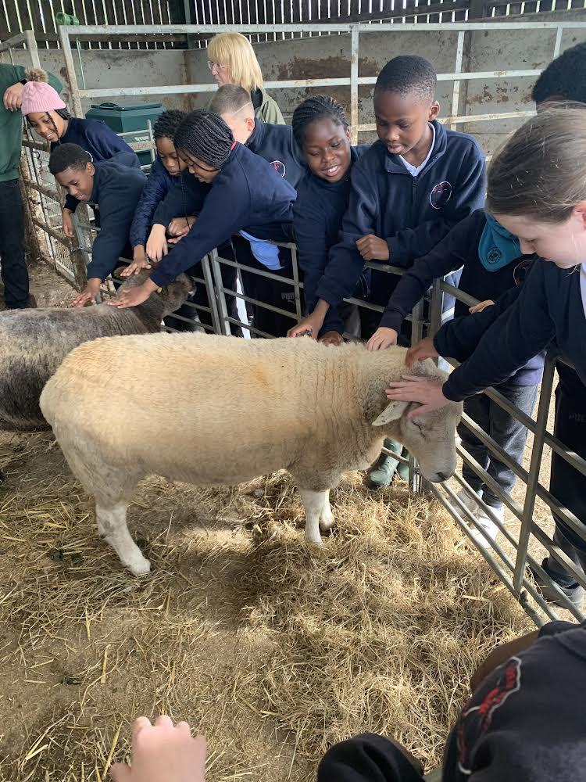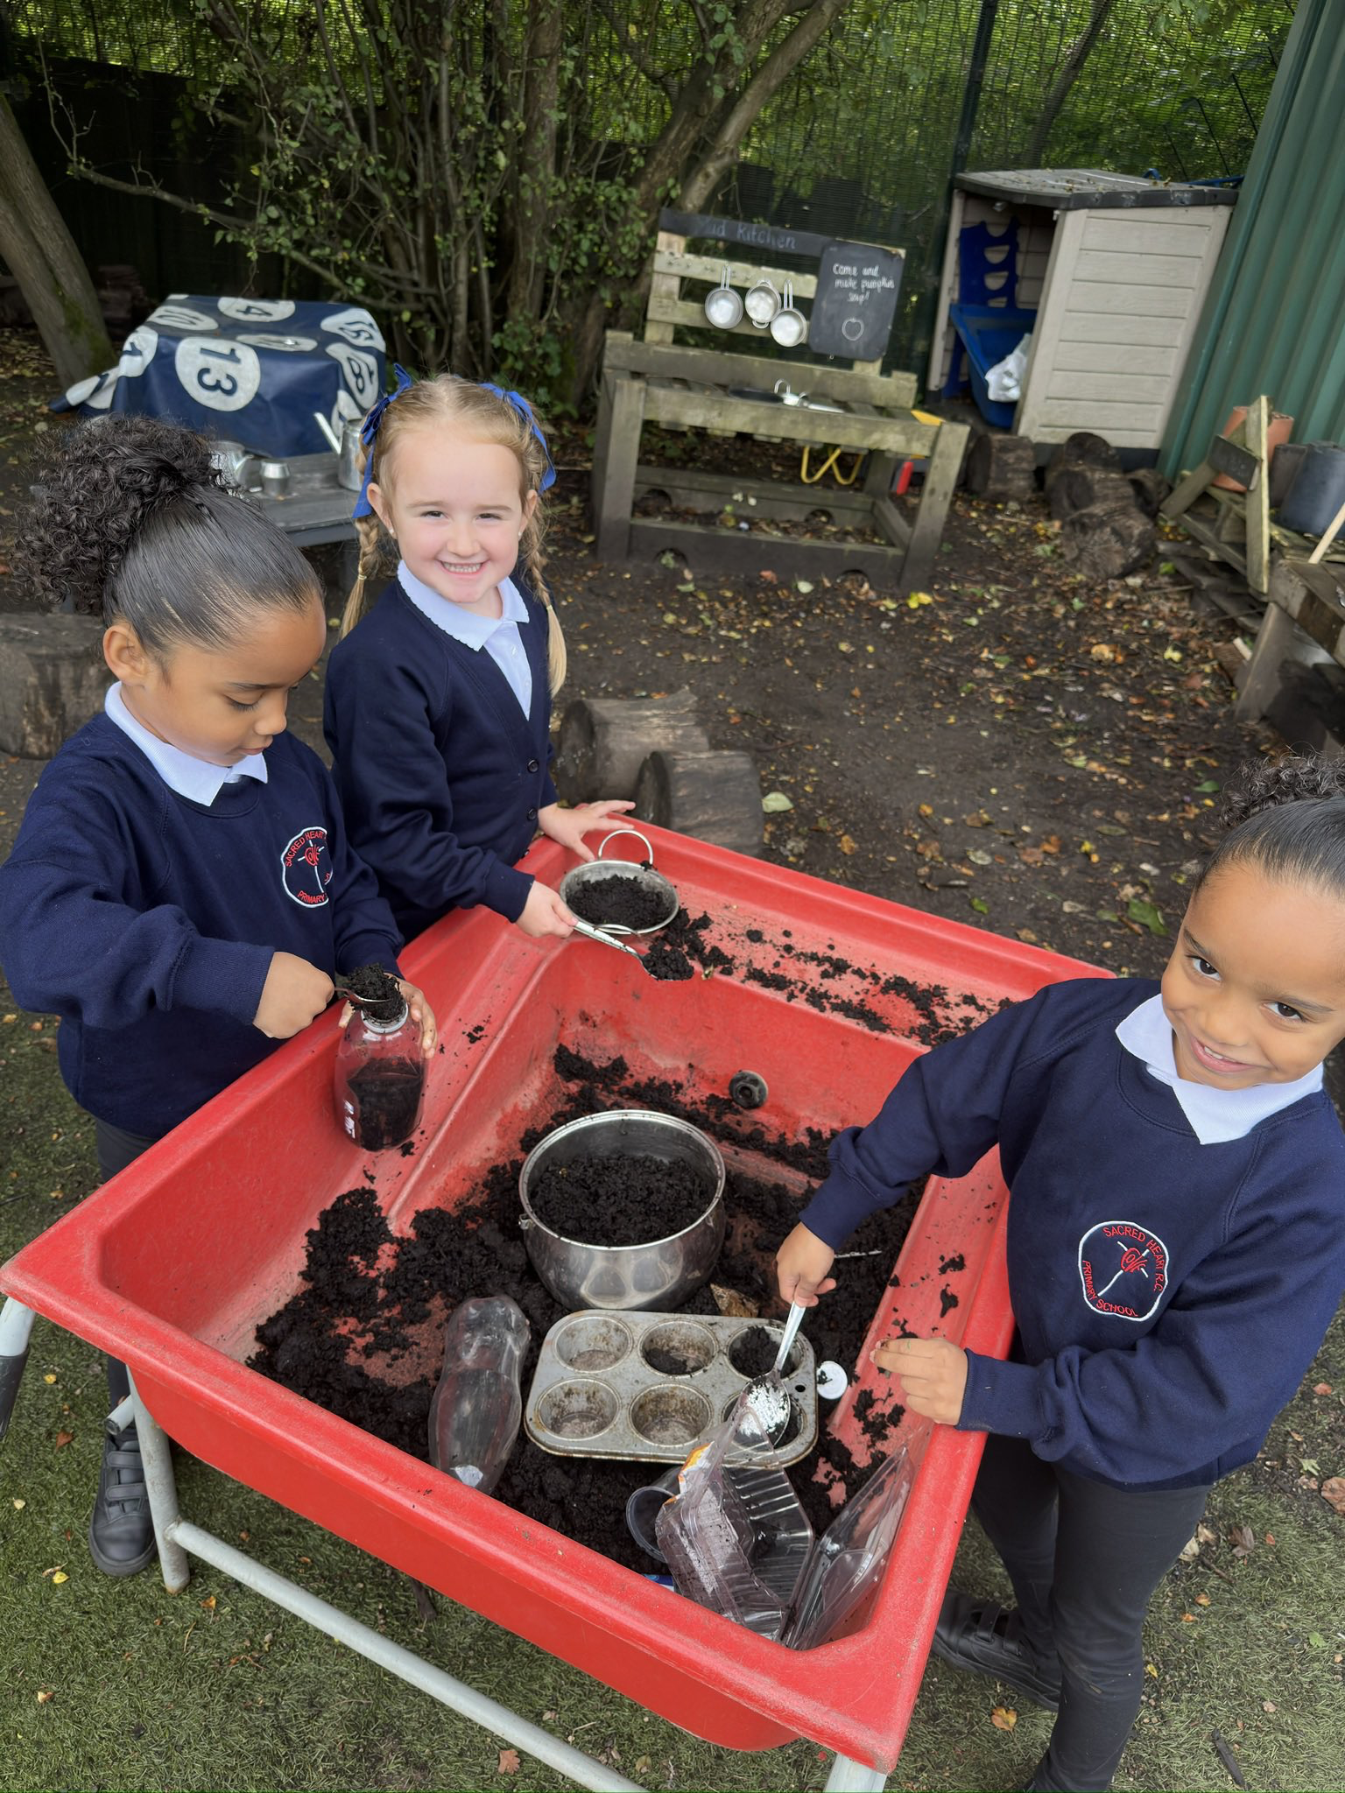

Reception
Reception have been having fun with bugs and all things mud this week! Ask Reception what dishes they love to make in their wonderful mud kitchen!

Fantastic football!
Well done to both the girls’ and the boys’ teams this week!
Our girls’ and boys’ football teams both represented our school at football matches this week and did us really proud! The girls braved rush hour traffic to complete Chorlton High School, and didn’t concede even one game; the boys played at home on our shared field and secured a fantastic 2-1 win! Well done to all the players, thank you to all the parents, carers and family members who came to support, thank you to Mrs Speed for driving the minibus and a massive thank you to Miss Andrew for organising all of these events in her own time.

In school on time every day
Please note that children are marked ‘late’ if they arrive after 8:55am
Lessons begin promptly at 8:55am and every class starts their day with either Phonics or Reading lessons so please ensure that your child is in class on time so that they don’t miss any vital learning. Thank you.

Birthday Celebrations
Non-uniform for birthday boys and girls but no cakes please
As a healthy school, we encourage healthy eating throughout the school day. For this reason, our tradition at Sacred Heart is for children to come to school in non-uniform on their birthdays. This way, all staff and pupils can wish the child happy birthday all day long! We also sing Happy Birthday in every Friday assembly. Whilst we appreciate the kind thought behind sending cakes/sweets into school on birthdays, we ask that you do not do this as it not only compromises our healthy eating practice but also puts additional pressure on families whose finances may be stretched. Thank you for your understanding in this matter.
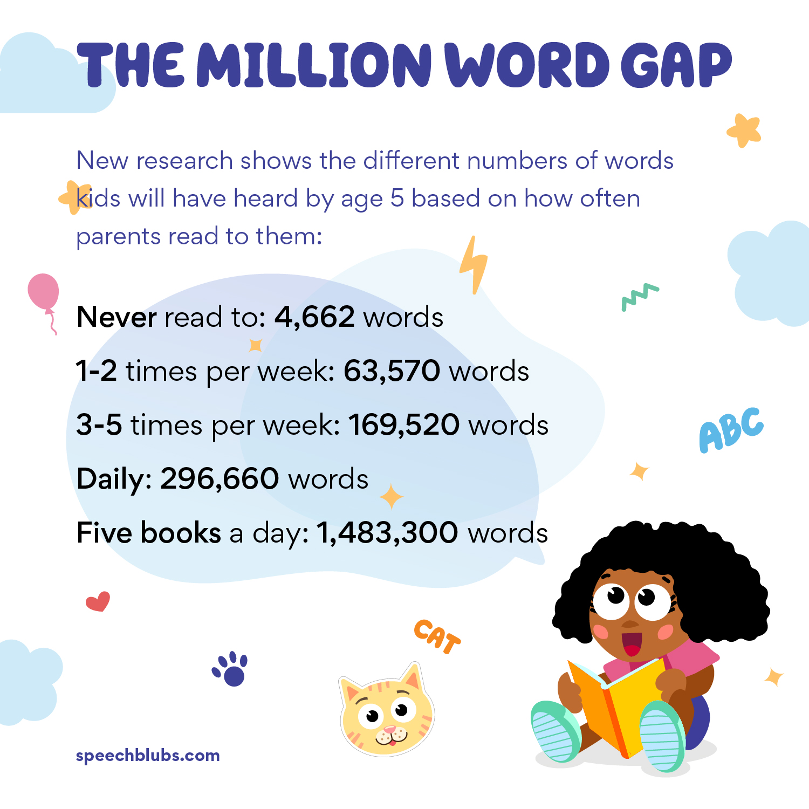

Reading
‘Children learn to read by reading.’ Marie M Clay
Just like learning to drive and learning to swim, the most effective way to learn to read is by reading… as often as possible!
We strongly suggest:
5 minutes of reading each day for children in Reception
10-15 minutes of reading each day for children in Years 1 & 2
15-20 minutes for children in Years 3 & 4
30 minutes of reading per day for children in Year 5 & 6
As children get older, they are welcome to read texts other than their school reading books, for example sporting articles, non-fiction books, newspapers and magazines.
Gorton Library is a fantastic resource - all lending is free and staff are able to order any books your child would like to read that can’t be found on the shelves on the day of your visit.
First News is a great resource that can be found in most large supermarkets - it’s a newspaper written especially for children and young people and bursts full of interesting articles and facts.
Please remember to continue to read to your children as well as listening to them read to you. Hearing how reading should sound is a valuable learning experience for your child and sharing a bedtime story is a wonderfully positive way to end the day.

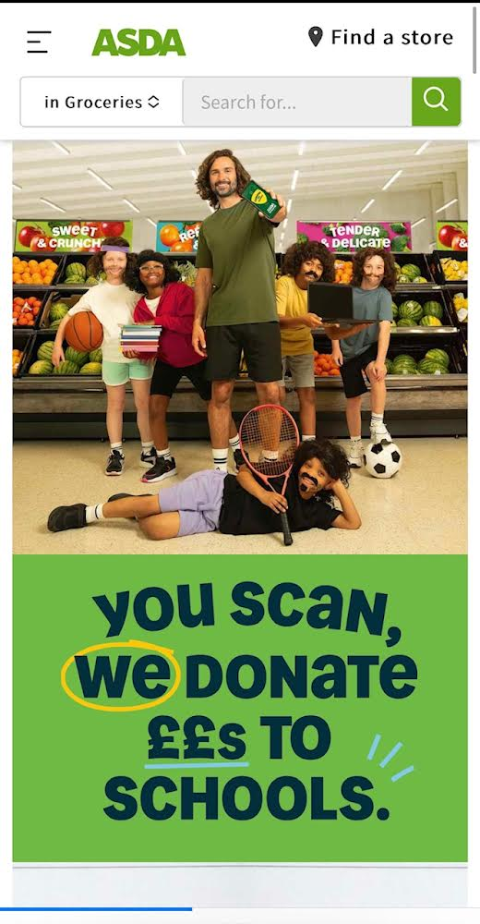
Asda Cashpot for schools
Please join!
Please follow the steps below to join our Cashpot for schools fundraising - all money received from the Asda Cashpot will be spent on school essentials for your children such as updated technology and reading books.
The initiative closes on November 30th and we already have £80 in our cash pot - thank you to everyone who has already signed up!

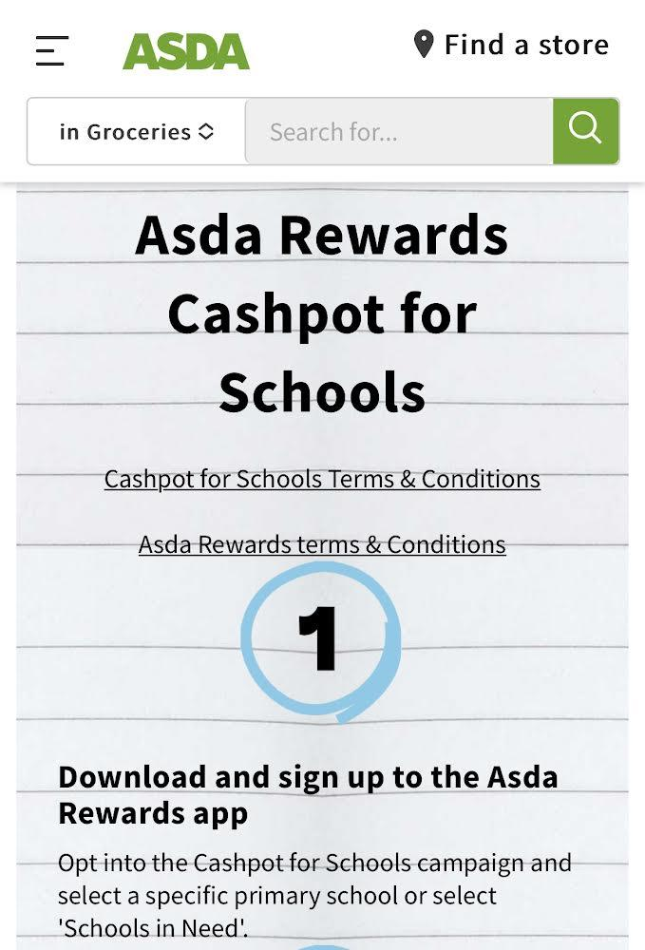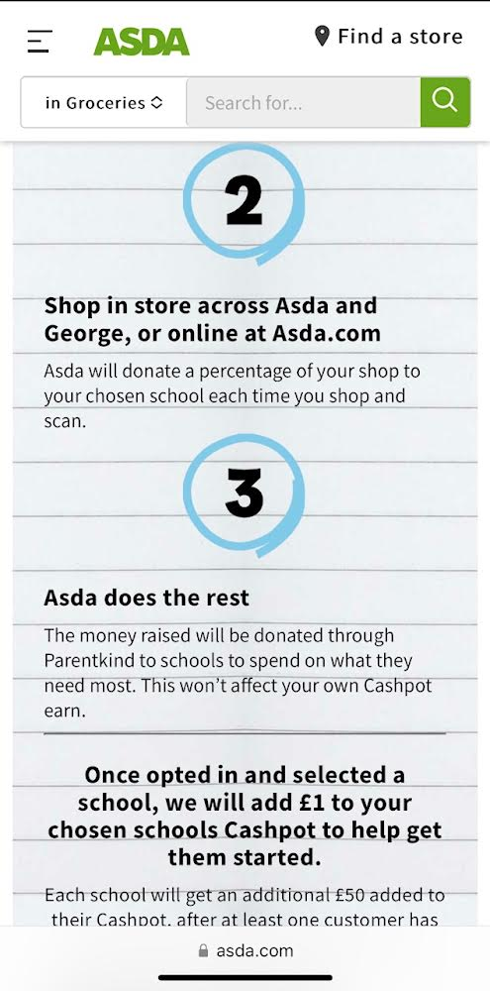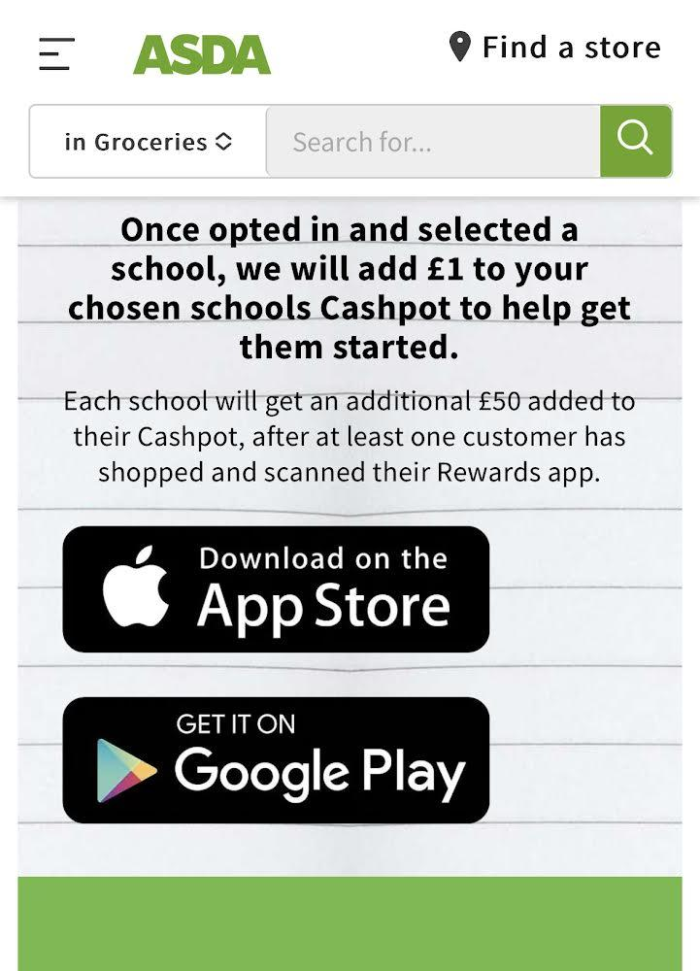

🎓 TT ROCKSTARS 🎓
Well done to our TT Rockstars winners this week!
KS1 - Murwira ⭐
LKS2 - Zaydok 💫
UKS2 - Gabriel 🌟

🏆 ATTENDANCE AWARDS 🏆

Reception 2 with 96.3% attendance
Classes 2 & 3 (Joint Winners!) with 98.3% attendance!
Class 9 with an amazing 100% attendance!

Well done to everyone who came to school on time
every day this week and an extra special congratulations to
Class 9 for scoring 100% attendance this week - amazing!!

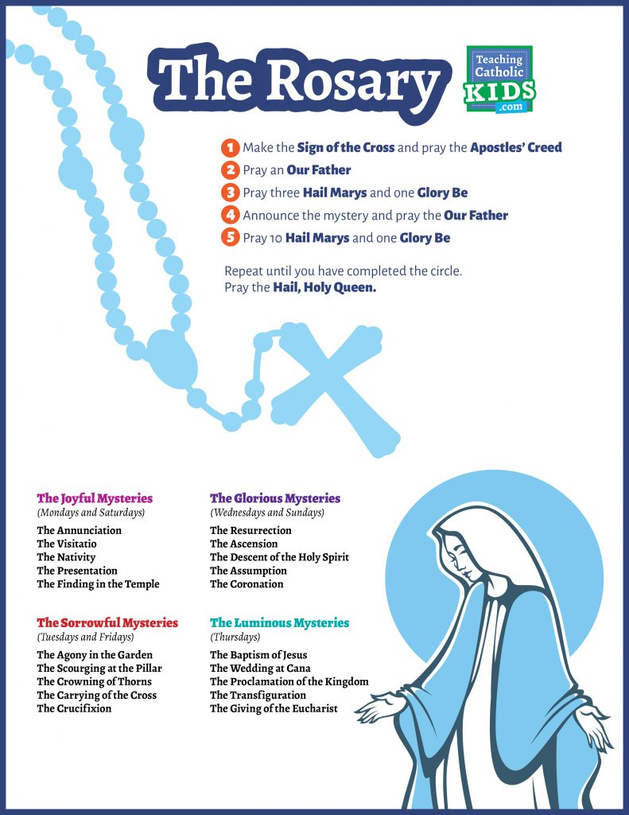

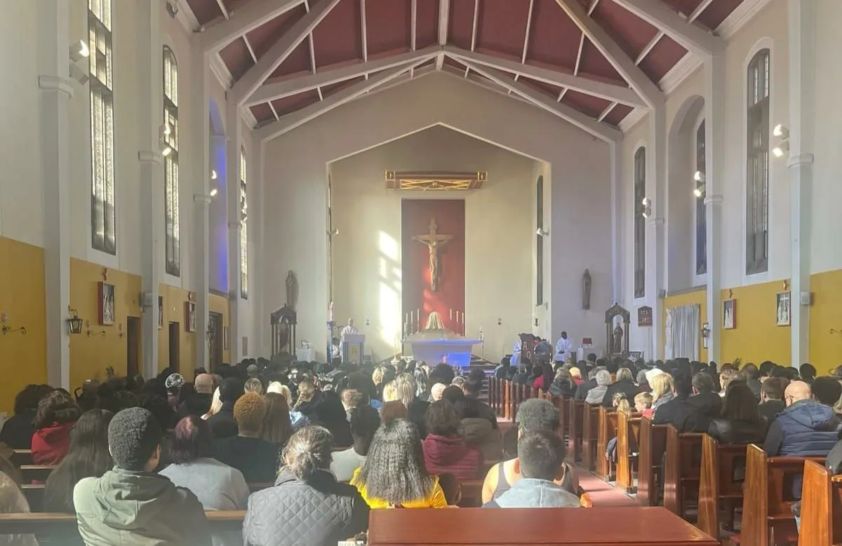
Click here for Mass times and other events in
the Parish of Sacred Heart and St Francis, Gorton
https://www.sacredheartstfrancisgorton.co.uk/mass-schedule

Don’t forget to check our X feed! @SHGorton

Sacred Heart RC Primary School
'Where Every Heart is Sacred’

