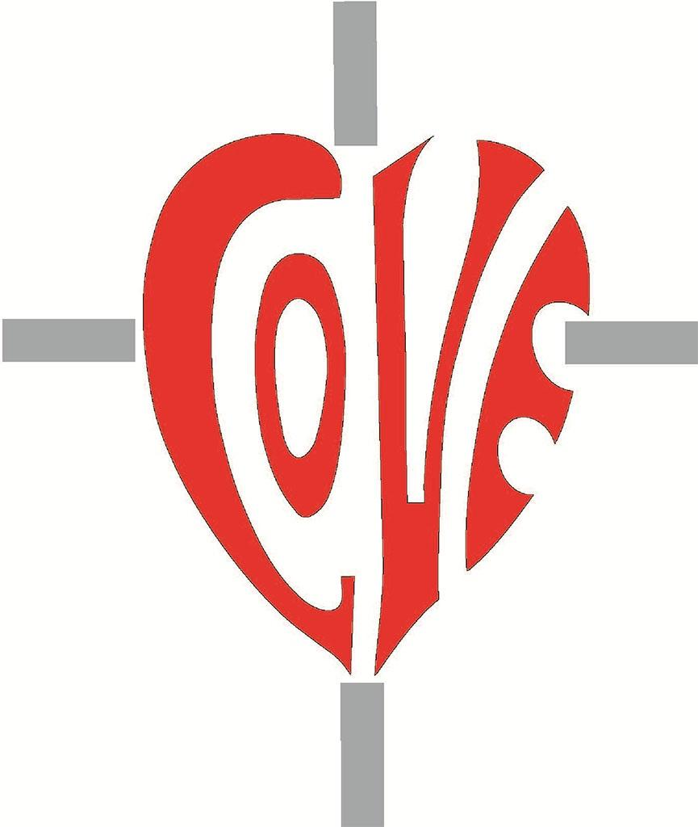

Sacred Heart RC Primary School
'Where Every Heart is Sacred’
Week Commencing: 7th October 2024

Black History Month


October is Black History Month - a time dedicated to celebrating and recognising the contributions of Black people to British society, as well as an opportunity to learn and broaden understanding of Black culture. It’s a great opportunity to teach young people about the ​efforts of Black people and communities, civil rights movements and equality as well as a chance to further their understanding of our ​fundamental British values of democracy, the rule of law, individual liberty, and mutual respect and tolerance of different faiths and ​beliefs. The theme of Black History Month 2024 is 'Reclaiming Narratives' to recognise and focus on correcting narratives of Black history and ​culture.



Friday 18th October 2024 - Non-uniform day
Children are invited to come into school on the last day of this half term (Friday October 18th) wearing their own clothes, including red clothing items if possible.

If you are able to contribute an item per child, or per family, to Manchester Central Foodbank, we would be most grateful. These are the items that the foodbank is currently in most need of:
- TINNED VEGETABLES
- TINNED FRUIT
- TINNED MEAT
- TINNED FISH
- COFFEE
- TEA BAGS

By wearing a red item or two on October 18th, Show Racism the Red Card’s Wear Red day, we aim to show our commitment to changing hearts, changing minds and changing lives.
THIS WEEK’S
TOP STORIES

Escape into a book and #Take10 to Read

At Sacred Heart, we love to read and on Thursday 10 October at 10am we took ‘10ToRead' in support of World Mental Health Day.
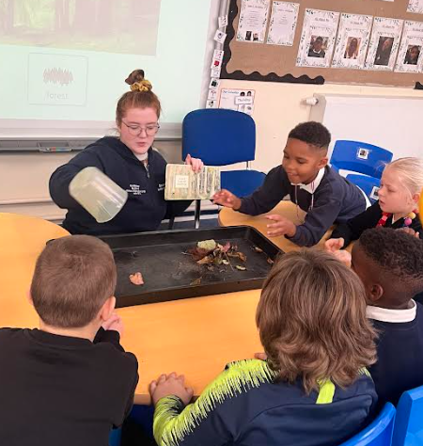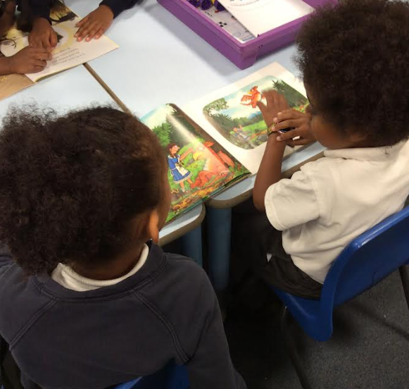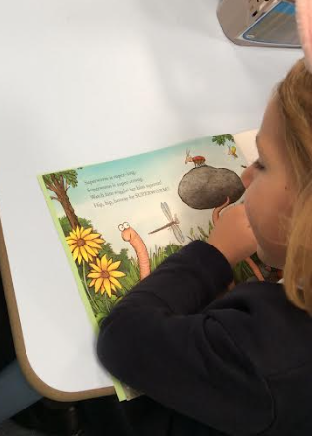
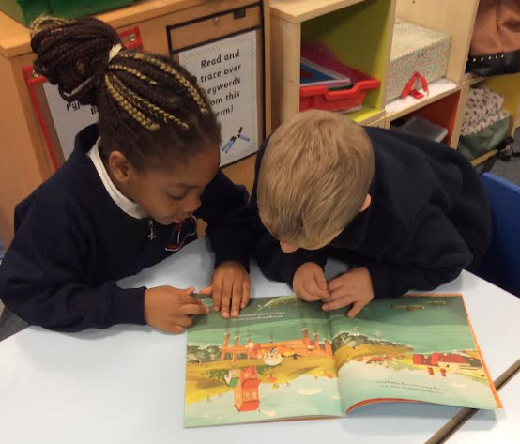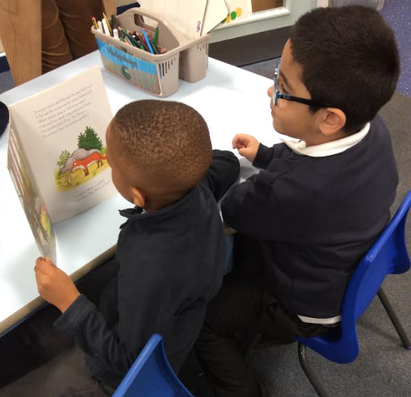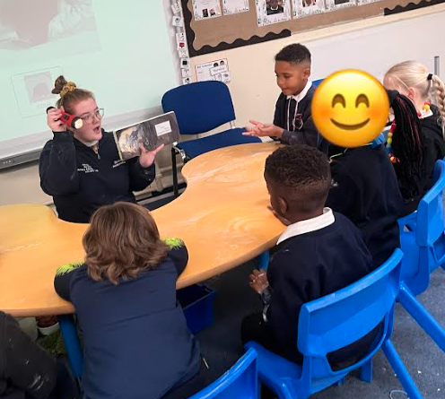

Reading can help you relax, boost your mood and escape elsewhere – and it doesn’t have to be a book. It could be the post-match analysis of Saturday’s football game, an interview with your favourite actor, DIY hacks or even recipes. Reading something that interests you can transport you away from day-to-day life.

Take 10 is a campaign to promote the wellbeing benefits of reading. Try it for 10 minutes today and see where it takes you.

Peace at Last by Jill Murphy

In Literacy, KS1 have been reading Peace at Last. To support their understanding and vocabulary development, the children learned to retell the story using a story map and actions. Ask your KS1 child to retell the story Peace at Last at home!
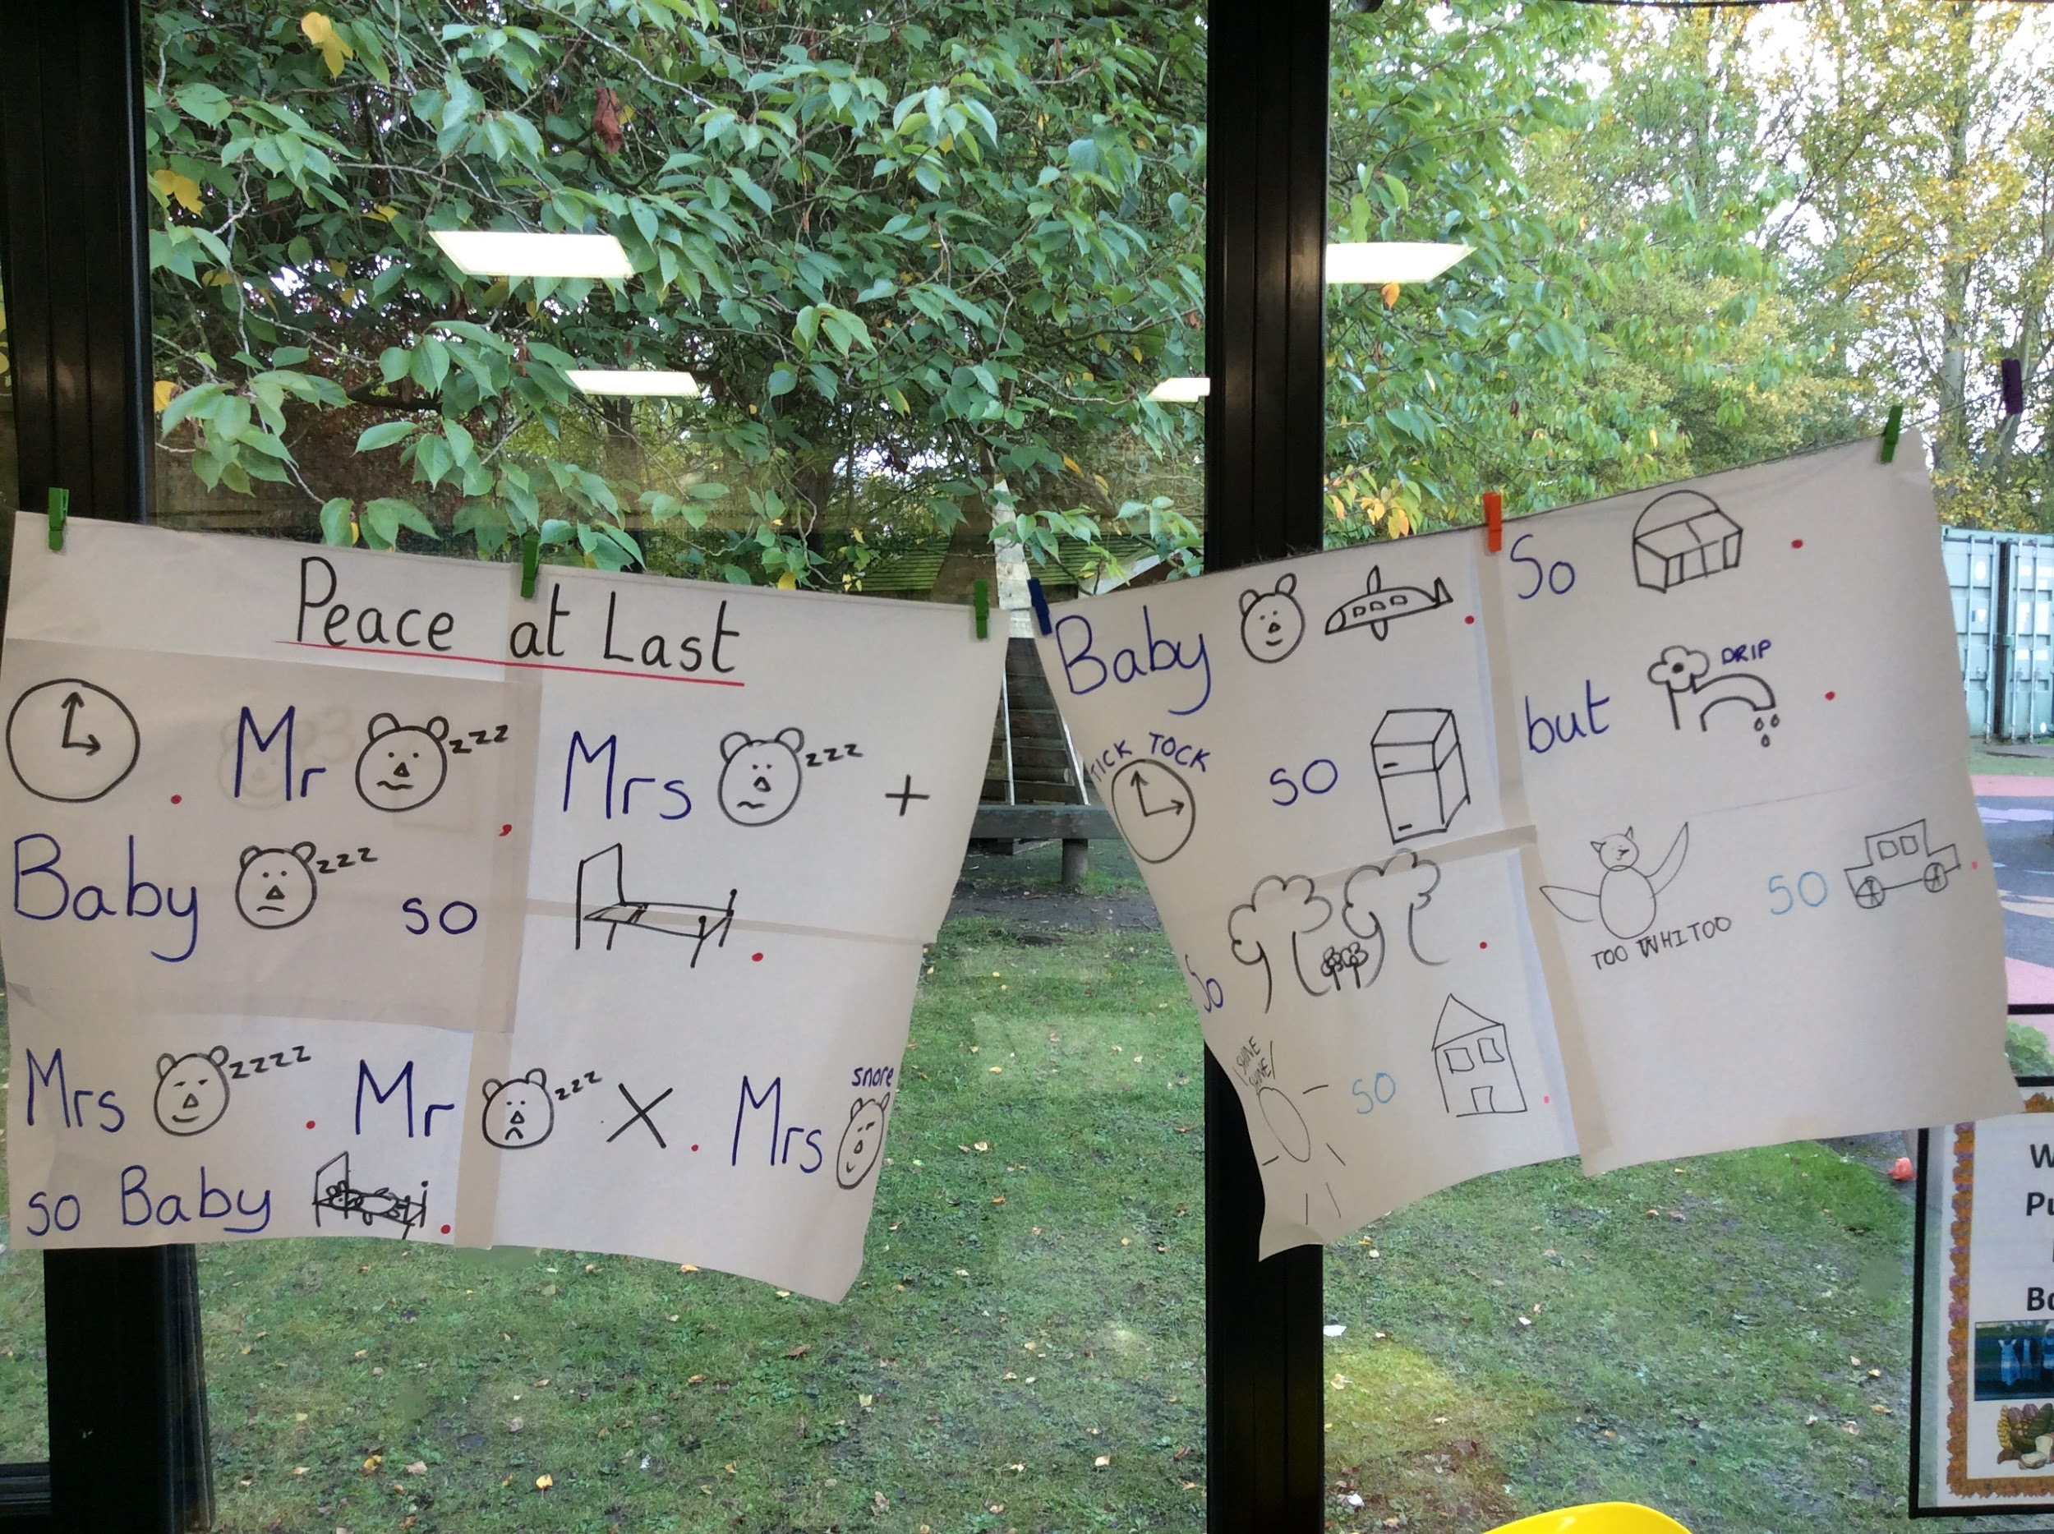

Castles in LKS2
This week, Class 4 children have been making castles in DT. They have thought about how to make it strong. We can’t wait to see the finished product!
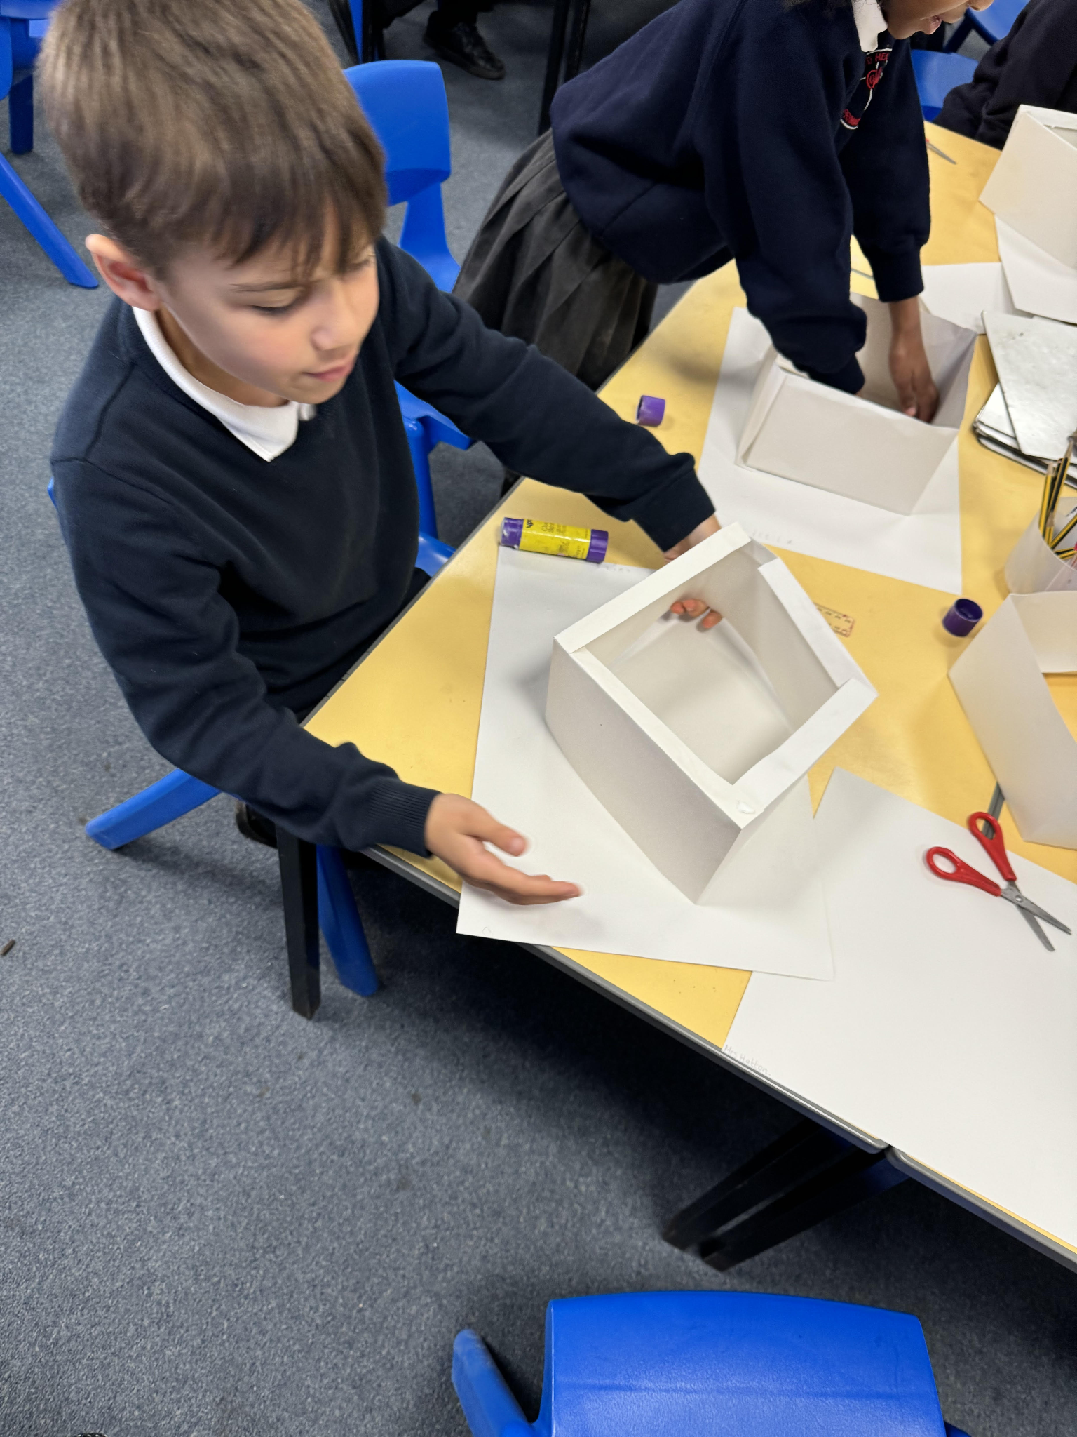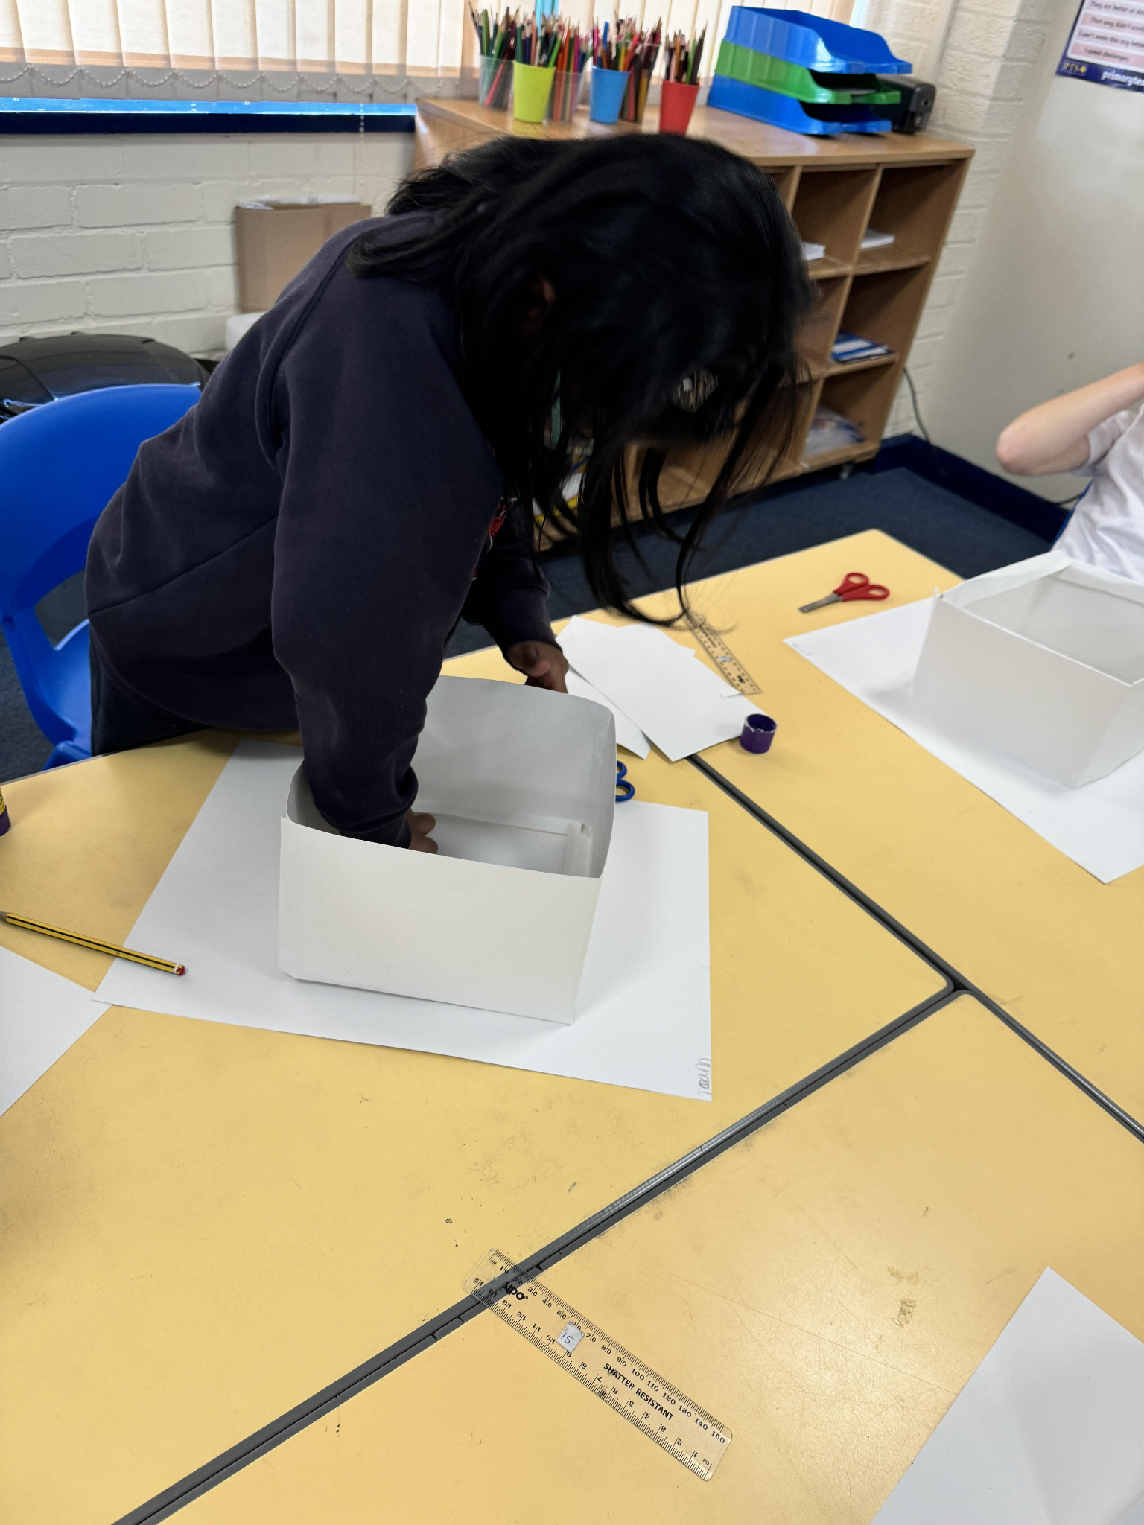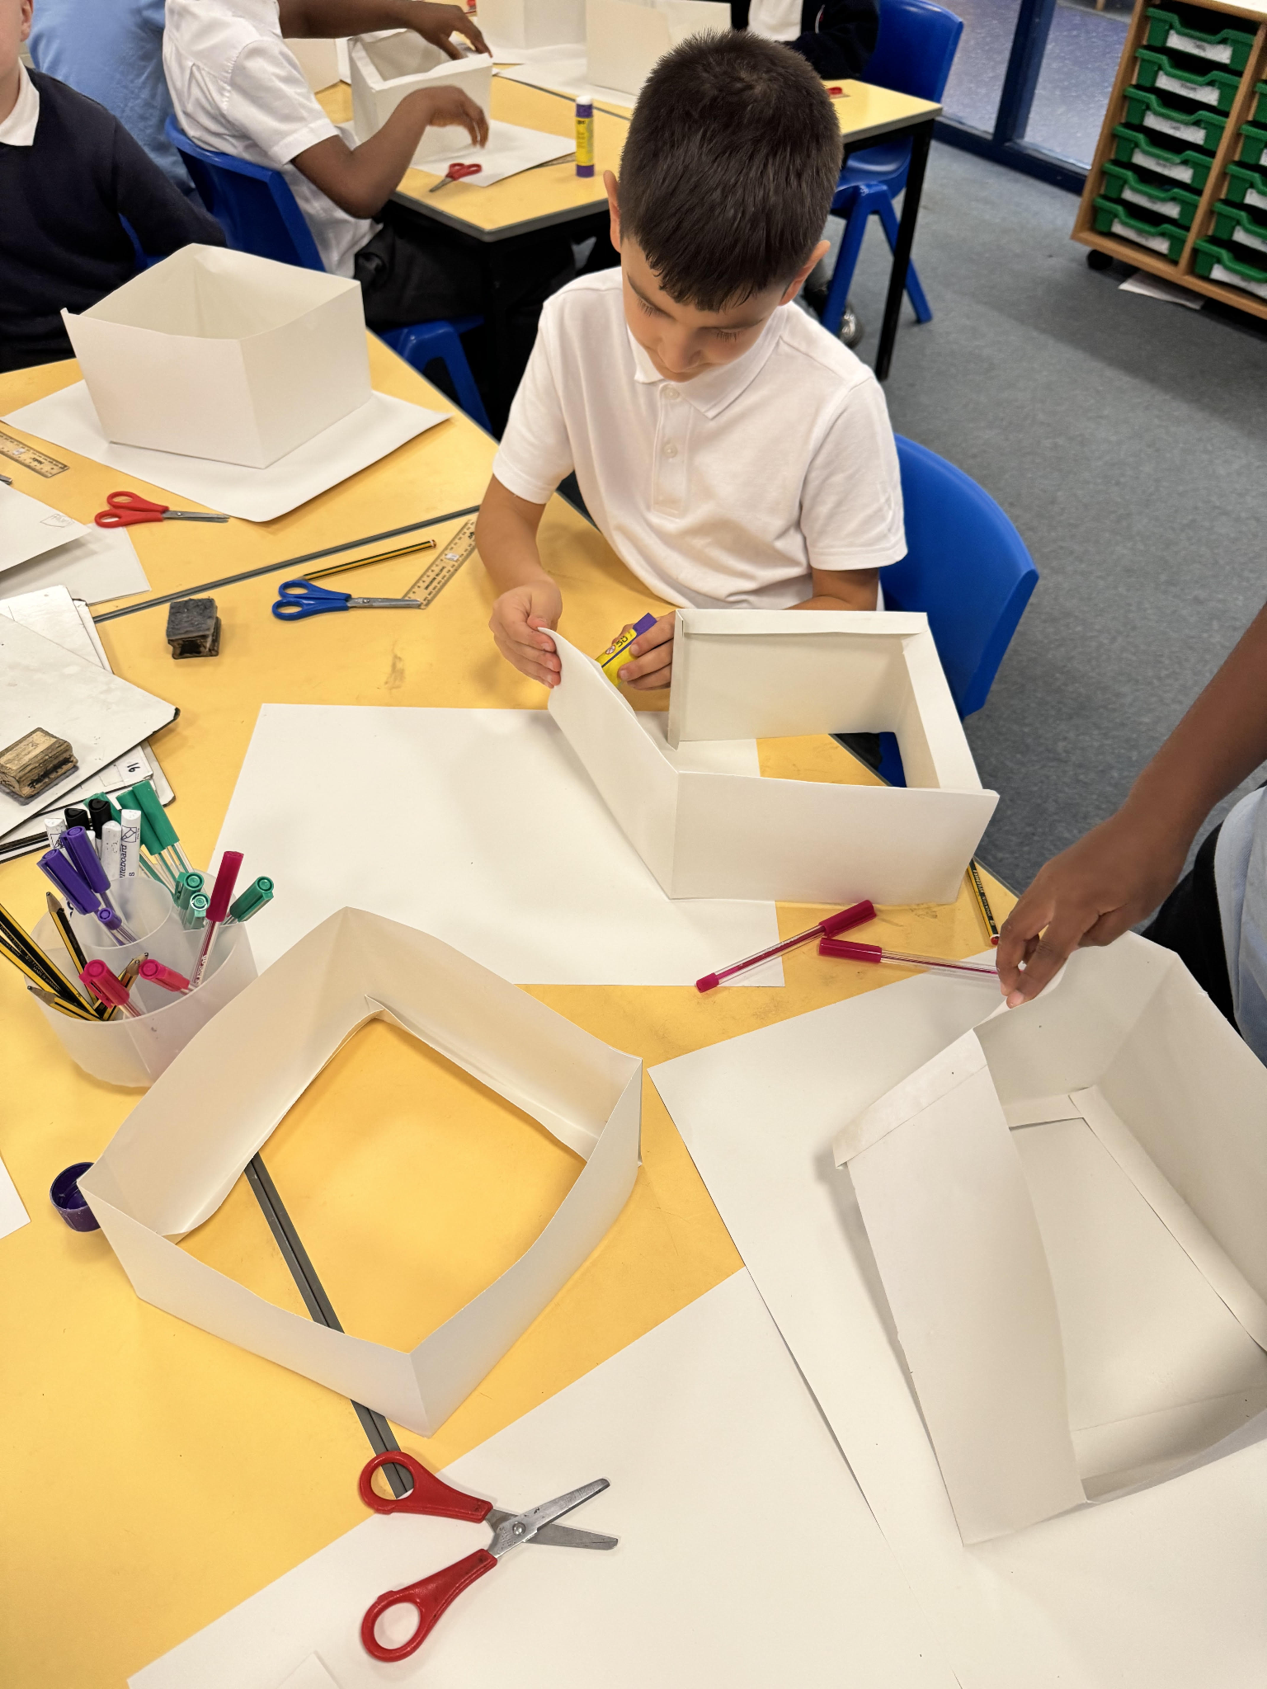

Nursery - When a Dragon Goes to School

This week in Nursery, the children have been learning the story When A Dragon Goes to School. They have been learning about good choices, helping and working together in school. They have enjoyed the small world play in the dragon themed tuff tray and painting dragons using water colour paint. The children have settled beautifully into Nursery this half term and we are all so proud of them!

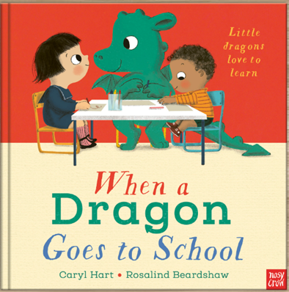
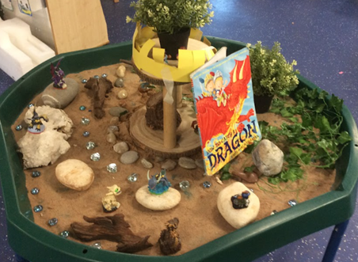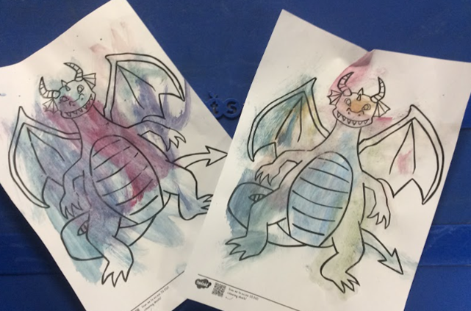

Asda Cash Pot for Schools
Running until November 30th
We are saving up to buy more play resources for lunchtimes - please help us by signing up to Asda’s Cash Pot for Schools initiative. Please click this reminder.

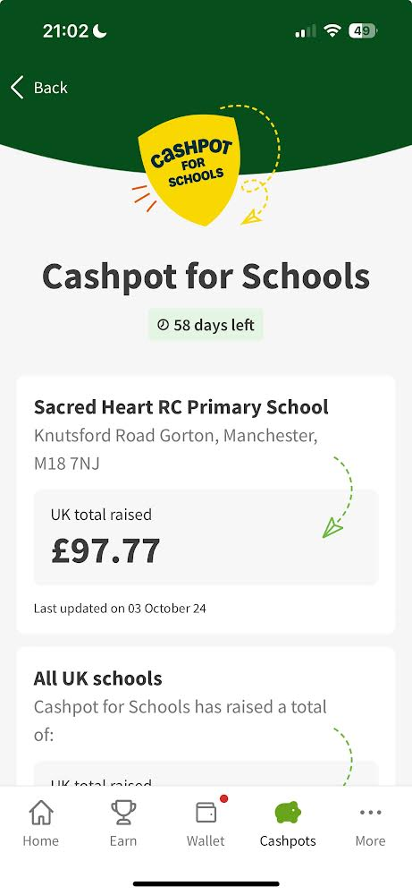

Screen Time and Smartphones
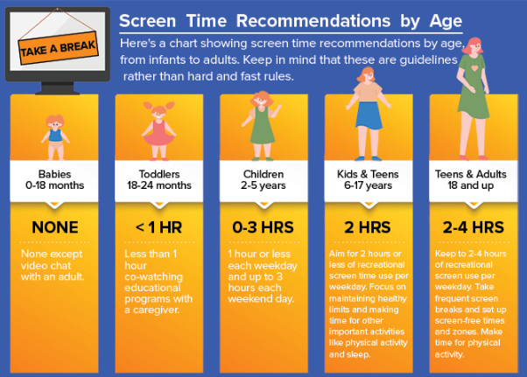

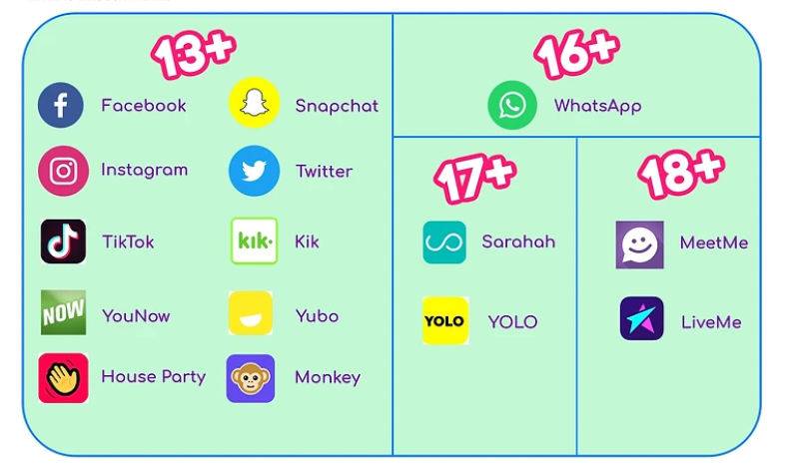

Please remember to check your child’s smartphone weekly in order to help to keep them safe online. Many games, including Roblox, also contain message functionality, including group messages, including messaging strangers.

🎓 TT ROCKSTARS 🎓
Well done to our TT Rockstars winners this week!
KS1 - Nanette⭐
LKS2 - Vincent💫
UKS2 - Denzel🌟

🏆 ATTENDANCE AWARDS 🏆

Class 9 with 99.7% attendance
Class 1 with 96.6% attendance
Reception 2 with 95.5% attendance

Well done to everyone who came to school on time every day this week!

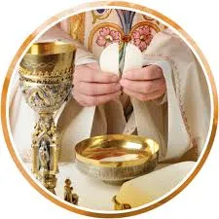

First Holy Communion
For children in Years 3, 4, 5 and 6
Details of this year’s programme and this year’s registration form are available on the parish website: https://www.sacredheartstfrancisgorton.co.uk/sacraments
The closing date for this year’s applications is 30th October 2024 and families will need to commit to weekly mass attendance as well as a number of Saturday meetings. The first meeting is November 2nd at 11am. The First Holy Communion Mass for children on the programme will take place in June 2025. Please speak to Father Kevin after Mass if you have any questions. Weekly Mass times can be found here.

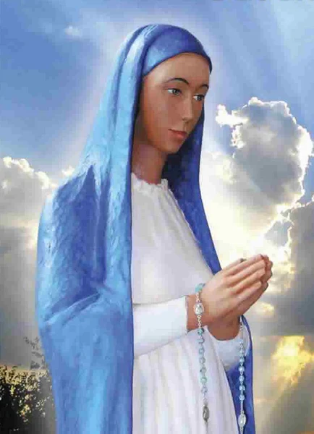
Our Lady, Queen of the Most Holy Rosary,
Pray for us.

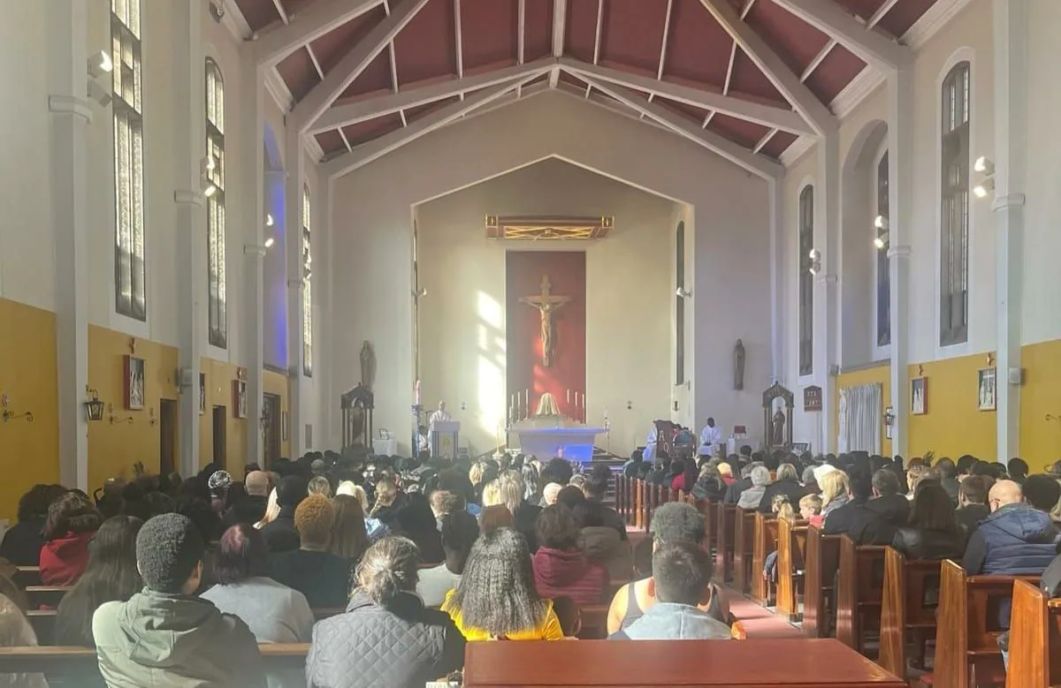
Click here for Mass times and other events in
the Parish of Sacred Heart and St Francis, Gorton
https://www.sacredheartstfrancisgorton.co.uk/mass-schedule

Don’t forget to check our X feed! @SHGorton

Sacred Heart RC Primary School
'Where Every Heart is Sacred’

