

Sacred Heart RC Primary School
'Where Every Heart is Sacred’
Week Commencing: 24th February 2025

Welcome Back!
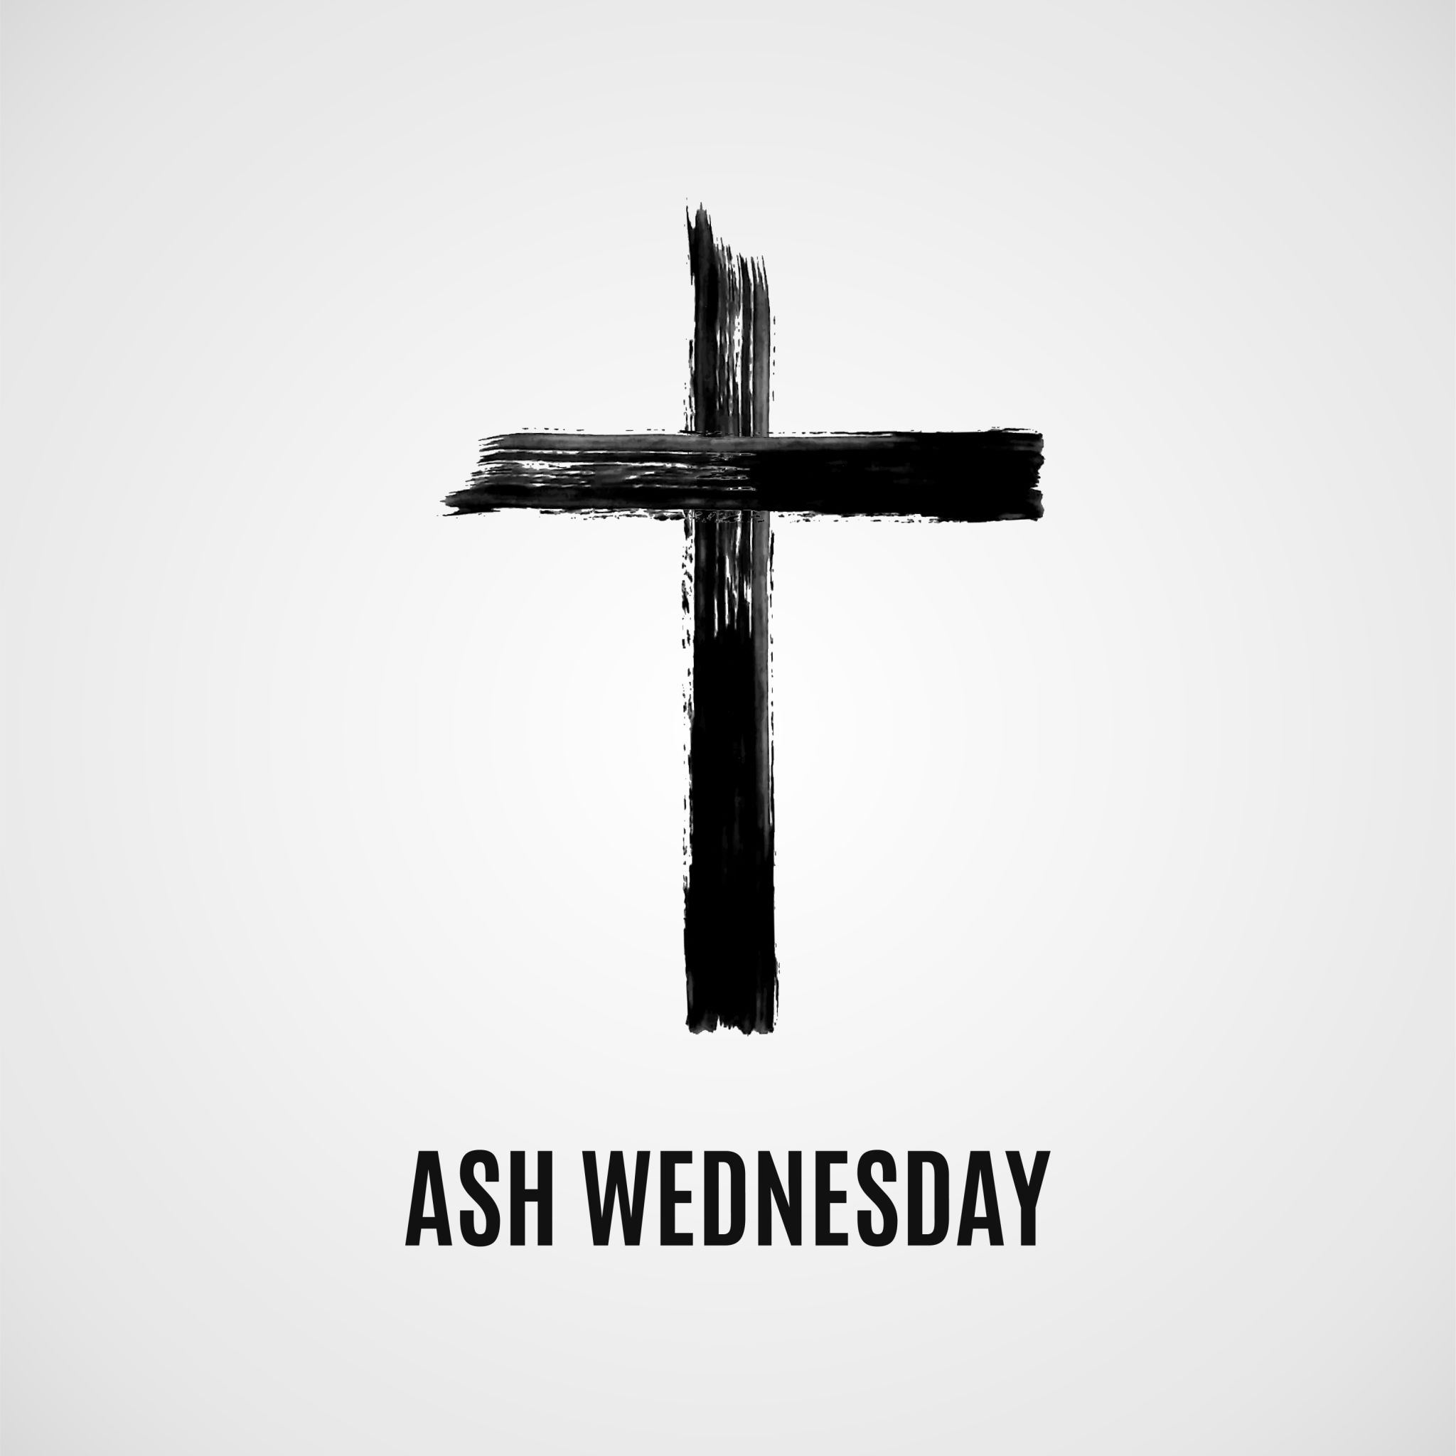
This year, Lent begins on Wednesday 5th March. This special day for Catholics is known as Ash Wednesday and children from KS1 and KS2 will visit Sacred Heart church to receive ‘the ashes’. These ashes, made from last year’s Palm Sunday palms, are a sign of repentance and a reminder of our journey with Jesus.
Receiving ashes is not a sacrament but a “sacramental,” helping us grow in faith. They are placed on our foreheads in the shape of a cross, with the words, “Remember that we are dust and unto dust we shall return,” or “Repent and believe in the Gospel.”
Keeping the ashes on throughout the day serves as a reminder of our commitment to Lent and our faith. Let us embrace this season with open hearts, prayer, and acts of kindness. Click here to access a short clip about Ash Wednesday that your children may enjoy.
THIS WEEK’S TOP STORIES
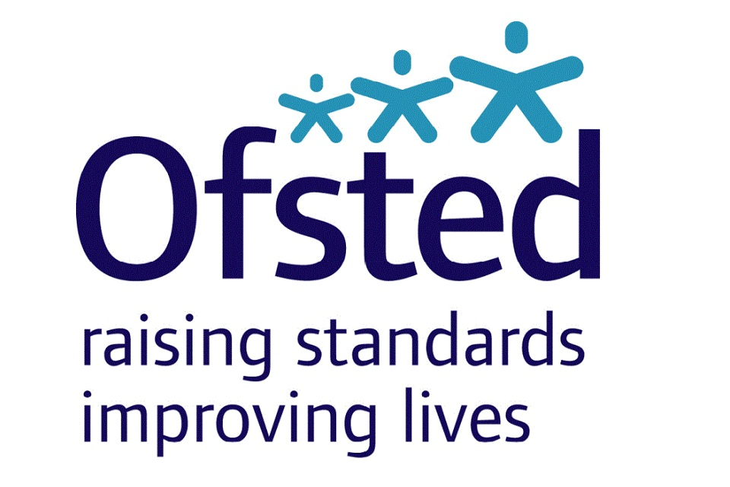
As you may remember, our friends from Ofsted visited school this week. This was a very positive experience and I wholeheartedly thank the inspection team for their rigour and compassion. I also thank every member of the staff team for working together so harmoniously and with such dedication so that our Ofsted friends could get a true picture of the very special nature of Sacred Heart RC Primary School. I thank those of you who were able to complete the Ofsted survey and those of you who were able to talk to the inspectors. And, last but absolutely not least, I thank your children who proved themselves to be the kind, caring, confident and charismatic individuals of whom we are so proud. I hope to be able to share our new Ofsted report with you before we break up for Easter. Please watch this space.

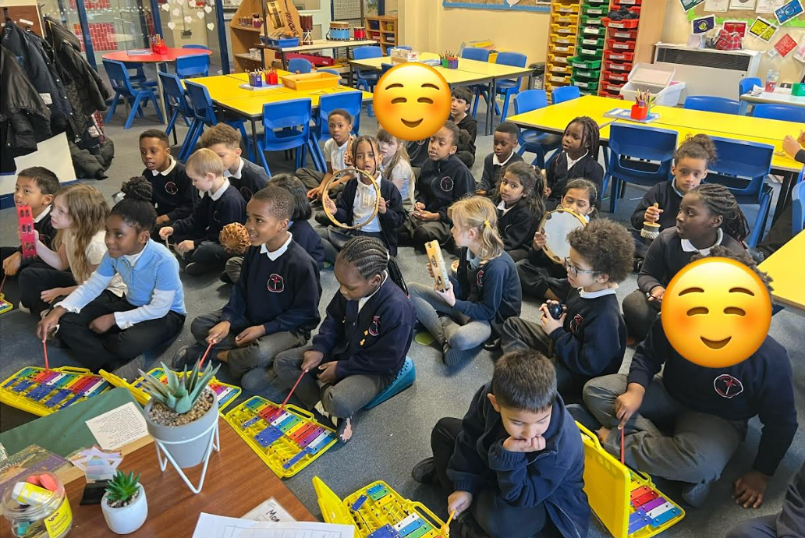

Class 2
In Class 2, we have been beginning to understand why Catholics say the Our Father Prayer. We have looked at lots of examples of the prayer being said/sung all around the world. We were inspired to create our own version of the prayer using musical instruments.
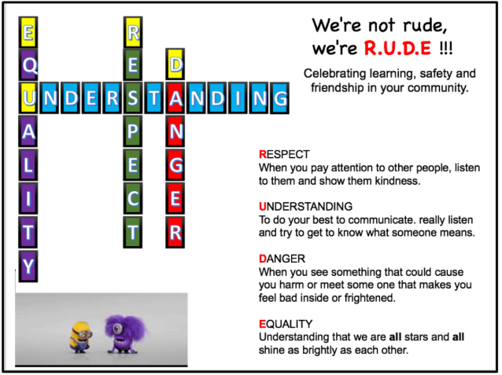

R.U.D.E Assembly
UKS2
Years 5 and 6 were visited by Dean Coady OBE, a former Soldier and Police Officer, to discuss street-based dangers and how we can recognise and respond to potentially harmful situations.

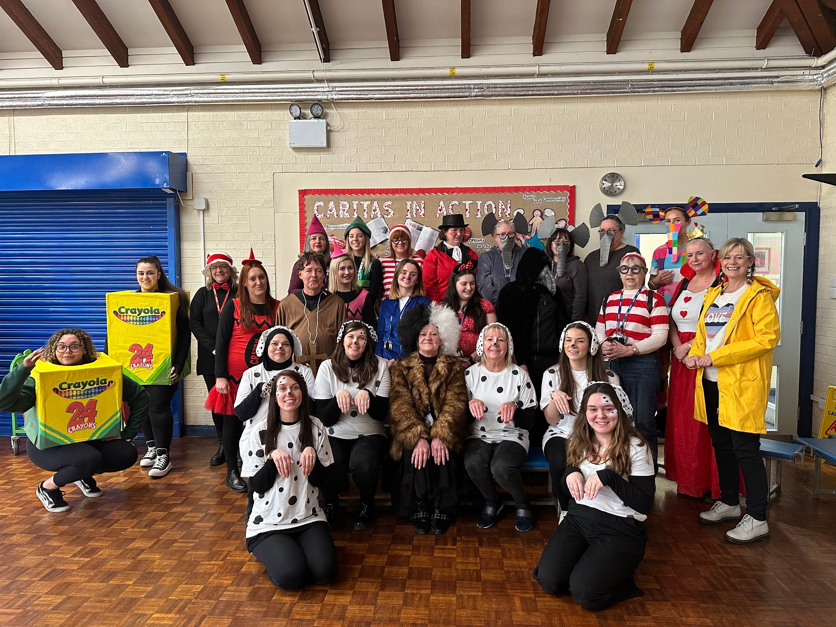

World Book Day 2025
Thursday 6th March 2025
World Book Day is coming up next week, so please start thinking about which book character you would like to come to school dressed as! Your character can be chosen from any fiction or non-fiction book, or even a biography/autobiography! Please remember that there are plenty of book characters who dress in pyjamas or normal clothes too!
Class 1 up to Class 5 will also be visiting Gorton Library on this day! 

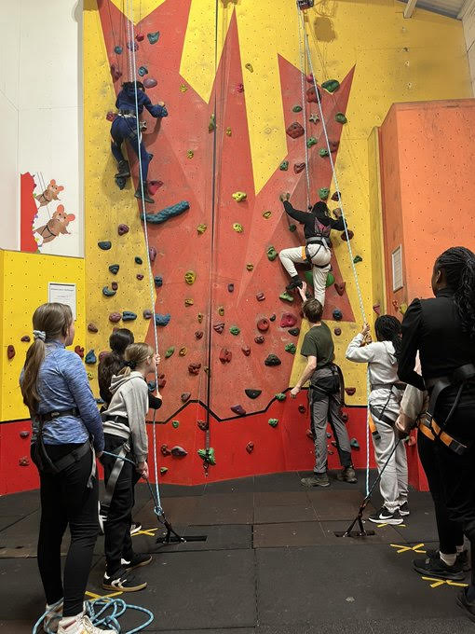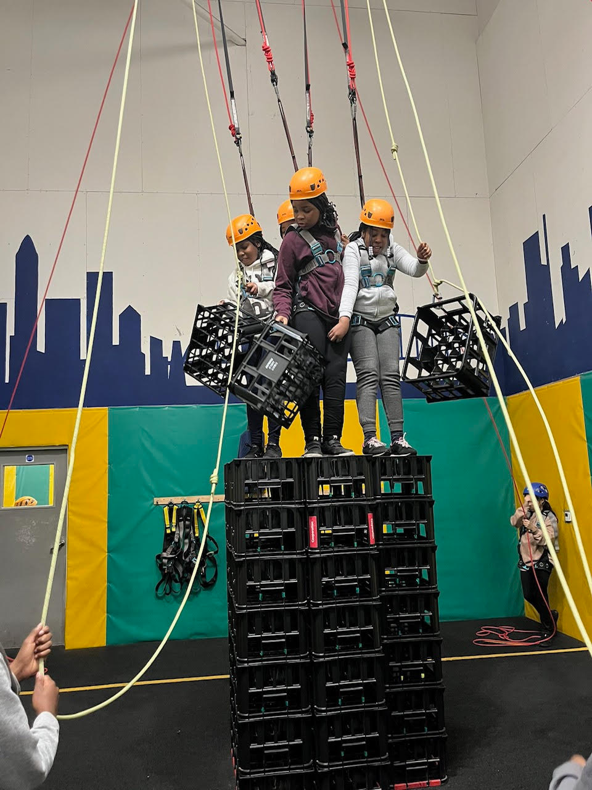
Robinwood residential
24th-26th February 2025
Our residential trip to Robinwood for our Year 6 children took place this week- the children (and staff!) took part in 15 activities including; canoeing, caving, ziplining and archery to name just a few! We had a fantastic time and the children were fabulous representatives of Sacred Heart.
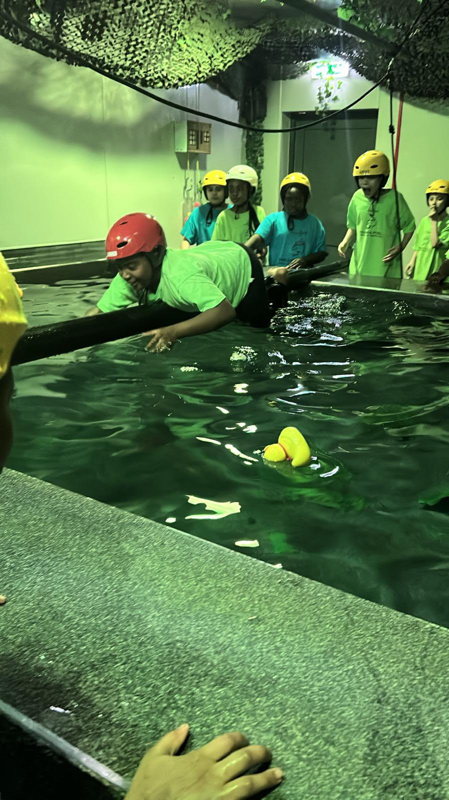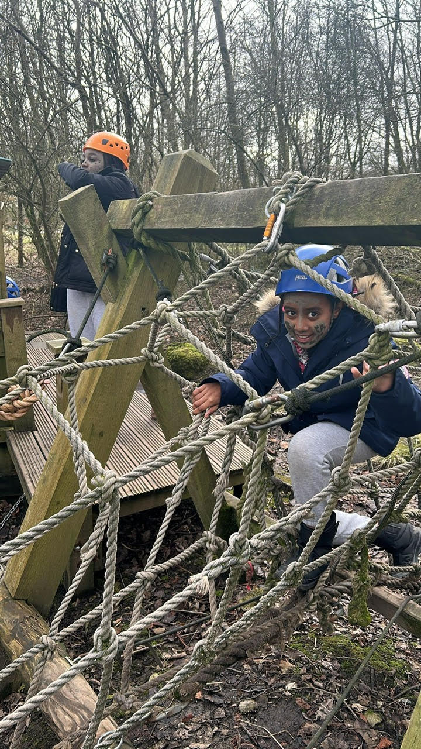
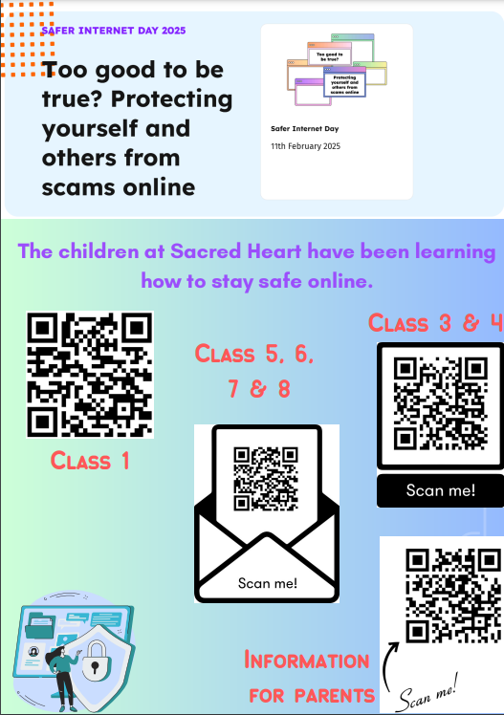

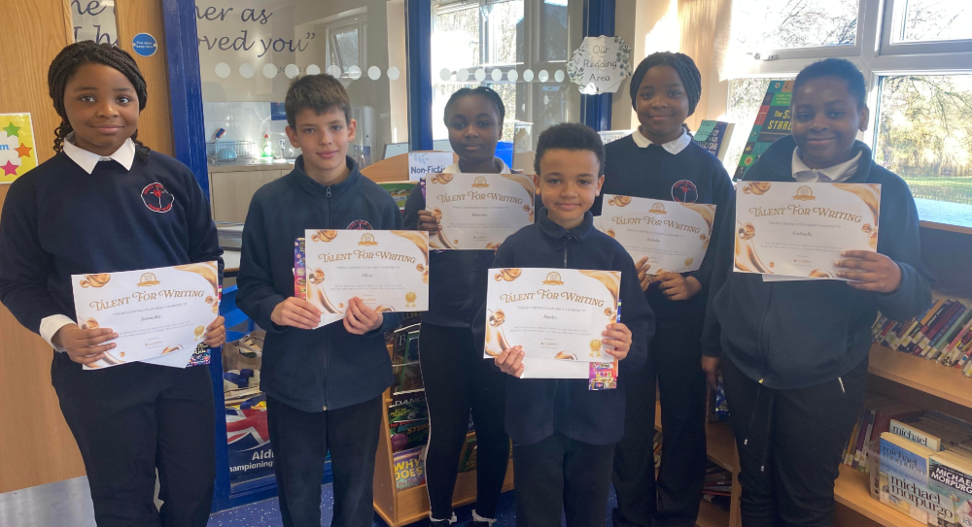

Talent for writing
Well done Year 6!
Our Year 6 children had the opportunity to enter a poetry competition this term, and we have had six children submit entries. Stay tuned to find out the winner…

📚 SUPERSTAR READERS 📚
LKS2 - Class 6 who read 233,981 words this week! 💫
UKS2 - Class 9 who read 273,106 words this week! 🌟

🎓 TT ROCKSTARS 🎓
Well done to our TT Rockstars winners this week!
LKS2 - Victoria Class 4💫
UKS2 - Paryjen Class 7🌟

🏆 ATTENDANCE AWARDS 🏆
Class 9 with 99.2% attendance
Class 2 with 97.9% attendance
Reception 1 with 94.3% attendance

Well done to everyone who came to school on time every day this week!

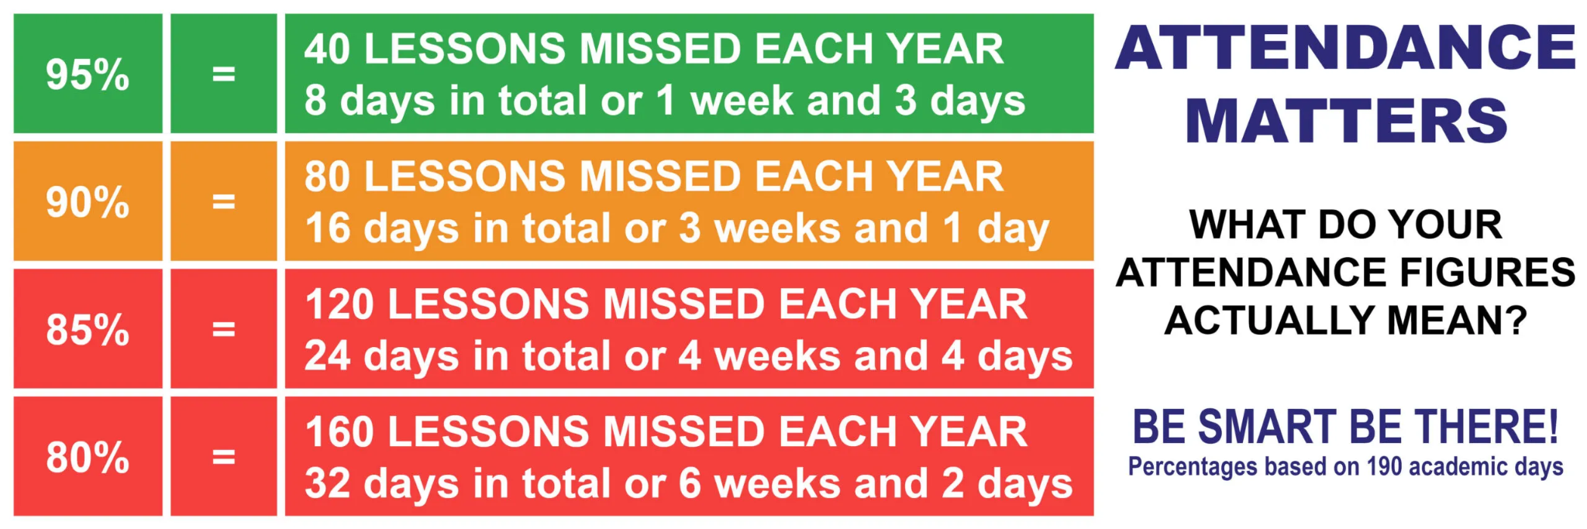
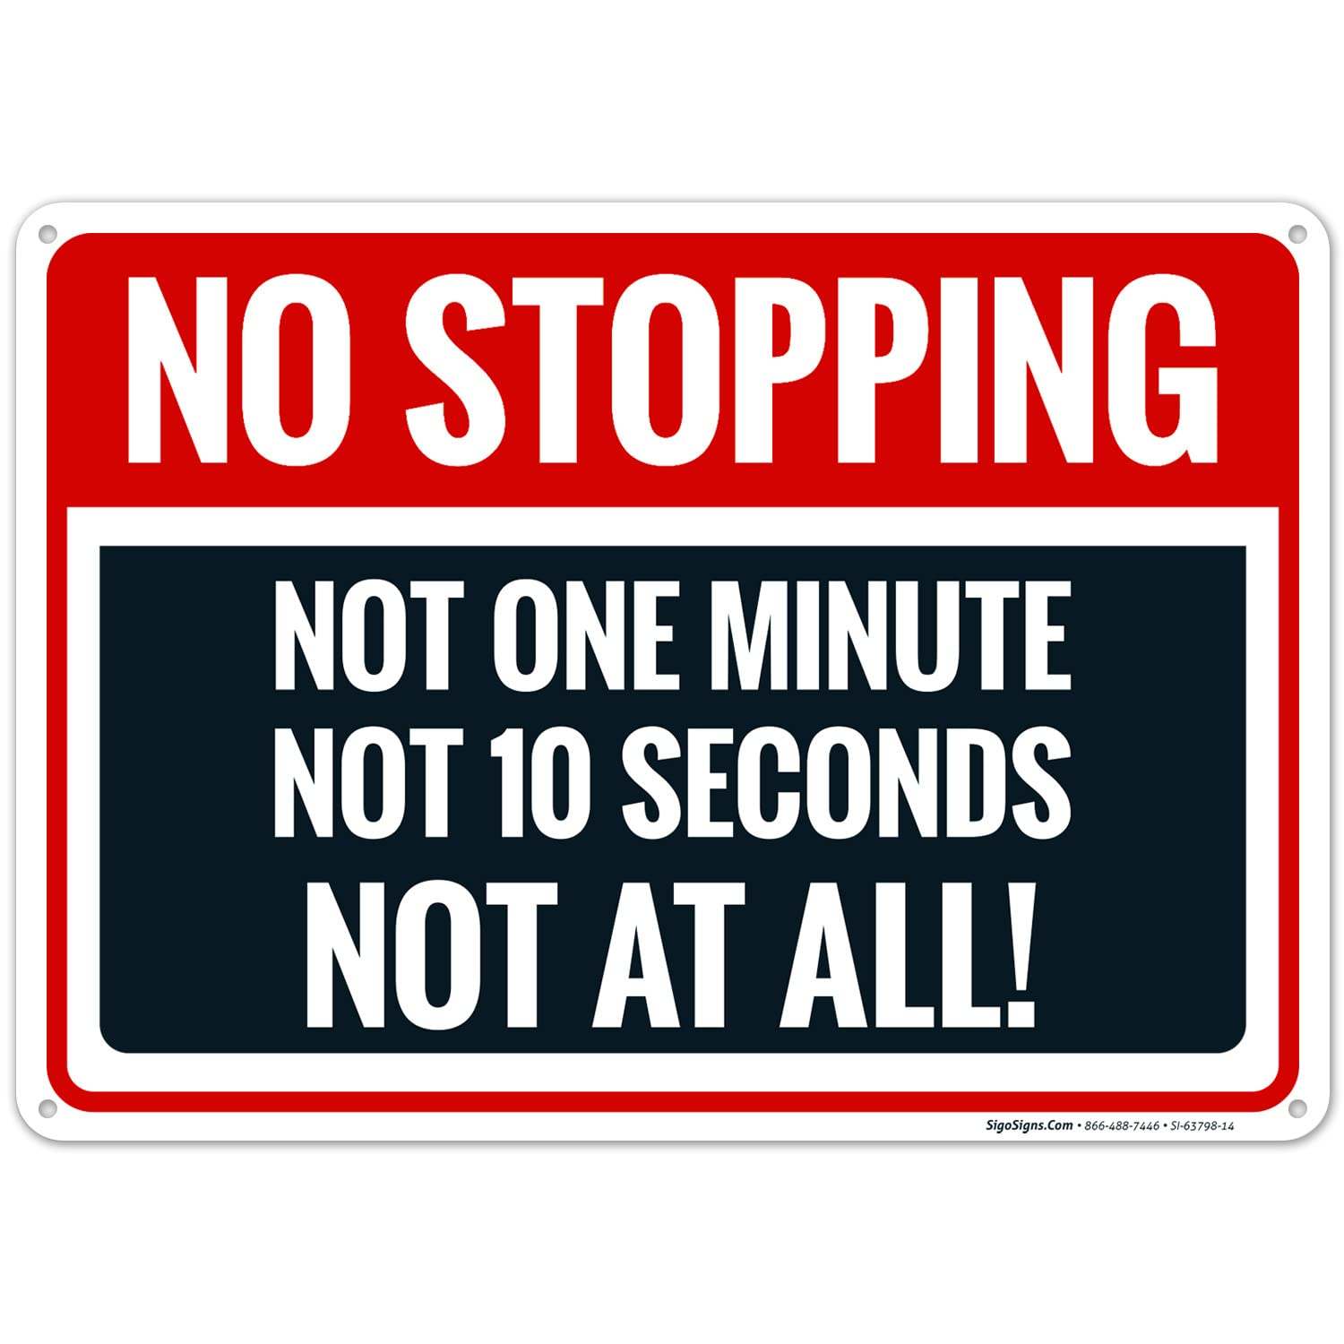Keep our children safe!
PLEASE NO PARKING OR STOPPING ON KNUTSFORD ROAD!
Unless you have a blue disabled badge, please do not park or even stop on Knutsford Road opposite the school or outside the school between the hours of 8am and 5pm as clearly marked on the yellow signs on both sides of the road.
In accordance with the Highway Code, please do not park within 10 metres of the junctions on Knutsford Road. I need to be clear that my staff are here to teach and care for your children; they are not traffic wardens or police officers. Please be respectful of other road users and our neighbours in order to reinforce the message we share daily with our children: Every Heart is Sacred.

Please report any dangerous or illegal parking here:
If you are experiencing difficulties navigating the roads near our school due to dangerous or illegal parking, you can report your concerns here.
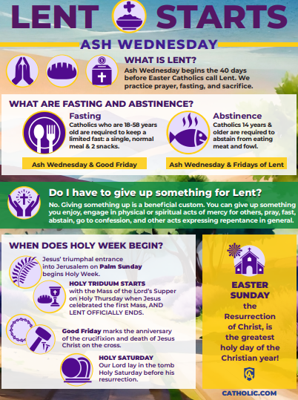
Click here for Mass times and other events in
the Parish of Sacred Heart and St Francis, Gorton
https://www.sacredheartstfrancisgorton.co.uk/mass-schedule

Sacred Heart RC Primary School
'Where Every Heart is Sacred’

