

Sacred Heart RC Primary School
'Where Every Heart is Sacred’
Week Commencing: 10th March 2025

St Patrick’s Day - March 17th
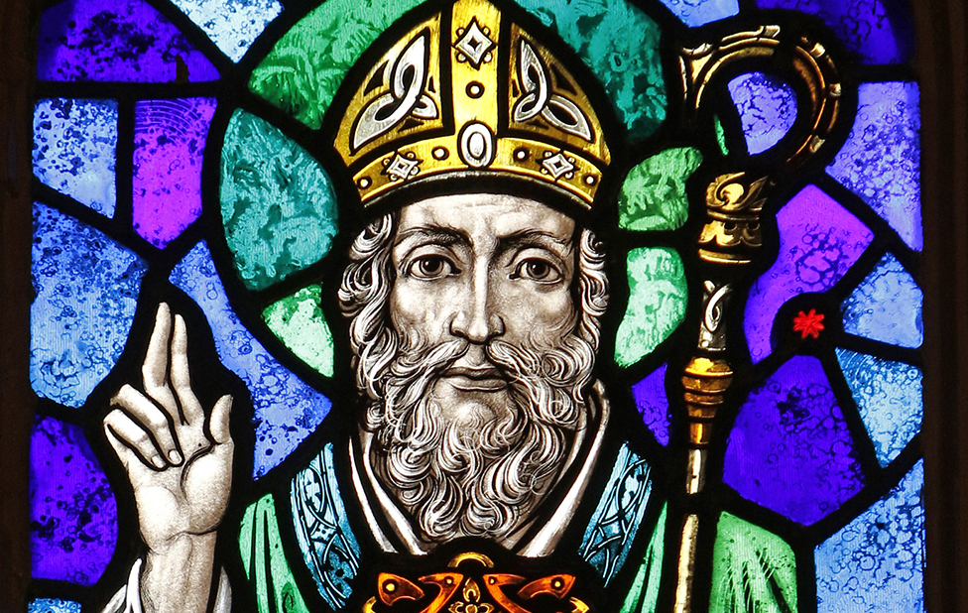
Saint Patrick: Bringing the Light of Christ to Ireland
Saint Patrick was born in Britain in the early 400s. At sixteen, he was kidnapped by Irish raiders and enslaved for six years before escaping home. Later, he became a bishop and felt called to return to Ireland to share the Christian faith.
One of his most famous moments happened on Holy Saturday. Patrick lit an Easter fire, even though Irish law forbade any flame before the druids' festival fire. The High King was furious, but Patrick bravely stood firm, proclaiming his faith. The king’s warriors were so impressed that one converted on the spot.
Patrick spent 29 years spreading Christianity in Ireland, baptising over 100,000 people. His courage and faith ensured that the light of Christ would never be extinguished from the land. Today, we remember him as the patron saint of Ireland, celebrating his legacy every year on 17th March.

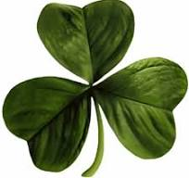
THIS WEEK’S TOP STORIES

St Patrick’s Day
Monday 17th March
All children in the school are invited to add a touch of green to their school uniforms on Monday to celebrate St. Patrick’s Day. For example, children may wish to wear green hair accessories, green socks, trainers or polo-shirts underneath their school sweaters.

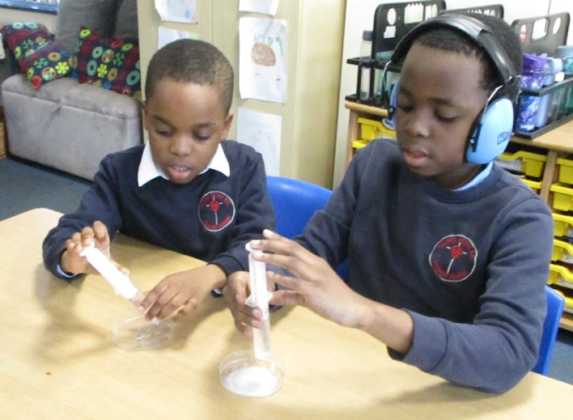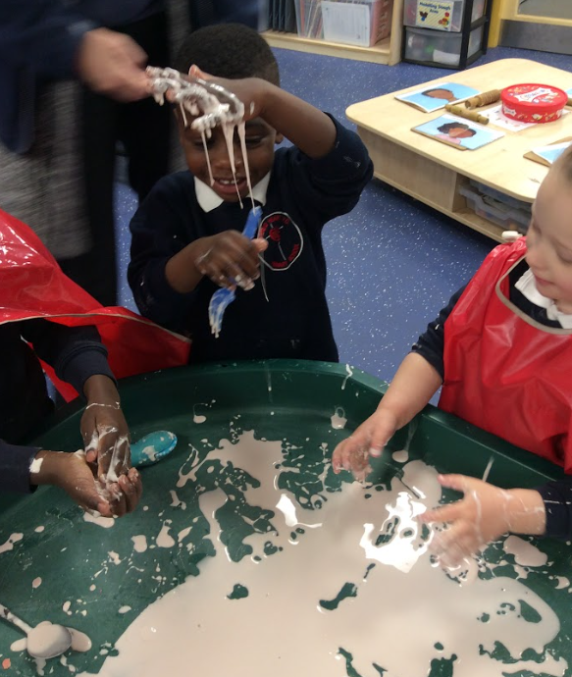

Science Week!
Thank you to everyone who worked so scientifically at Sacred Heart this week!
The theme for British Science Week 2025 has been 'adapt and change'. Pupils in Lower Key Stage Two have been growing gummy bears using a salt solution whilst Key Stage One have made their own blow rockets and changed some of the rocket features to make it travel further. Pupils in Early Years have been rolling eggs down a ramp and have placed obstacles in the way to change the direction in which the egg will roll. Upper Key Stage Two have been continuing to work scientifically during their 'Forces' unit by testing out parachutes and experimenting with water resistance over the half-term.

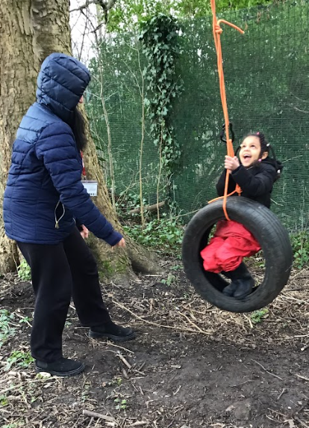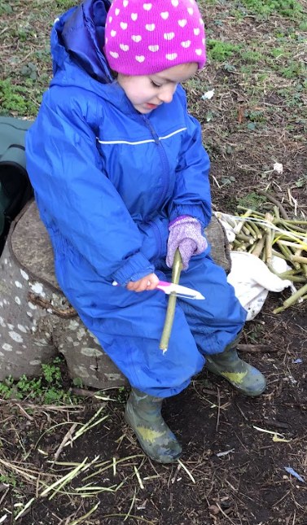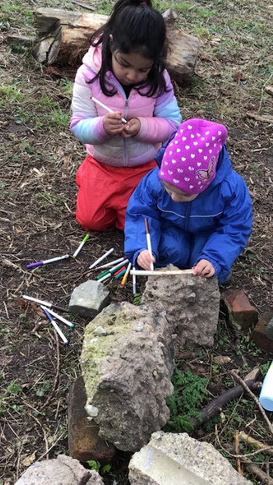

Forest School
Reception 1
Reception had a great time at Forest School with Martha this week. We used tools for the first time, whittling wood to make magic wands! It was great fun!
We look forward to welcoming our mummies into school in a couple of weeks for a Mother's Day Spa Treat. Please sign up with your child's class teacher!

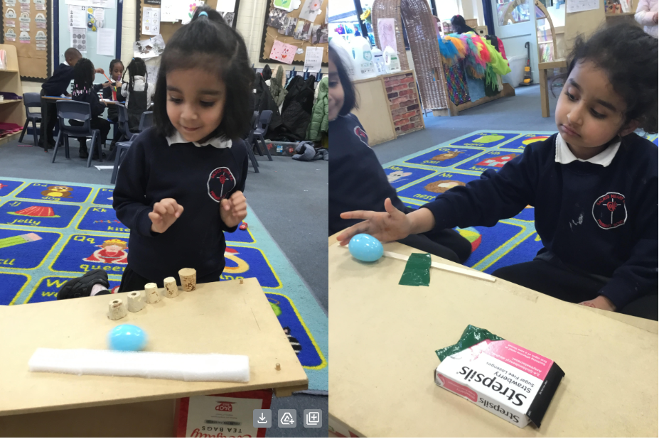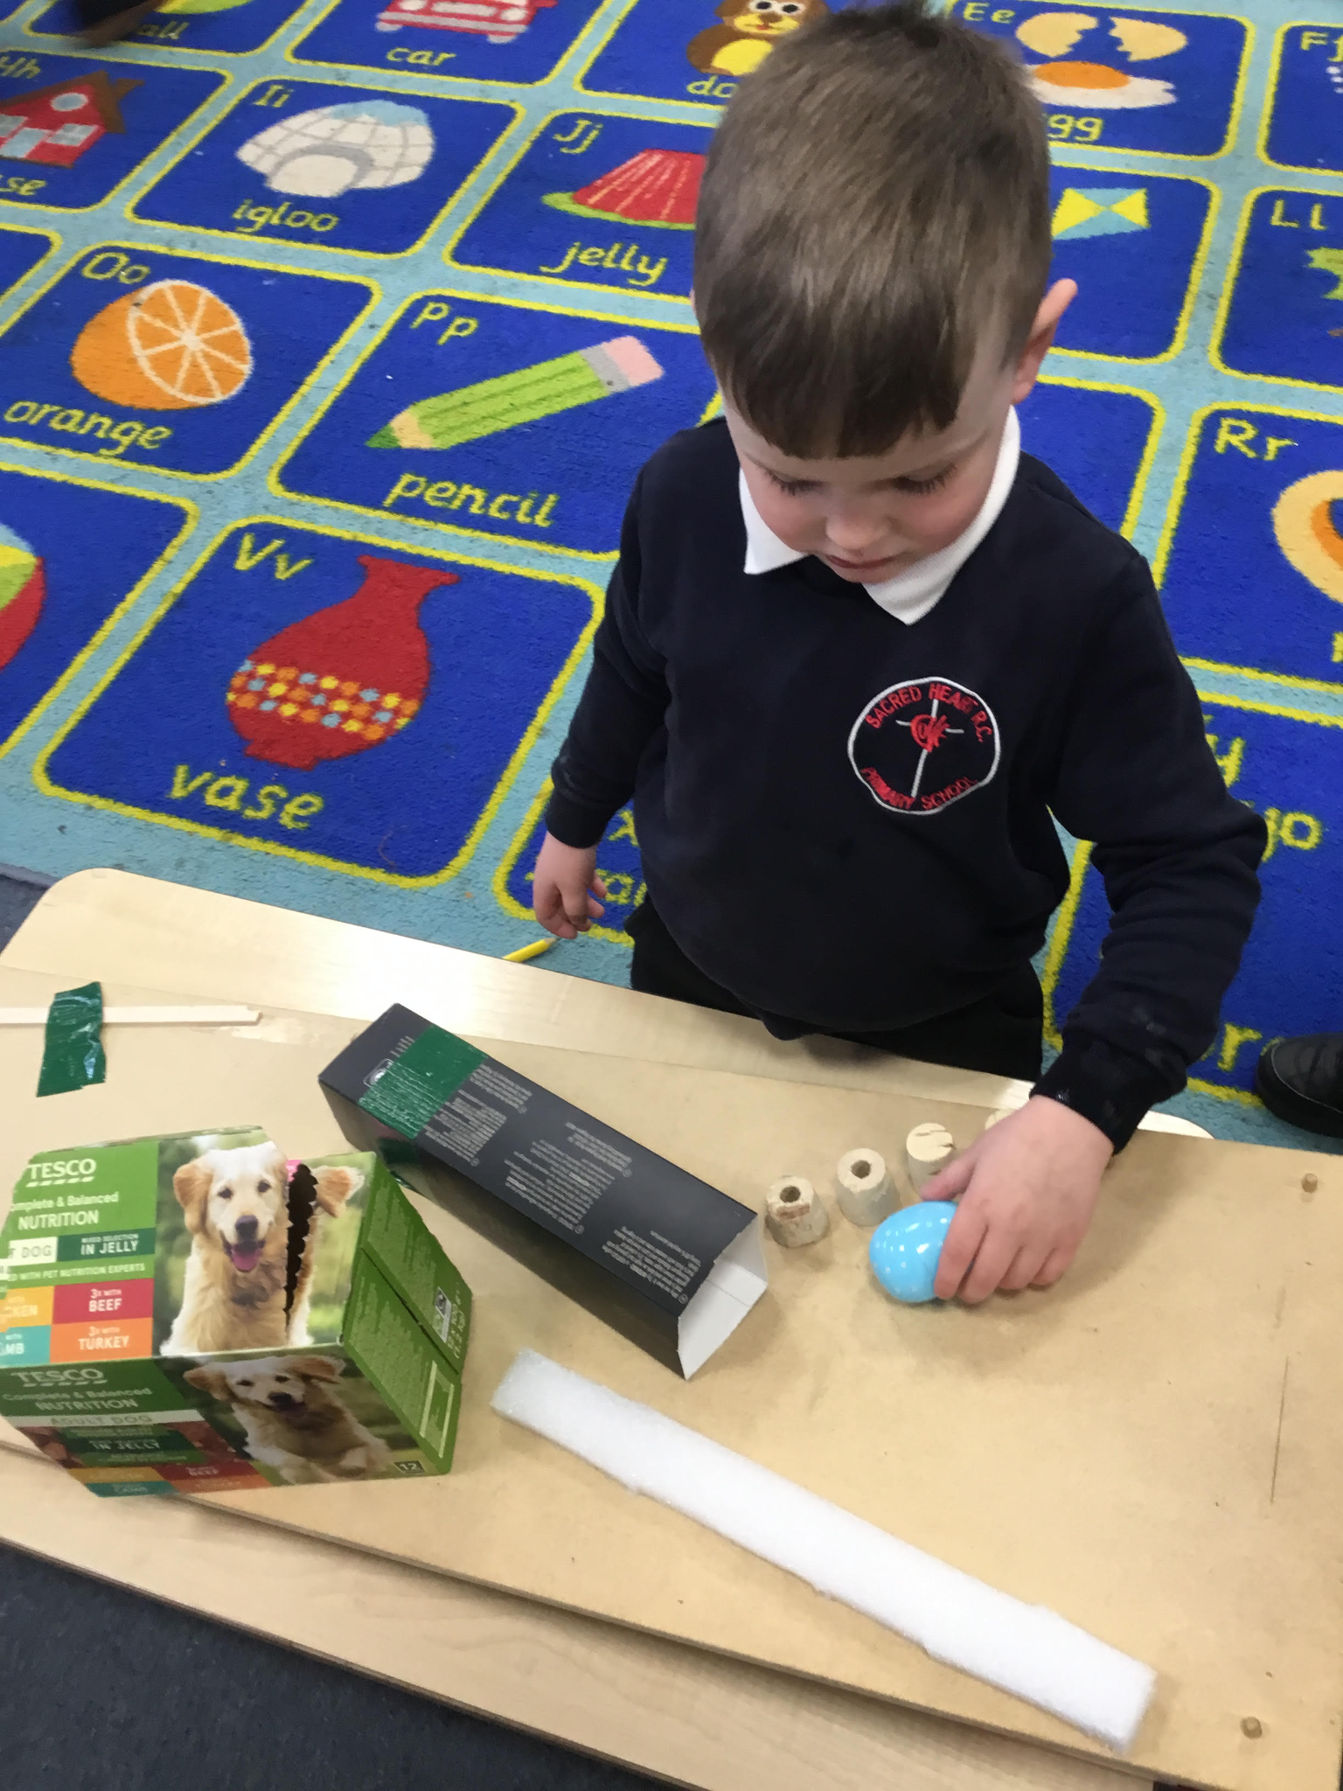

Experimentation
Reception 2
As part of Science Week, Reception has really enjoyed carrying out our own experiment! We explored how to change the ramp to make the egg roll down in different ways and how we can add obstacles to help us control the egg!

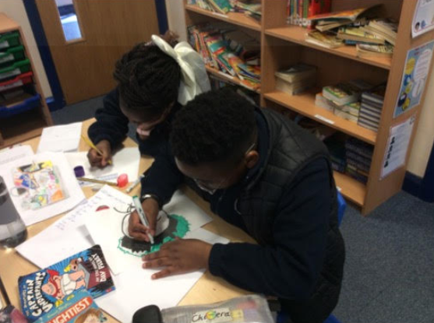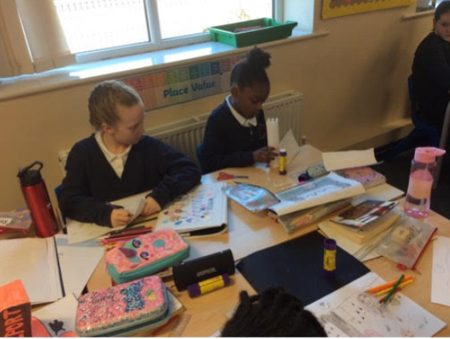
Design & Technology
Class 7
This week, the children in Class 7 have begun constructing their 3D models as part of our DT topic- making a steady-hand game. The children will then use a series circuit to complete their game, later this half term.

Twitter/X
Please follow us!
For more regular updates, please follow our school twitter page @SHGorton

Neurodiversity Celebration Week
March 17th-23rd

We are excited to share the schedule of events with you for Neurodiversity Celebration Week 2025!

This year there are more panel discussions than ever before, with inspirational speakers from a range of backgrounds and professions. The discussions will all be focussing on key neurodiversity topics, and aim to educate while inspiring conversations about neurodiversity.

All events are free of charge and open to all. Please do sign up to as many events as you like and share with your networks, so we can all join together in celebrating different minds!

https://www.neurodiversityweek.com/events

📚 SUPERSTAR READERS 📚
LKS2 - Class 5 who read 190,613 words this week! 💫
UKS2 - Class 9 who read 434,905 words this week! 🌟

🎓 TT ROCKSTARS 🎓
Well done to our TT Rockstars winners this week!
LKS2 - Victoria💫
UKS2 - Prayjen🌟

🏆 ATTENDANCE AWARDS 🏆
Class 6 with 98.9% attendance
Class 3 with 98.3% attendance
Reception 2 with 97.3% attendance

Well done to everyone who came to school on time every day this week!

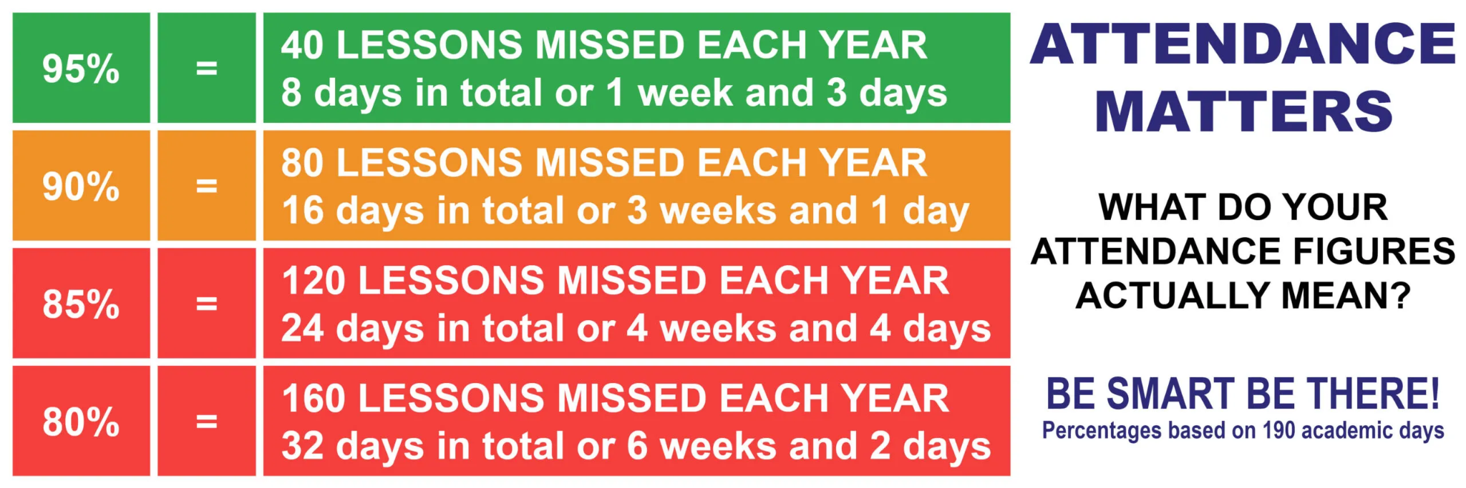

Keep our children safe!
PLEASE NO PARKING OR STOPPING ON KNUTSFORD ROAD!
Unless you have a blue disabled badge, please do not park or even stop on Knutsford Road opposite the school or outside the school between the hours of 8am and 5pm as clearly marked on the yellow signs on both sides of the road.
In accordance with the Highway Code, please do not park within 10 metres of the junctions on Knutsford Road. There was an extremely dangerous situation this week involving two large buses and many cars. I need to be clear that my staff are here to teach and care for your children; they are not traffic wardens or police officers. Please be respectful of other road users in order to reinforce the message we share daily with our children: Every Heart is Sacred.
Please report any dangerous or illegal parking here:
If you are experiencing difficulties navigating the roads near our school due to dangerous or illegal parking, you can report your concerns here.

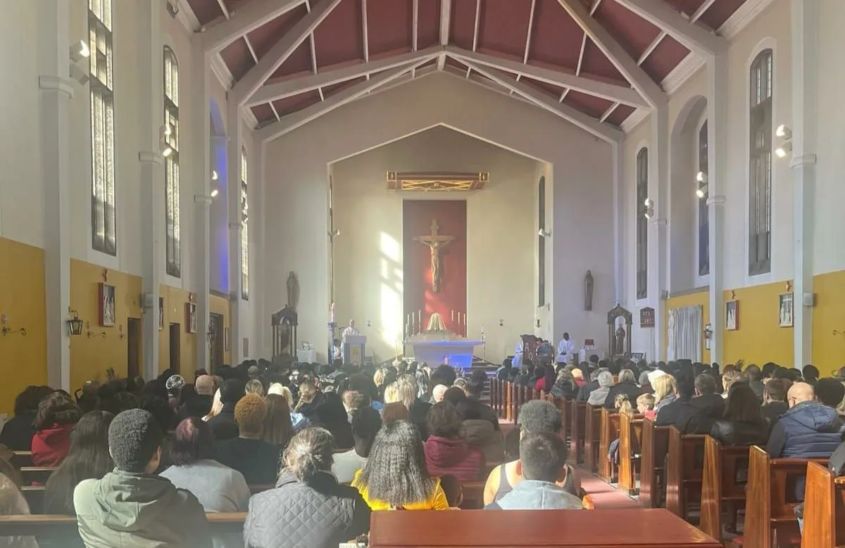
Click here for Mass times and other events in
the Parish of Sacred Heart and St Francis, Gorton

https://www.sacredheartstfrancisgorton.co.uk/mass-schedule

Sacred Heart RC Primary School
'Where Every Heart is Sacred’

