

Sacred Heart RC Primary School

**'Where Every Heart is Sacred’**

Week Commencing: 31st March 2025

horizontal line

# Palm Sunday and the Betrayal of Christ



Thank you to Classes 8 and 2 for deepening our understanding of the events of Palm Sunday and the heartbreaking nature of the betrayal of Christ by Judas Iscariot.

Palm Sunday, the Sunday before Easter, marks Jesus’ triumphant entry into Jerusalem, where people welcomed Him with palm branches and joyful praise. It begins Holy Week, the most important time in our Church’s year, leading to His sacrifice and resurrection.

Each year, Palm Sunday reminds us of how people first celebrated Jesus but later turned away from Him. It encourages us to reflect on our own faith—do we always stand by Jesus in our daily lives? When we enter Holy Week on Sunday 13th April, let us renew our commitment to follow Him with love and faithfulness.

horizontal line

**THIS WEEK’S TOP STORIES**

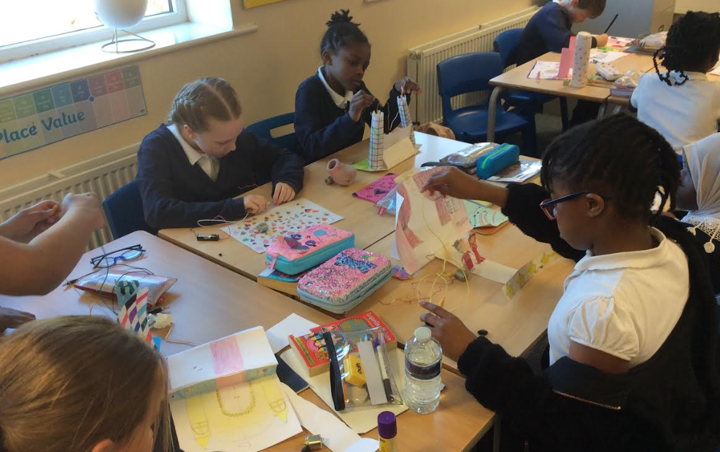

## Design & Technology

Class 7

Class 7 have been working extra hard this week, learning all about electricity and creating their own steady hand game!

Ask Class 7 if you could have a turn on one of their games.

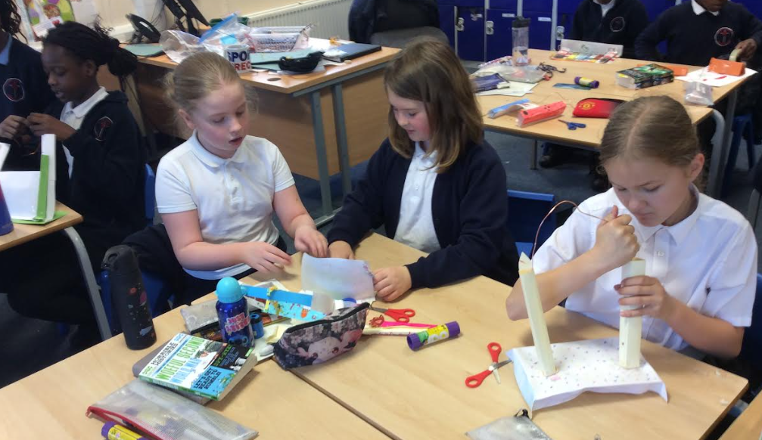

## 

## Wonderful Writing

Class 8

Class 8 have been learning all the features of a balanced argument and have now written a wonderfully independent balanced argument. Last week, the children worked hard to design and create mother's Day cards and gifts to show their appreciation for their mums.

Ask Class 8 to give you their opinion on the ‘Boy in the Striped Pyjamas’.



## Lenten Fundraising

Last day of term - Friday 11th April

Friday 11th April will be a non-uniform day for pupils with a suggested donation of £1 for Cafod, the Catholic Agency for Overseas Development.

Please note that school finishes at 2pm on Friday 11th April. Thank you.

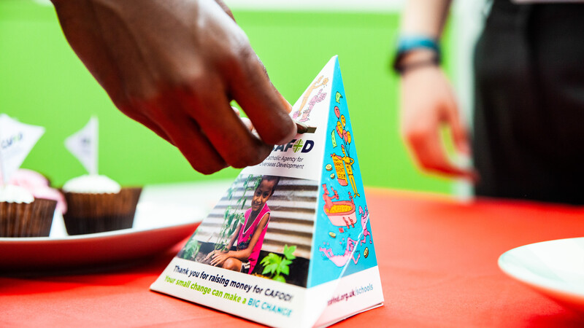

**📚 SUPERSTAR READERS 📚**

LKS2 - Class 6 who read 168,195 words this week! *💫*

UKS2 - Class 9 who read 524,588 words this week! *🌟*

**🎓 TT ROCKSTARS 🎓**

**Well done to our TT Rockstars winners this week!**

LKS2 - Ikem, Class 4 💫

UKS2 - Denzel, Class 7🌟

**🏆 ATTENDANCE AWARDS 🏆**

**Class 7 with 100% attendance!**

**Class 6 with 98.7% attendance**

**Class 3 with 97% attendance**

**Class 7 will have an ‘own clothes day’ after Easter as a treat for having 100% attendance!**

**Well done to everyone who came to school on time every day this week!**

Experiencing difficulties?

Parking, litter or fly-tipping issues?

If you are experiencing difficulties navigating the roads near our school due to dangerous or illegal parking, you can report your concerns [here](https://manchester.portal.uk.empro.verintcloudservices.com/site/myaccount/request/report_illegal_parking).

If you are experiencing issues with litter or fly-tipping, you can report your concerns [here](https://www.manchester.gov.uk/environment).

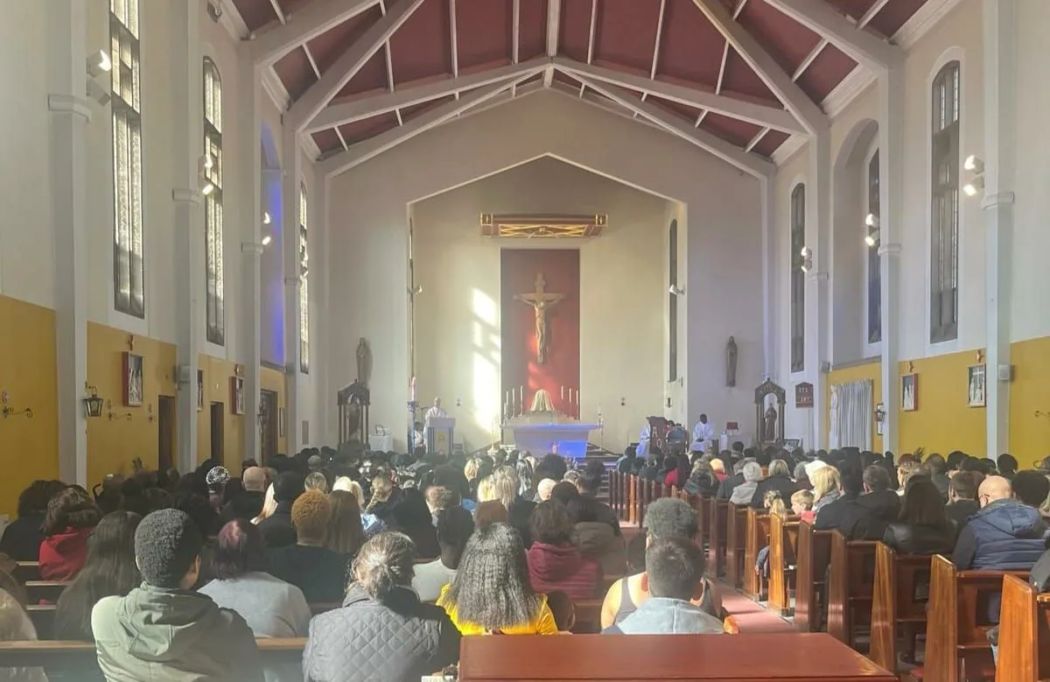

Click here for Mass times and other events in

the Parish of Sacred Heart and St Francis, Gorton

<https://www.sacredheartstfrancisgorton.co.uk/mass-schedule>

horizontal line

Sacred Heart RC Primary School

**'Where Every Heart is Sacred’**

