

Sacred Heart RC Primary School
'Where Every Heart is Sacred’
Week Commencing: 7th April 2025

The Last Supper and The Passion of Christ
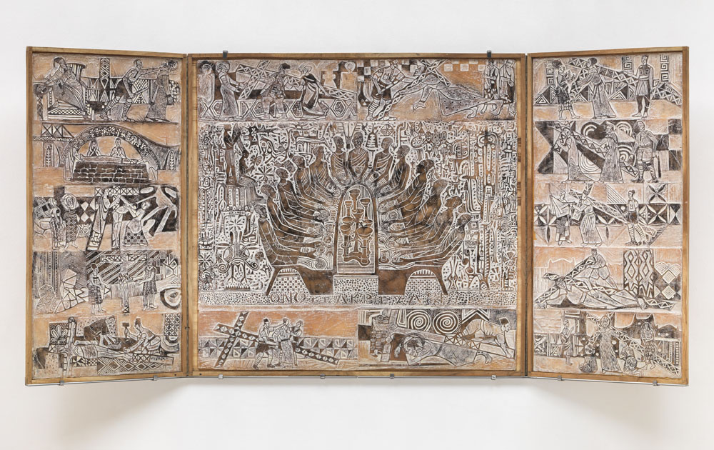
Bruce Onobrakpeya: The Last Supper, 1981, resin, wood, metal, and paint, Tate Modern, London.
The week between Palm Sunday and Easter Sunday, Holy Week, is the most sacred time of year. During this special time, we enter into the passion of Christ — his crucifixion, death and resurrection — through liturgical celebration and personal conversion. While the season of Lent is a very important time in the Church, it is helpful to remember that our Lenten practices (prayer, fasting and almsgiving) are meant as preparation for the three days of the Triduum.
Click here for Mass times in the Parish of Sacred Heart and St Francis this Easter:
https://www.sacredheartstfrancisgorton.co.uk/mass-schedule
THIS WEEK’S TOP STORIES



Forty Days and Forty Nights
Thank you
Thank you to all of those who have helped us on our Lenten Journey this year, especially Classes 1 and 7 who helped us to deepen our understanding of the Last Supper and Christ’s Passion during their poignant assemblies this week, and to the children who read wonderfully in Mass on Tuesday.
May I take this opportunity to wish you a happy and holy final week of Lent and a joyous Easter.
School reopens on Tuesday April 22nd at 8:45am, for another term filled with love, laughter and learning.
Until we meet again, may the Lord bless and keep you and those you love.

Easter
Nursery
The children in Nursery have been learning more about the Easter story this week. They have learned that Jesus died on Good Friday and rose again on Easter Sunday. They have enjoyed making Easter cards for their families. They have also enjoyed exploring the egg tuff tray in provision, opening, closing, counting and sorting the eggs.
Some other things they have enjoyed this week in provision are:
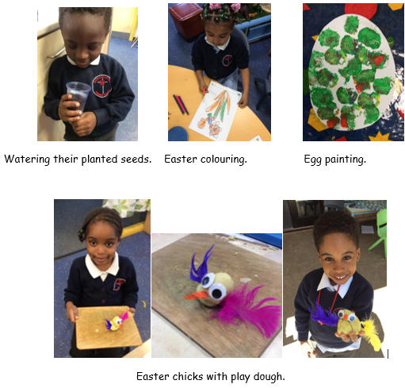

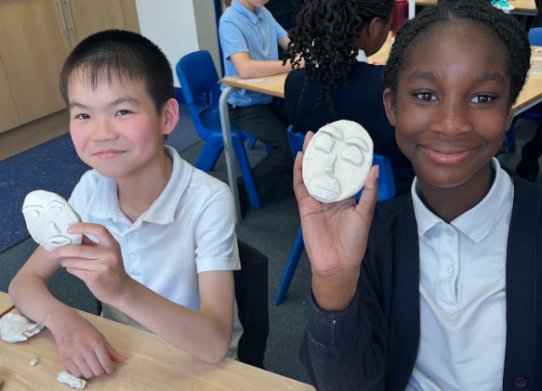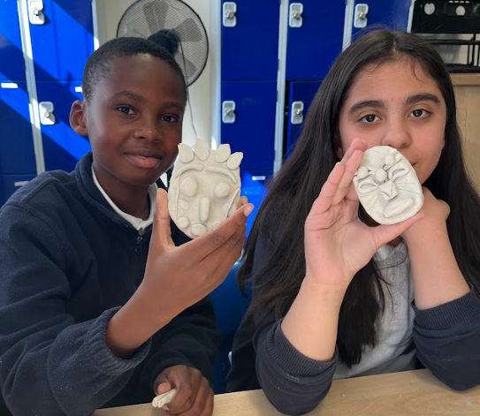Art
Class 9
C9 have been busy with Mrs Katsihtis in their Art lessons this half term.
The children made clay masks in the style of James Dupree.

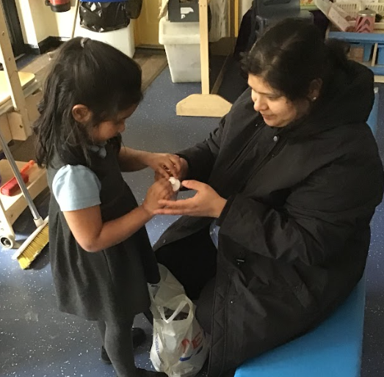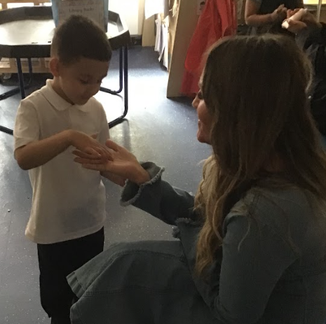
The Sacred Heart Spa!
Reception
Reception 1 and 2 invited their mums into school to celebrate Mother’s Day recently, to be pampered in our spa! Our massage therapists were great at making sure their mums’ hands felt brand new!

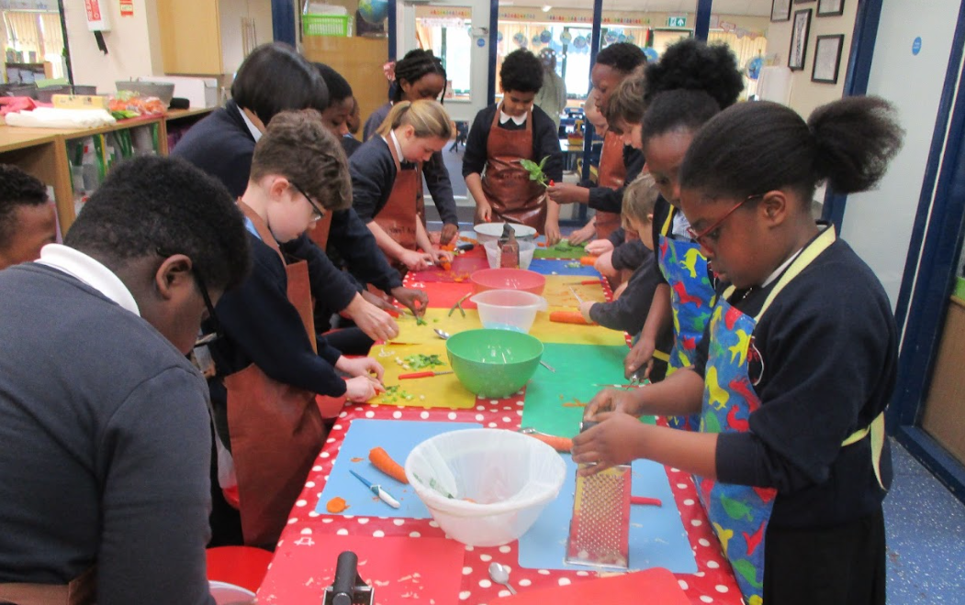Cooking
Class 6
Class 6 chopped and prepared seasonal vegetables to add to their puff pastry and tomato puree base. The children chose to add beetroot, cheese rocket, carrot and basil to their tarts. The children learnt new skills such as how to use a vegetable peeler, chop vegetables finely and identify which flavours compliment each other.
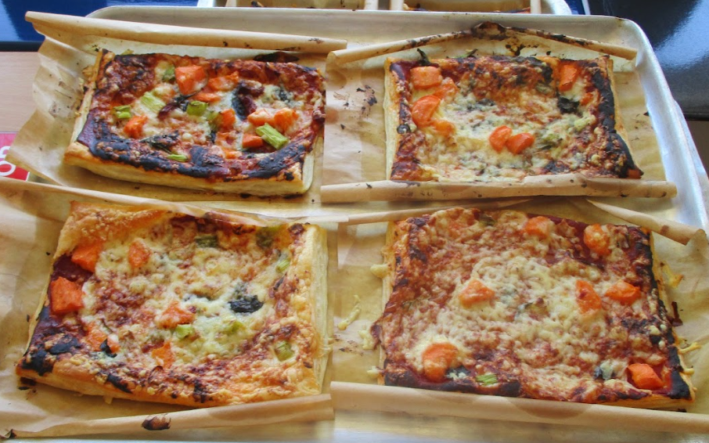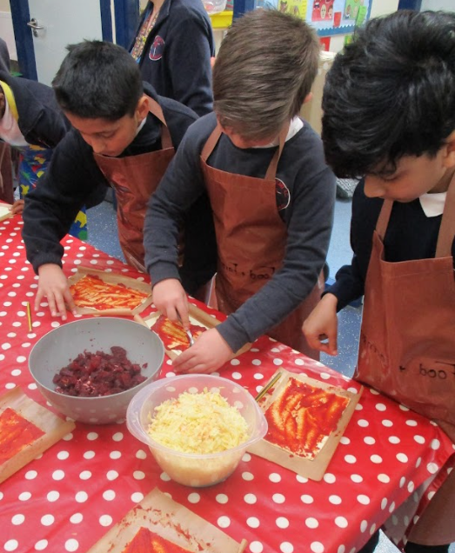

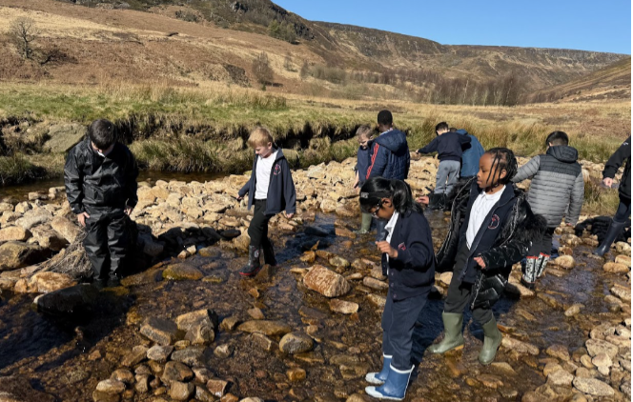Crowden River
Classes 4 & 6
Class 4 and 6 have visited Crowden to conduct a river study. The day was filled with lots of fun including river wading and using our geographical knowledge to measure the width and depth of the river. We also spotted and named some mini creatures that live in the river!
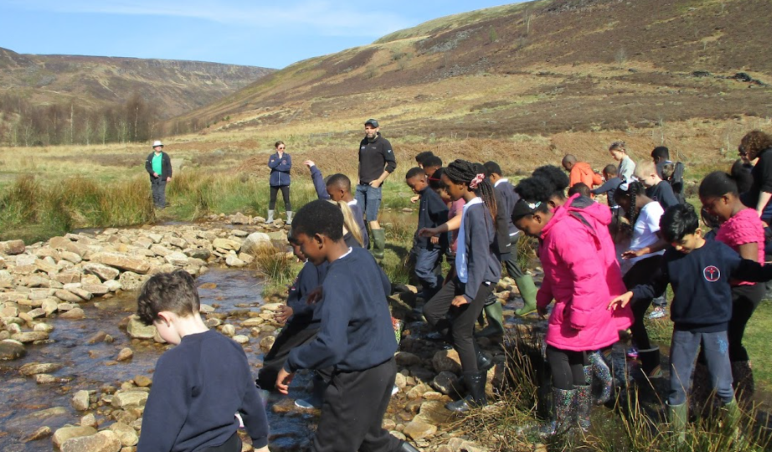

The Sacred Heart Talent Show
A special thank you to Mrs Tiplady for organising this fabulous event for our children.
Children in Reception, KS1 and KS2 had the opportunity to perform in a talent show this week. It was a beautiful celebration of their talents and confidence. A huge well done to everyone who participated!

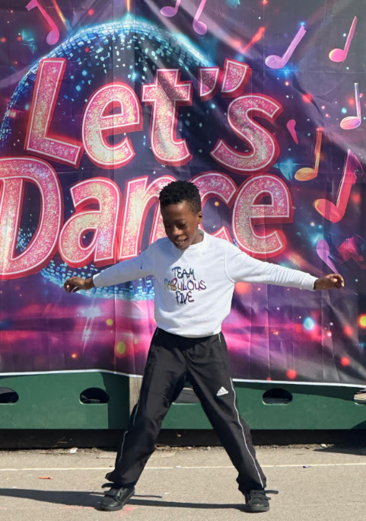

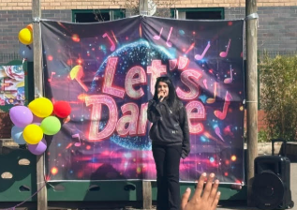
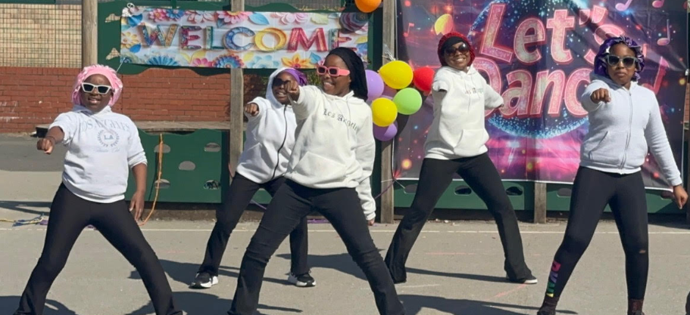

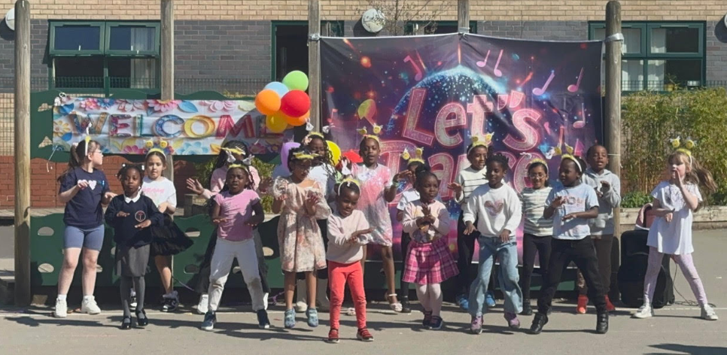

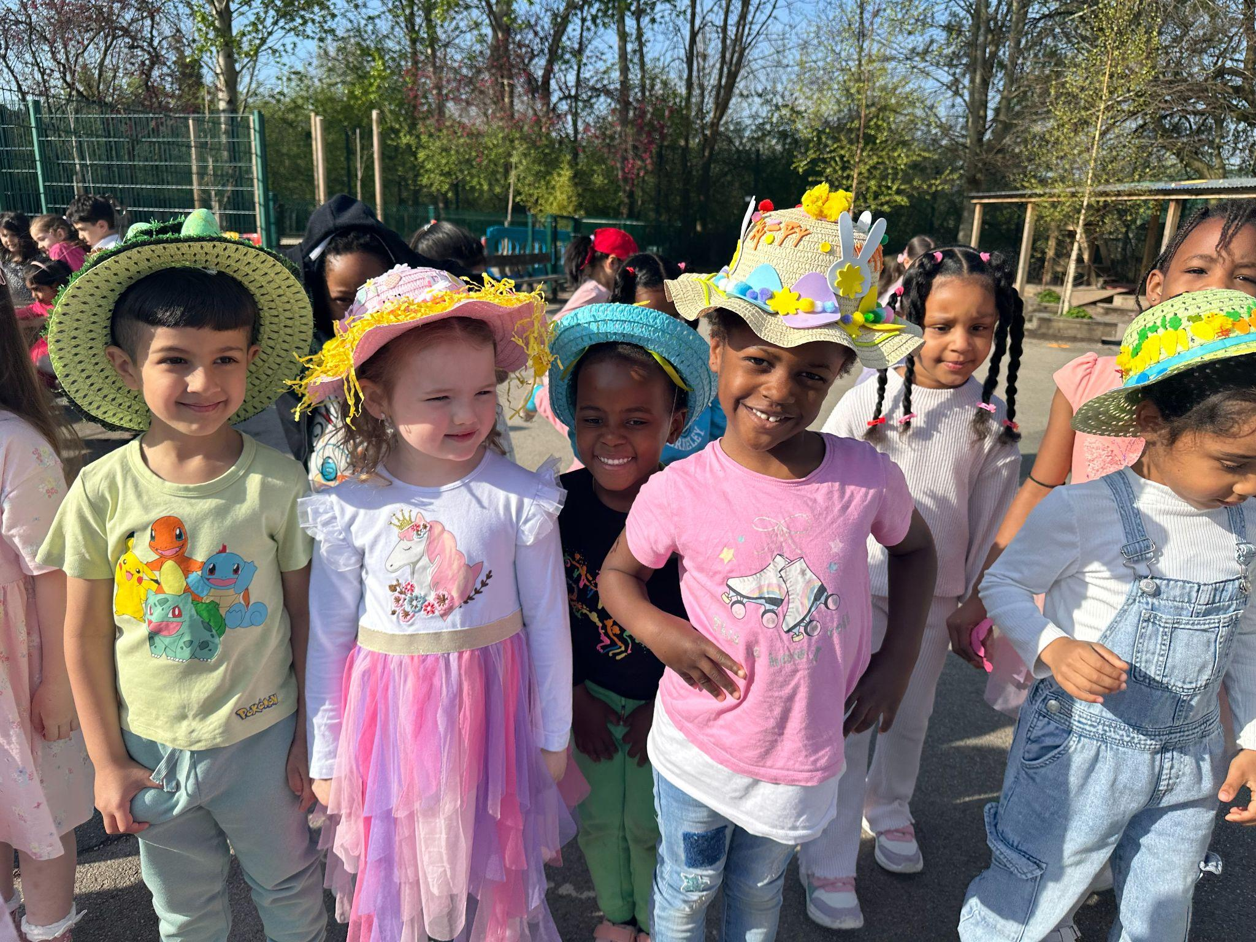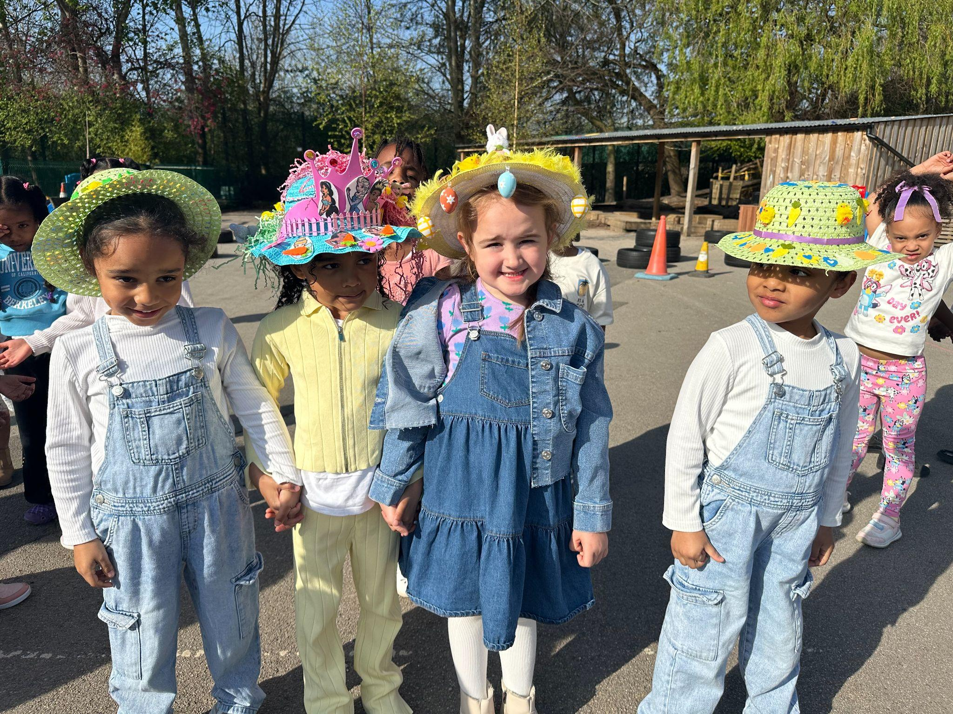Easter Bonnet Parade
Reception
Reception have been busy making Easter bonnets at home to display in our parade today. Thank you to parents for your support with this. You all looked amazing, Reception!

Charity fundraising
We have raised £570!
We have been raising money for CAFOD this half term, collecting funds through an own clothes day and an Easter egg raffle. Thank you so much for all your contributions and support to this important charity.

📚 SUPERSTAR READERS 📚
LKS2 - Class 4 who read 88,797 words this week! 💫
UKS2 - Class 9 who read 527,724 words this week! 🌟

🎓 TT ROCKSTARS 🎓
Well done to our TT Rockstars winners this week!
LKS2 - Layla Rae T💫
UKS2 - Denzel 🌟

🏆 ATTENDANCE AWARDS 🏆
Class 2 with 99.3% attendance!
Class 6 with 99.0% attendance!
Class 7 with 99.0% attendance!

These are fabulous attendance figures that show our families’ commitment to their children’s education and social development. Very, very well done!


Experiencing difficulties?
Parking, litter or fly-tipping issues?
If you are experiencing difficulties navigating the roads near our school due to dangerous or illegal parking, you can report your concerns here.
If you are experiencing issues with litter or fly-tipping, you can report your concerns here.
Click here for Mass times and other events in
the Parish of Sacred Heart and St Francis, Gorton
https://www.sacredheartstfrancisgorton.co.uk/mass-schedule

Sacred Heart RC Primary School
'Where Every Heart is Sacred’

