

Sacred Heart RC Primary School
'Where Every Heart is Sacred’
Week Commencing: 24th March 2025

Lent
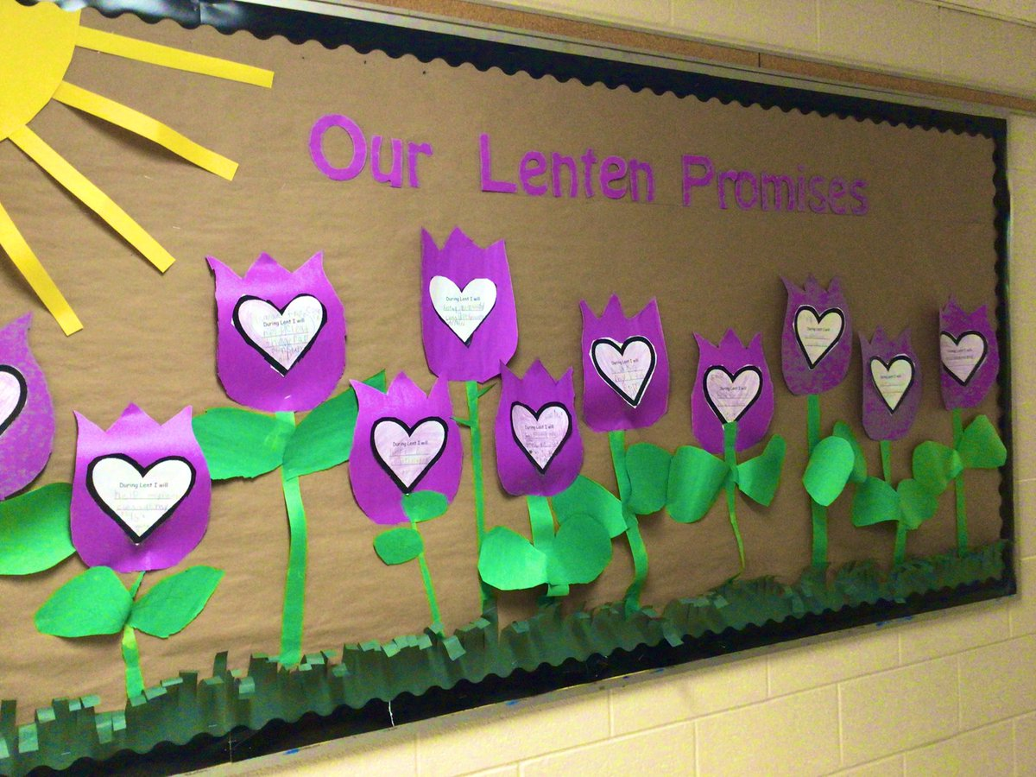
Lent is a special season for reflecting on our faith and growing closer to God. While many choose to give something up for 40 days, others take on small acts of kindness and sacrifice instead. Every step we take, no matter how small, brings us closer to God.
As Easter draws near, this weekend may be a great time to reflect with your child on their Lenten promises. Have they forgotten any? Have some been more difficult to keep?
We remind our children that with God, every day is a new beginning. It’s never too late to start again, to say sorry, and to renew our commitment to making Lent meaningful. Let’s embrace these final days with open hearts and make this our best Lent yet.
Click here to access a different short clip about Lent that your child may enjoy.


THIS WEEK’S TOP STORIES

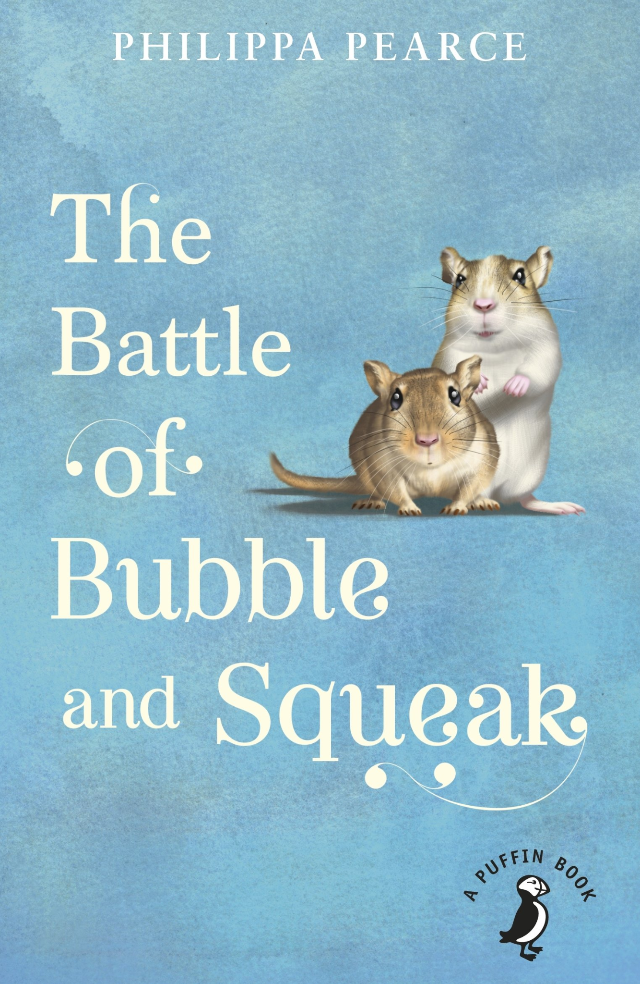
Science
Class 5
Class 5 has finished the guided reading text of ‘Bubble and Squeak’, and the children have enjoyed learning about the characters Sid, Amy and Peggy. We have been observing our plants in a science experiment - we have learned that plants without light have grown more than plants without water or heat.
Ask Class 5: If you want your house plants to grow well, where is the best place to put them?

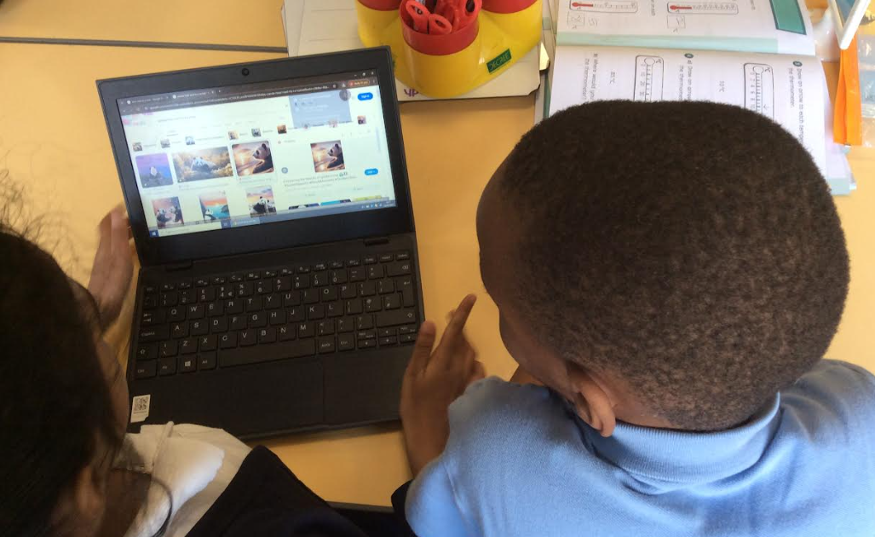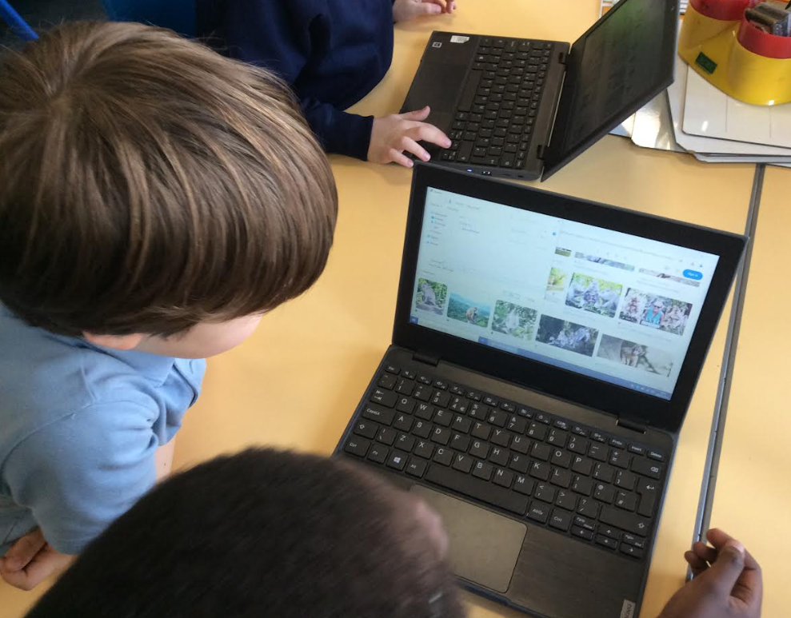

Computing
Class 3
This week in Computing, Class 3 took their digital skills to the next level! The children learned how to safely import pictures from secure websites before using sketch.io to edit their images. They explored how to adjust colours, resize photos, and experiment with rotation — showing off their creativity and technical skills.
Ask Class 3 which image they were most proud of after they had completed their editing.

Note from Father Kevin:
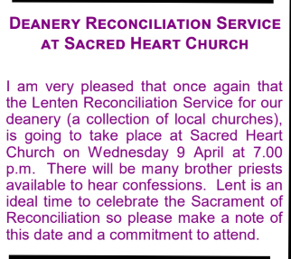

📚 SUPERSTAR READERS 📚
LKS2 - Class 6 who read 212,341 words this week! 💫
UKS2 - Class 8 who read 259,313 words this week! 🌟

🎓 TT ROCKSTARS 🎓
Well done to our TT Rockstars winners this week!
LKS2 - Ikem, Class 4💫
UKS2 - Nicole, Class 7🌟

🏆 ATTENDANCE AWARDS 🏆
Class 4 with 99.0% attendance
Class 7 with 98.3% attendance
Class 2 with 97.7% attendance

Well done to everyone who came to school on time every day this week!

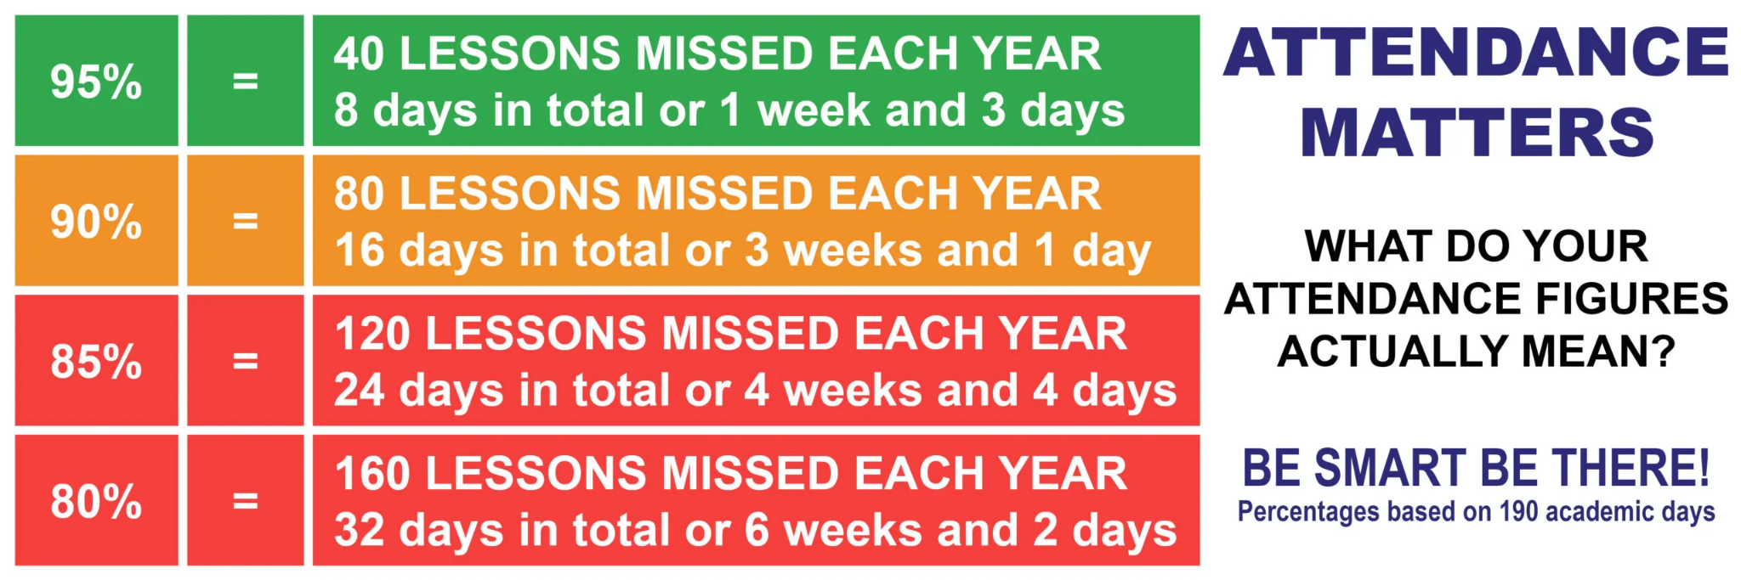

Experiencing difficulties?
Parking, litter or fly-tipping issues?
If you are experiencing difficulties navigating the roads near our school due to dangerous or illegal parking, you can report your concerns here.
If you are experiencing issues with litter or fly-tipping, you can report your concerns here.

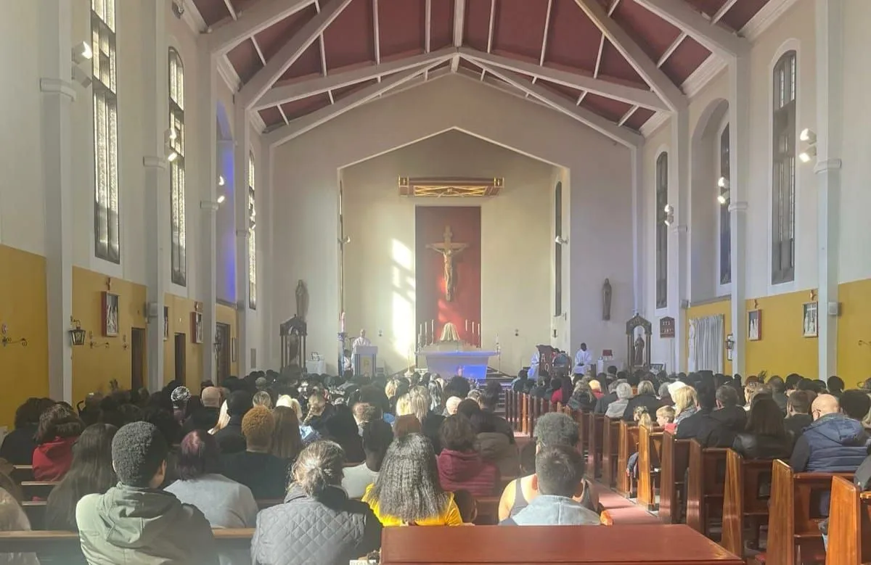
Click here for Mass times and other events in
the Parish of Sacred Heart and St Francis, Gorton

https://www.sacredheartstfrancisgorton.co.uk/mass-schedule

Sacred Heart RC Primary School
'Where Every Heart is Sacred’

