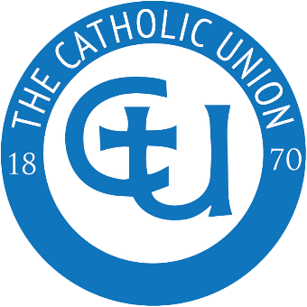
Catholic Union Young Artist Competition 2026
Application Form

- First Name…………………………………………………………………………….

- Year & Class……………………………………………………………………………

- School and/or Parish………………………………………………………………..

- Email Address of School/Parent………………………………………………….

- Contact Number……………………………………………………………………….
The competition is open to children of primary school age to depict what forgiveness looks like to them.
Email your entry to:
info@catholicunion.org.uk www.catholicunion.org.uk

The above email address will be added to the Catholic Union’s Weekly Briefing
- I do not wish for my email to be added
- I am happy for my email address to be added

