

Sacred Heart RC Primary School
'Where Every Heart is Sacred’
Week Commencing: 21st April 2025

Pope Francis

May he rest in peace and rise in glory
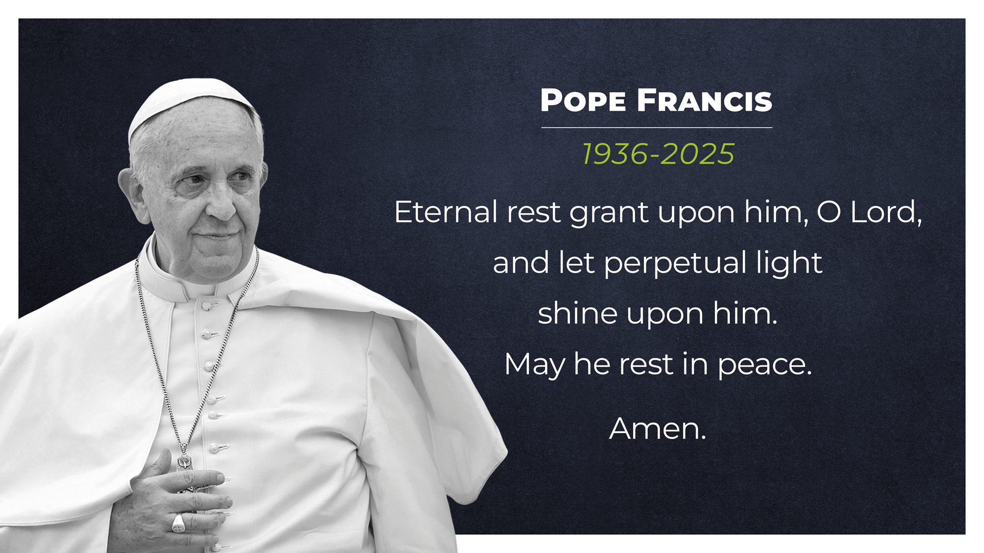

God in Heaven,

We thank you for the gift of Pope Francis and for all the wonderful ways he inspired us to build a better world.

Help us to continue his work by being Pilgrims of Hope, like he was.

May he rest in your peace.

Amen.

Easter Blessings
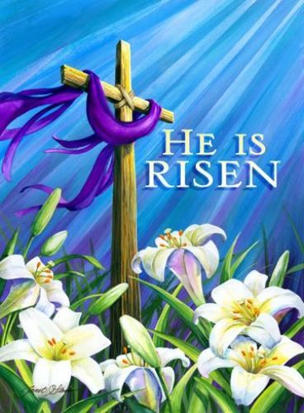
Easter is a time of renewal, reminding us of God’s infinite love and the promise of new life. At school, as well as mourning the passing of our beloved Pope Francis, we will continue to reflect on the joy of the Risen Christ in our learning, our prayers, and the way we treat one another with kindness and compassion.
As a Catholic community, we are blessed to walk this journey of faith together, supporting one another and nurturing the gifts God has given us.
Thank you for your continued support, and may this new term be filled with growth, peace, and the light of Christ in all we do.


Dates for your diaries:
Parents and carers are very welcome to join us in the school hall when their children are presenting a class assembly. Here are the next class assembly dates for your diaries:
Friday 2nd May (9:05am) - Class 4 (Miss Leadbetter)
Friday 16th May (9:05am) - Class 5 (Miss Scappaticci)
Friday 16th May (2:45pm) - Class 3 (Miss Chaudry)

Key Stage Masses:
Friends and family are very welcome to join us in Sacred Heart RC Church when their children are celebrating a class, key stage or whole school Mass. Here are the next Mass dates for your diaries:
Tuesday 29th April (9:15am) - KS1 and KS2 (Classes 1-9)
Tuesday 6th May (9:15am) - LKS2 (Classes 4, 5 and 6)
Tuesday 20th May (9:15am) - Class 2 (Miss Andrew)

School closes for the next half term break on Friday 23rd May.

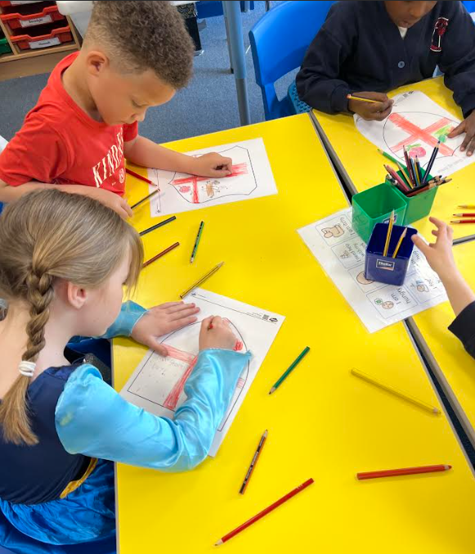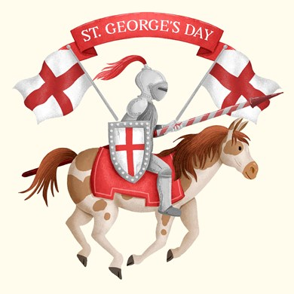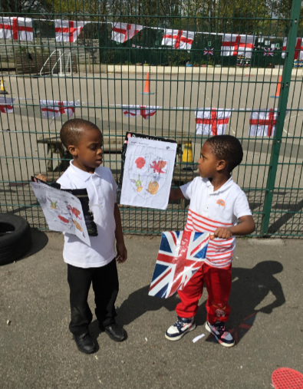
St George’s Day
23rd April, 2025
St George’s Day was a chance for us to explore some of the traditions and stories that are part of England’s history. It was a great opportunity for the children to learn about our shared heritage, as well as enjoy some creative and imaginative fun together! The children were invited to come into school wearing red or white, or even dressing up as a character related to St George, such as a King or a Knight!
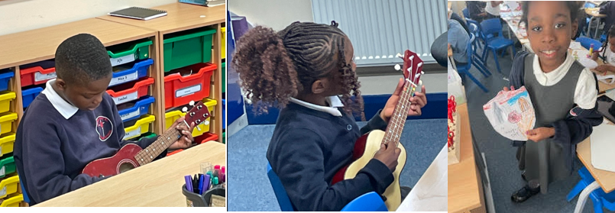Lots of learning!
Class 5
This week Class 5 had their first Ukulele lesson. They learnt 2 notes; C and A minor, which they used in 2 songs: ‘Hey hoy’ and ‘Thick of it’. We have continued to develop our knowledge about Fractions, learning about what an improper fraction is and how to convert improper fractions to mixed numbers and vice-versa. Class 5 have also started to learn about the artist James Rizzi and the qualities and features of his work that make it so unique. We also celebrated St George’s day by dressing in an item of red or white and making our own shields.

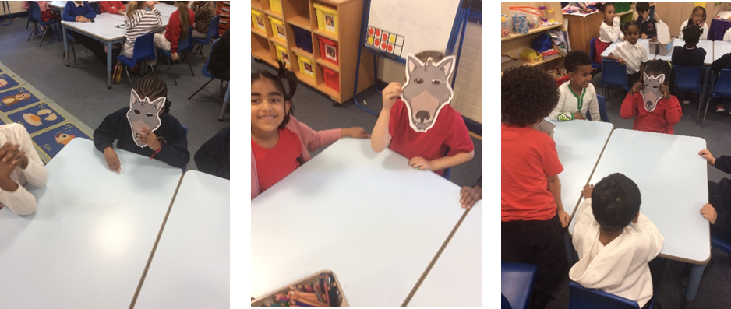The Wolf’s Story
Class 1
In Literacy, Class 1 have begun exploring The Wolf’s Story, a fascinating twist on the classic tale of Little Red Riding Hood — this time told from the wolf’s point of view! The children have been diving into character through hot seating and role play, stepping into the wolf’s shoes to understand his side of the story.
Over in History, Class 1 have kicked off their new topic on the artist L.S. Lowry. The classroom transformed into an art gallery as the children moved around to observe and discuss a range of Lowry’s paintings. Inspired by what they saw, they then created fact files filled with interesting information about his life and work.
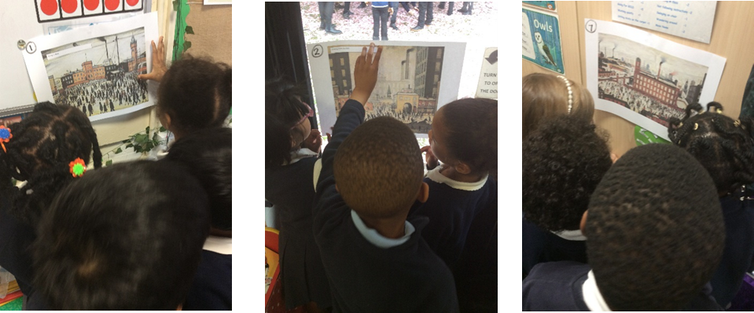

📚 SUPERSTAR READERS 📚
LKS2 - Class 6 who read 332,611 words this week! 💫
UKS2 - Class 9 who read 562,542 words this week! 🌟

🎓 TT ROCKSTARS 🎓
Well done to our TT Rockstars winners this week!
LKS2 - Ehinomhen, Class 4💫
UKS2 - Denzel, Class 7 🌟

🏆 ATTENDANCE AWARDS 🏆
Class 2 with 99.2% attendance
Class 7 with 95.4% attendance
Reception 2 with 95.4% attendance

Well done to everyone who came to school on time every day this week!

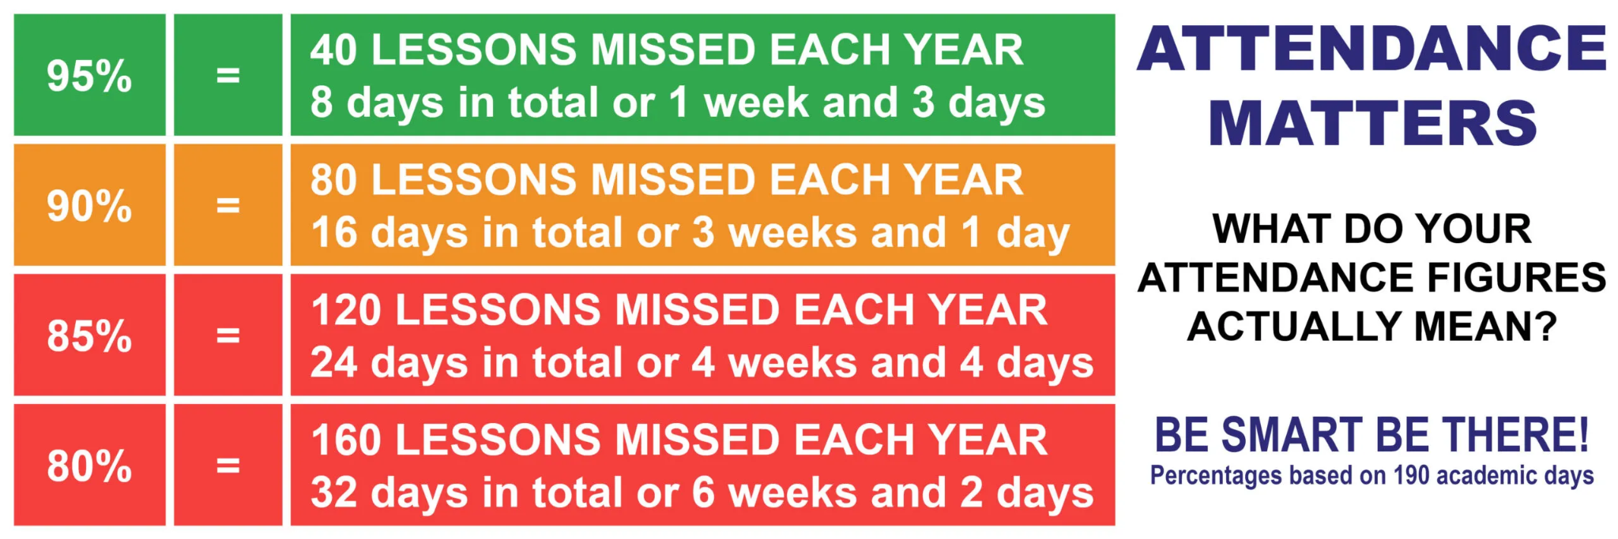



No makeup or jewellery please
Please remember that makeup and jewellery are not permitted in primary or secondary schools. Here is a link to our uniform policy, should you need a refresher: https://sacredheartschool-gorton.org.uk/parentscarers/school-uniform/
Thank you.

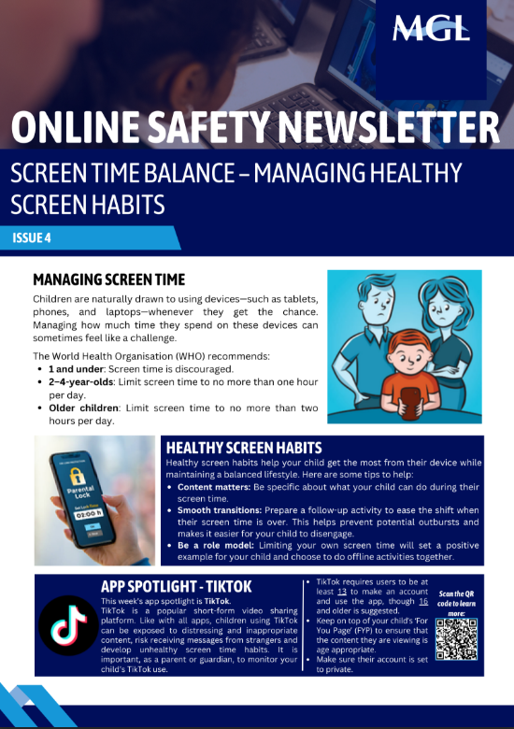

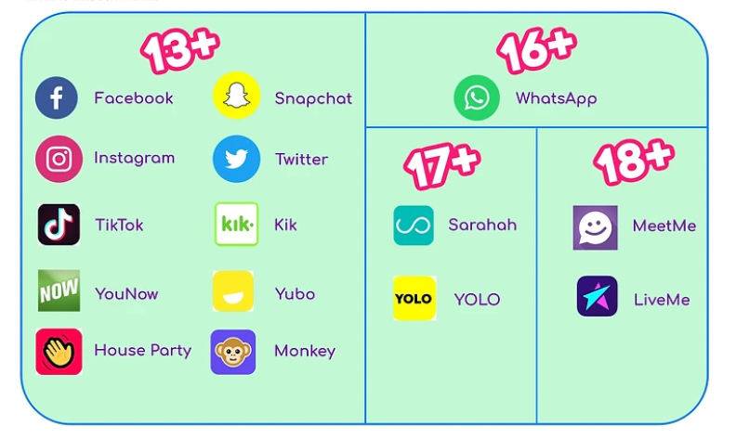
Whatsapp
Please respect the age limits on social media apps
Please remember that the minimum age for using WhatsApp in the UK is 16 years old. Please also remember to check through your child’s phone/tablet every week to ensure that they are using their technology responsibly.

Experiencing difficulties?
Parking, litter or fly-tipping issues?
If you are experiencing difficulties navigating the roads near our school due to dangerous or illegal parking, you can report your concerns here.
If you are experiencing issues with litter or fly-tipping, you can report your concerns here.

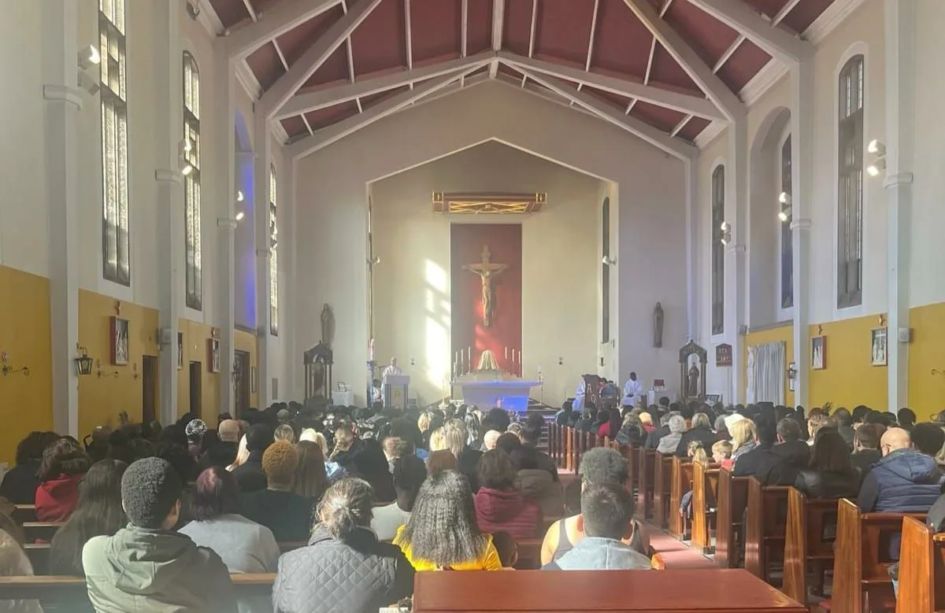
Click here for Mass times and other events in
the Parish of Sacred Heart and St Francis, Gorton

https://www.sacredheartstfrancisgorton.co.uk/mass-schedule

Sacred Heart RC Primary School
'Where Every Heart is Sacred’

